Case presentation of Cryptococcus Neoformans
Riham A. Abd ElHafiez, Master degree of Clinical Pharmacy, EGYPT

Abstract
Statement of the Problem:
Cryptococcus neoformans under microscope is a spherical, encapsulated, non-myceliated, and non-fermenting fungal cell. It is an obligate aerobe that can live in both plants and animals. In its yeast state, it is often found in bird excrement.
A 44 years old male patient has been diagnosed HIV, has admitted to ICU ward by the following clinical presentation: Fever, Vomiting and semiconscious. CSF culture has revealed Cryptococcus Neoformans
Methodology & Theoretical Orientation: After Lab results has showed Cryptococcus Neoformans, and according to the recommendations that I add to the health care professionals as a clinical pharmacist, we start the therapy plan of treating Cryptococcus Neoformans.
By following the treatment guidelines the patient has clinically improved.

Image
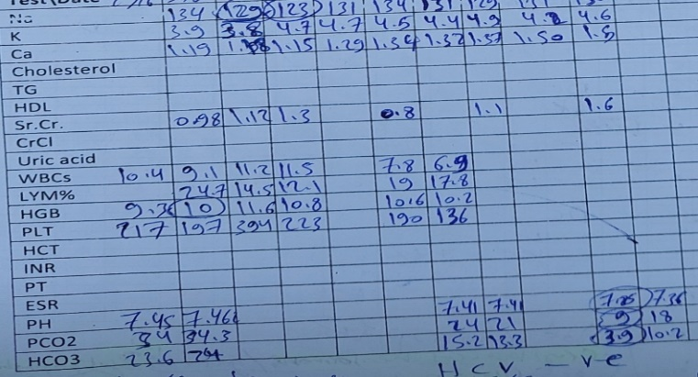
Recent Publications
- Riham A. Abd ElHAfiez (2010) Pharmaceutical Care Of Diabetes Mellitus In Pregnant Women
- Riham A. Abd ElHAfiez (2010) Pharmaceutical Care Of Recurrent Miscarriage In Pregnant Women


Specialist Clinical Pharmacist

Biography
Riham A. Abd ElHafiez has her expertise in training and clinical pharmacy practice. She has a considerable amount of responsibilities, handled them effortlessly. She showed her skills to communicate with both health professional staff and patients, and due to her dedication and attention to detail. Her characteristics showed that she is hardworking and working under stress without compromising the quality and quantity of work. In addition to her professional patient skills, she has excellent interpersonal skills which maintain relationship with her colleagues and administrative personnel.
Email: specialistclinicalpharmacist@yahoo.com

Presenting author details
Full name: Riham Adel Abd ElHafiez
Contact number: +201006616244
Mail id: specialistclinicalpharmacist@yahoo.com
Category: Oral presentation

