Green Chemistry and Food Application: Incorporation of Rosmarinus officinalis Leaves into Fresh Cheese

Lila Boulekbache-Makhlouf and Hayet Himed-Idir

Laboratoire de Biomathématiques, Biophysique, Biochimie et Scientométrie, Faculté des Sciences de la Nature et de la Vie, Université de Bejaia, Bejaia 06000, Algérie

Abstract (300 word limit)
Rosmarinus officinalis L. leaves can be valorized by their uses in the production of healthy foods. Dry rosemary leaves powder and its lyophilized ethanolic extract at different concentrations (g/100 g) were used for the formulation of fresh cheeses. This study evaluated whether or not this fortification could affect some physicochemical characteristics, phenolic composition and antioxidant capacity of fresh cheeses along storage period at 5°C.Results showed that this enrichment did not affect physicochemical parameters (pH, acidity, proteins, fat) of the formulated cheeses while its effect on cheese color parameters was more marked. Moreover, this incorporation has increased substantially values of total phenolic content (TPC) and ABTS scavenging activity during storage period compared to the control cheese. Principal components analysis (PCA) was performed and results confirmed a strong relationship between antioxidant activity and these phenolic compounds. Additionally, a correlation between physicochemical parameters, antioxidant activity as well as the sensory characteristics was carried out. Cheeses fortified with 0.5%, 0.75% of powder and 0.5% of extract, were most appreciated (60%–80%) by the panelists.
In conclusion, the consumers can successfully use rosemary as dairy supplements as it improves markedly the TPC and the antioxidant activity of cheese as well as a distinctive taste, aroma and acts as flavor enhancer for better acceptability.

Image

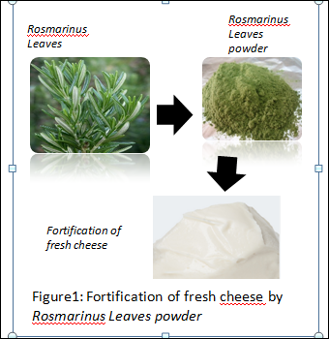

Recent Publications (minimum 5)

- Abayneh Kassahun and Gezu Feleke (2019). Proximate analysis, physicochemical properties and chemical characterization of Rosmarinus officinalis L. oil. Nat. Volatiles & Essent. Oils; 6(2): 20-24.
- Dairy Industries International (2019). Global cheese markets hit record highs.
Farkye, N. Y. (2004). Cheese technology. Internatinal Journal of Dairy Technology, 57 (2-
3), 91-98. dilution methods to determine the antibacterial activity of plant extracts. J.
Microbiol. Methods 81, 121–126.
- Djaoud, K., Boulekbache‐Makhlouf, L., Yahia, M., Mansouri, H., Mansouri, N.,
Madani, K., & Romero, A. (2020).Dairy dessert processing: Effect of sugar substitution by
date syrup and powder on its quality characteristics. Journal of Food Processing and
Preservation, 44(5), e14414. doi: 10.1111/jfpp.14414
- Fernandes, P. A., Ferreira, S. S., Bastos, R., Ferreira, I., Cruz, M. T., Pinto, A.,
Coelho, E., Passos, C. P., Coimbra, M. A., & Cardoso, S. M. (2019).Apple pomace extract
as a sustainable food ingredient. Antioxidants, 8(6), 189
- Guo, J., Yue, T., & Yuan, Y. (2019). Impact of polyphenols on the headspace
concentration of aroma compounds in apple cider. Journal of the Science of Food and
Agriculture, 99(4), 1635-1642. https://doi.org/10.1002/jsfa.9345

Biography (150 word limit)
Paste your Logo here
Lila Boulekbache Makhlouf has her expertise in food processing and green chemistry.
Email: lila.makhlouf@univ-bejaia.dz

Notes/Comments:
Presenting author details
Full name: Lila BOULEKBACHE-MAKHLOUF
Contact number: + 213 5 52 93 27 38
Twitter account:
Linked In account:
Session name/ number: Green and sustainable Chemistry
Category: (Oral presentation)

