Optimal@NRW: optimized acute care of nursing home residents using an intersectoral telemedical cooperation network – a stepped-wedge trial
Susanne Rademacher
University Hospital RWTH Aachen

Abstract
Statement of the Problem: The aging of society is increasing the number of hospitalizations of nursing home residents (NHRs). NHRs experience a lack of adequate outpatient medical care, especially when the family doctor is not available. Consequently, NHRs with non-emergency health issues are transported to hospitals only to ensure timely treatment. Those potentially avoidable hospitalizations (PAHs) are frequent, costly, and can cause severe side effects like developing delirium for dementia patients. Researchers showed that delirium in elderly is associated with significantly higher mortality rates and longer hospital stays. Besides, nurses in NHs feel overwhelmed when medical care is unavailable for their NHRs. Telemedicine has been shown to reduce the PAHs of NHRs. However, cross-sector collaboration is missing for implementing telemedicine strategies effectively to improve on-site care for the NHRs. The study aims to reduce the number of PAHs by implementing an intersectoral telemedicine network with an early warning system to register changes in the health status of NHRs early, a 24/7/365 availability of physicians via teleconsultations on demand, an electronic health record and non-physician practice assistants who perform delegable medical treatment in NHs.
Methodology: We performed a stepped-wedge cluster randomized trial (May 2021 to April 2023) to establish the network among 24 NHs (with N=1064 current NHRs), the university hospital, and outpatient physicians in North Rhine-Westphalia, Germany. The primary outcome is the number of days spent in the hospital.
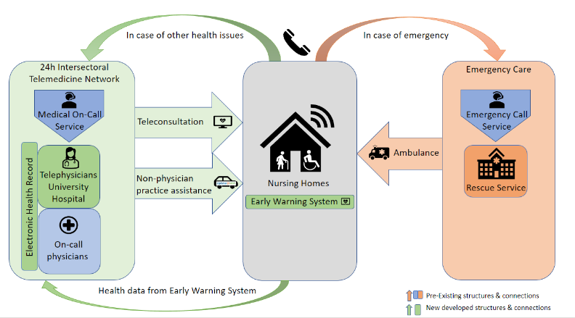
Findings: Final evaluation results are expected in 2024. Recent experiences of the tele-physicians show huge open-mindedness of the elderly for teleconsultations and sample cases in which diseases could have been treated in the nursing homes. Furthermore, we experienced reduced insecurities regarding the hospitalizations decision-making processes of the NHs staff.

Figure 1Schematic diagram of pre-existing structures in health care for nursing home residents and innovative form of healthcare delivery implemented within the project Optimal@NRW
Conclusion: The need for intersectoral care of NHR is unambiguous, and the project builds the basis for future collaboration and improvement.
References
- Kurte MS, Blankart K. Ambulant-sensitive Krankenhausfälle in Deutschland – Abgrenzung, Prävalenz und Kosten. Gesundheitsökonomie & Qualitätsmanagement. 2019;24(06):277-91.
- Grabowski, D. C., & O'Malley, A. J. (2014). Use of telemedicine can reduce hospitalizations of nursing home residents and generate savings for medicare. Health affairs (Project Hope), 33(2), 244–250.
- Zoremba N, Coburn M, Schälte G. Delir beim Intensivpatienten. ProCare. 2019;24(1):24-9.
- Inouye SK, Westendorp RG, Saczynski JS. Delirium in elderly people. Lancet. 2014;383(9920):911-22.
Biography
Miriam Hertwig is a medical doctor experienced in trauma surgery and emergency medicine. After participating in voluntary surgical missions worldwide, she decided to gain more experience in the field of international collaboration and research by studying Global Health. Her research topics are pre-clinical emergency medicine, care of severely injured people, and acute care of vulnerable groups.
Susanne Rademacher is research associate at University Hospital RWTH Aachen. She was involved in several successful projects focusing on telemedicine and improving intensive and emergency medical care. She is currently leading the Optimal@NRW project.

