Differential expression of sema 4C and sema 3F in the hippocampus and anterior temporal lobe (ATL) of pilocarpine model of temporal lobe epilepsy
Vivek Dubey

All India Institute of Medical Sciences, New Delhi

Abstract

Introduction: Epilepsy is a chronic neurological disease, introduced as the fourth most common neurological disorder affecting about 65 million people worldwide. Temporal lobe epilepsy (TLE), a distributed network disorder, is the most common form of drug-resistant epilepsy, and termination of epileptic seizures primarily takes place in the hippocampus in TLE. In this study, we set out to investigate the role of semaphorins (SEMA 3F and SEMA 4C) in the hippocampus, and anterior temporal lobe (ATL) of TLE rats.
Methods: For this study, the hippocampus and anterior temporal lobe from 8 TLE model rats, 8 controls rats were included. mRNA levels of SEMA 3F and SEMA 4C were evaluated by quantitative real-time PCR. Immunohistochemistry was performed to evaluate the expression of these proteins.

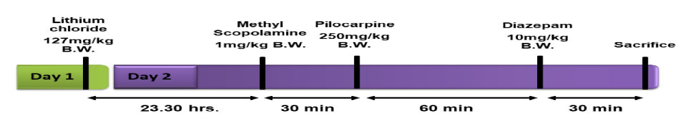
Figure 1. imescale for creation of lithium–pilocarpine model of status epilepticus. (B.W.: bodyweight).
Results: Significant up regulation of mRNA level of SEMA4C was observed in the hippocampus (2.47±0.93, P = <0.001) and ATL (4.00±2.14, P = <0.014) of TLE model as compared to control rats. Similarly, SEMA3F mRNA expression was also increased in the hippocampus (3.35±1.14, P = <0.001) and ATL (4.78±2.00, P = <0.012) of TLE rat model as compared to control rats. Immunohistochemical expression of SEMA3F and SEMA4C also showed the significant upregulation of these proteins in the hippocampus and ATL of TLE model as compared to control rats.
Conclusion: We have first time demonstrated the significant changes in SEMA3F and SEMA4C expression in pilocarpine model of epilepsy, providing a rationale for conducting further exploratory studies to better understand the role of semaphorin mediated mechanism in TLE .
References
- Banerjee, J., Banerjee Dixit, A., Srivastava, A., Ramanujam, B., Kakkar, A., Sarkar, C., Tripathi, M., & Chandra, P. S. (2017). Altered glutamatergic tone reveals two distinct resting state networks at the cellular level in hippocampal sclerosis. Scientific reports, 7(1), 319. https://doi.org/10.1038/s41598-017-00358
- Banerjee J et al., (2014). Annals of Indian Academy of Neurology. 17, 134-140
- Dubey, V., Dey, S., Dixit, A. B., Tripathi, M., Chandra, P. S., & Banerjee, J. (2022). Differential glutamate receptor expression and function in the hippocampus, anterior temporal lobe and neocortex in a pilocarpine model of temporal lobe epilepsy. Experimental neurology, 347, 113916. https://doi.org/10.1016/j.expneurol.2021.113916
- Dey S, Dubey V, Dixit AB, Tripathi M, Chandra PS, Banerjee J. Differential Levels of Tryptophan–Kynurenine Pathway Metabolites in the Hippocampus, Anterior Temporal Lobe, and Neocortex in an Animal Model of Temporal Lobe Epilepsy. Cells. 2022;11(22):3560. Published 2022 Nov 10. doi:10.3390/cells1122356
- Funded by-DBT(BT/PR20392/MED/122/26/2016)
Biography
Vivek Dubey Final year PhD Student in AIIMS, new Delhi, India. He has been compleated master in neuroscience from school of studies in neuroscience Gwalior, JU , MP india and Graduate fron Institute of science , Banaras Hindu university (BHU)

