Drezonotomy in a senile patient with post-herpetic neuropathy

* G. Salas and J. Bucett
Hospital Santa Cruz, Bolivia

Abstract

Pain is the first symptomatology that changes a patient's life and that of her social environment. The fact that the patient's pain becomes chronic and intractable without having the expected effectiveness with pharmacological therapy.

Tolerating their undesired effect, such as opioid abuse, non-invasive treatment failure, among others, have led to the study of probable surgical techniques for pain relief in these patients, in search of being able to grant them a better quality of life and in some cases return them to society.

In search of alternatives, the drezotomy is reached, which is the destruction of the entry region of the sensitive posterior root in the posterior horn of the medulla (dorsal root entry zone) for its acronym in English D.R.E.Z. (Dorsal Root Entry Zone).

The effectiveness of this technique is demonstrated in the clinical case and its evolution, being viable and safe hfor the control of intractable pain with medication.

Keywords: Herpes zoster, Elderly Risk factor's, Postherpetic neuralgia, Drezonotomy.

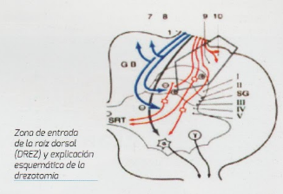
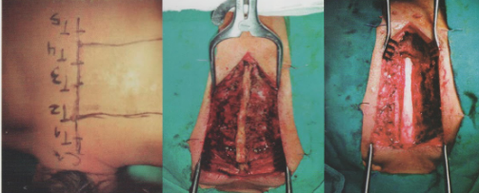
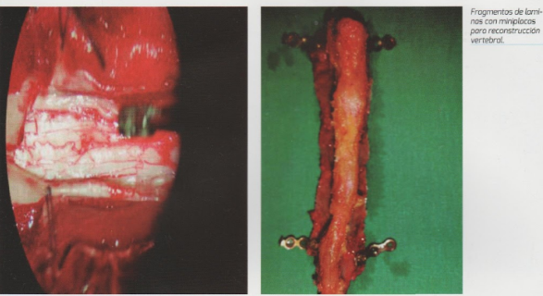

Recent Publications (minimum 5)

- Freer G, Pistello M. Varicella-zoster virus infection: natural history, clinical manifestations, immunity and current and future vaccination strategies. New Microbiol. [Internet] 2018 [consul-tado el 4 de febrero de 2020]; 41(2): 95-105. Disponible en: http://www.newmicrobiologica.org/PUB/allegati_pdf/2018/2/95.pdf
- Sauerbrei A. Diagnosis, antiviral therapy, and prophylaxis of varicella-zoster virus infections. Eur J Clin Microbiol Infect Dis. [Internet] 2016 [consultado el 4 de febrero de 2020]; 35: 723-734. https://doi.org/10.1007/s10096-016-2605-0
- Le P, Rothberg M. Herpes Zoster infection. Brit Med J. [Internet] 2019 [consultado el 4 de febrero de 2020]; 364: k5095. https://doi.org/10.1136/bmj.k5095
- Schmader, K. Herpes Zoster. Clin Geriatr Med. [Internet] 2016 [consultado el 4 de febrero de 2020]; 32(3):539-553. https://doi.org/10.1016/j.cger.2016.02.011
- Schmader, K. Herpes Zoster. Ann Intern Med. [Internet] 2018 [consultado el 4 de febrero de 2020]; 169(3):ITC17-ITC31. https://doi.org/10.7326/AITC20180800

Carmen Judith Bucett Santa Cruz. Was resident en Neurosugery in Caja petrolera de salud Hospiital between 2013 – 2028. Se have been make community service the Trinidad hospital, between 2019 – 20210. Actually she has her expertise in evaluation and passion in improving the health and quality life. Her open and contextual evaluation model based on responsive constructivists creates new pathways for improving health care. She has built this model after years of experience in research, evaluation, teaching and been neurosurgeon attending in hospital caja de salud CORDES and education institutions, like uni9versity of Aquino Bolivia (IDABOL), Valle university (UNIVALLE), Franz Tamayo University (UNIFRANZ). This approach is responsive to have a different way of focusing and aborda

