Neurocognitive Effect of Cannabis on Adolescents
Vivens Ulysse, RN BSN, CCRN
Dr. Donna Fife, DNP, APRN MCPHS University, USA
INTRODUCTION
Over 1.6 million individuals between the ages of 12 and 17, roughly 6.5 % of the U.S. adolescent population reported current use of cannabis. Congress legalizing marijuana use in 36 states, combined with a change in public opinion and a flawed perception regarding the harm caused by cannabis has resulted in a steady rise in psychiatric illness. Cannabis is the most commonly used psychoactive drug with which US youths present for substance use treatment (Hammond et al., 2020).
METHODOLOGY
The methodology for this research includes a review of the literature through databases such as Google Scholar, PubMed, Medline Ovid, CINAHL, and Cochrane Database of Systemic Reviews. Exclusion and inclusion criteria includes only articles written within the last five years that are full text, written in English, and relevant to the research topic. Articles comprised of peer-reviewed, scholarly, and primary research studies, and keywords searched included "cannabis and adolescents," “impact of cannabis on adolescents,” “cannabis misuse,” “cannabis misuse among high school students,” “cannabis and college students,” and “effects on cannabis use and anxiety and depression.”
KEY FINDINGS
Those who started using cannabis before age 15 years and used it frequently at 21 years were more likely to report symptoms of AD in early adulthood. Daily use in young women was associated with an over fivefold increase in the odds of reporting a state of depression and anxiety after adjustment for intercurrent use of other substances. Weekly or more frequent cannabis use in teenagers predicted an approximately twofold increase in risk for later depression and anxiety. As shown below, the risk of psychiatric illness later in life is heightened when cannabis is used during adolescents 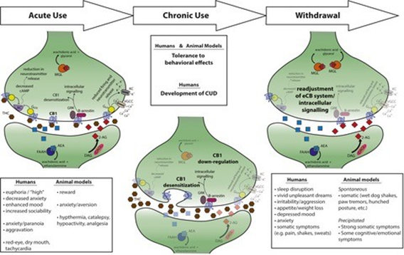

DISCUSSION/CONCLUSIONS
The research revealed a strong link between longer exposure of cannabis use with psychotic symptoms between the ages of 18-20 years old in addition to anxiety and depression lasting into the adult years. Those who smoked cannabis even for a short period of time (1-2 x a week or 5-6x a month) have an increased occurrence of anxiety, depression and mood dysregulation. The earlier one begins to use cannabis, the stronger the link between cannabis use, a lowered IQ, suicidal thoughts and ideation, and schizoaffective disorders. If left untreated, cannabis use disorder can activate psychosis and mood disorders in those more sensitive to psychiatric disorder (i.e., those with a mother/father, aunt, uncle with bipolar

