Hierarchical Zeolite Y Catalyst Synthesis for Biodiesel Production using Waste Cooking Oil
1Prof M.S. Haruna ,1 Dr. A.R. Agava , 1N.J.Sani and 2*Prof A.S. Kovo
1National Agency for Science and Engineering Infrastructure , Abuja , Nigeria
2Department of Chemical Engineering, Federal University of Technology, Minna
*kovo@futminna.edu.ng, +2347013377258 [

Abstract (300 word limit)

This study reports synthesis of hierarchical zeolite Y for biodiesel using waste cooking oil as feedstock. The hierarchical zeolite Y catalyst produce were characterized using X-Ray diffraction (XRD), scanning electron microscopy (SEM) and Brunnauer, Emmeitt and Teller(BET) analysis. From the BET results of hierarchical mesoporous Y zeolite produced shows that mole concentration of simultaneous desilication and mild dealumination determine the hierarchical factor of the produced hierarchical Y zeolite. Furthermore, this process was optimized by varying both the mole concentration aqueous solutions of Sodium Hydrides (NaOH) and Ethylenediaminetetraacetic acid (H4EDTA). The two (2) process variables NaOH and H4EDTA were found to be statistically significant for high surface area, pore volume and pore size whereby, the value obtained for surface area are 193.83, 216.03, 212.34 and 218.33 m2/g while the hierarchy factor were calculated to be 0.0571, 0.1540, 0.1781 and 0.1042 respectively. The highest value of hierarchy factor (0.1781) of hierarchical zeolite Y sample (HZY-3) occur at 0.3 M of NaOH and 0.3 M of H4EDTA with pore volume of 0.3785 c m3/g and pore size 8.5512 nm, which represent the most suitable for optimum reactivity compared to other. the SEM/EDX determined the crystallite size and the morphology. From the EDX, the hierarchical zeolite Y Si/Al ratio was calculated to be 15.0. HZY gave biodiesel yield of 94.8 % at 55 °C for 90 Mins while CZY gave yield of 62.00% at the same condition. Reusability test was also carried out and it was observed that at repeated 5th runs, biodiesel yield using the same HZY catalyst dropped to 83 % which was still reasonable enough compare to CZY catalyst which was observed to have dropped to 41.

Recent Publications (minimum 5)
Friday Ohiani Bello , Jane Kagher , Rashida Salihu Safiyanu , Rekiya Abdullahi Usman , Ambali Saka Abdukareem and Abdulsalami Sanni Kovo,(2022), Production and characterization of hierarchical zeolite Y catalyst for biodiesel production using waste cooking oil as a feedstock, BIOFUELS https://doi.org/10.1080/17597269.2022.2140883, Taylor and Francis
Jane Mngohol Gadin , Eyitayo Amos Afolabi , Abdulsalami Sanni Kovo, , Ambali Saka Abdulkareem and Moritiwon Oloruntoba James (2022) A retrospect on recent research works in the preparation of zeolites catalyst from kaolin for biodiesel production, BIOFUELS https://doi.org/10.1080/17597269.2022.2132723, Taylor and Francis
F. O. Mbagwu · S. H. Auta · M. T. Bankole · A. S. Kovo · O. P. Abioye, (2022), Biosynthesis and characterization of silver nanoparticles using Bacillus subtilis, Escherichia coli, and leaf extracts of Jatropha and Ocimum species, International Nano Letters https://doi.org/10.1007/s40089-022-00387-9, Springer
J T. Mamman, · A. Y. Atta · B. Mukhtar,· A. S. Kovo · B. O. Aderemi, B. Y. Jibril (2022), Zinc modified hierarchical ZSM-5 for Aromatisation of Propane, Journal of Porous Materials, https://doi.org/10.1007/s10934-022-01239-9
A.J.Otaru,M.Abdulkadir,A.S.Kovo,M.R.Corfield,N.Tanko,O.A.Odey,A.Kenfack, U.O.Aroke, (2022), Three-dimensional high-resolution image inversion and pore level CFD characterisation of effective thermal conductivity of replicated microcellular structures, International Journal of Thermofluids, Volume 14, May 2022, 100141

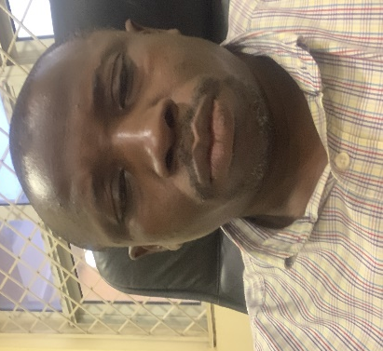
Paste your Logo here
Biography (150 word limit)
Prof Kovo has an expertise in the synthesis and characterization of Zeolite Catalyst for biodiesel production and other catalytic processes. He has worked severally on the use of cheap precursor for making different zeolites and also study their various applications in adsorption, catalysis and separations.
Email: kovo@futminna.edu.ng

Presenting author details
Full name: Kovo Abdulsalami
Contact number: +2347013377258
Category: (Oral presentation/ Poster presentation)

