Effectiveness of Supply Chain Planning in Ensuring Availability of CD/NCD Drugs in Non-Metropolitan and Rural Public Health System

Nagarajan, Dr. Shyama*
Sahamanthran Pvt. Ltd, India
Abstract
Statement of the Problem: Several studies have reported on the shortage of drugs with the changing demographic and disease profile, especially triggered by the growing burden of lifestyle diseases in India. However, very few have evaluated the demand side challenges from the objective of universalization of healthcare. Therefore, this study was designed to evaluate the factors that have impeded access to affordable generic and essential drugs in non-metropolitan urban and rural India.
Methodology & Theoretical Orientation: The study was conducted in six states and responses were elicited from a sample of doctors, pharmacists, nurses, ASHA workers, state officials, warehouse managers and patients across the study states of India .
Findings: The study reveals that while the acceptance of prescribing generic drugs has improved over the last decade, the use of branded drugs has been restricted only to complex cases or where generic drug efficacy has not been established. The centralized (state) procurement efficiencies seem to have hit a plateau in terms of assuring drug availability to the last mile, thereby necessitating costlier local purchase. Most states have also established dedicated corporations for drug procurement, albeit at different levels of organizational maturity as far as adherence to the processes and (IT) systems are concerned. However, supply chain phenomena like the bullwhip effect gets accentuated given the levels of our public health system. Learnings from other consumer facing sectors with similar challenges of increased variability and uncertainty are yet to be explored for the health sector to leapfrog towards achieving improved ‘drug availability’ OR ‘zero stock-out’
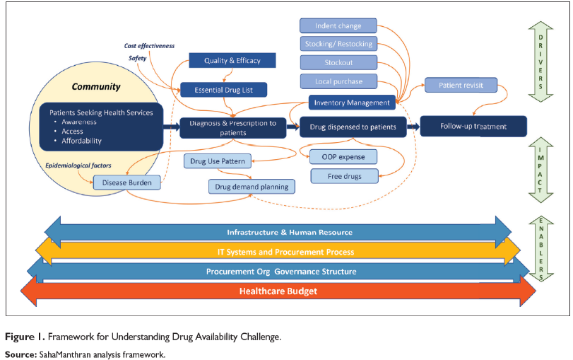
Conclusion & Significance: Standardizing drug categories, regular updating of the Essential Drug List (EDL) reflecting the demographic and disease profile, various practices like complete digitalization, rolling forecasts, SKU rationalization, flexible public procurement contracts, etc., have been explored as potential solutions in this paper. Creating a dedicated team of forecasters within the procurement organizations, well adept at using analytics, could be key to real-time demand estimation, paving the way for a quarterly rolling forecast to facilitate procurement using well-designed and flexible rate contracts with suppliers that captures variability in such rolling forecasts.
References:
- Bhargava, A., & Kalantri, S. (2013). The crisis in access to essential medicines in India: Key issues which call for action. Indian Journal of Medical Ethics, 10(2), 86.
- Farooqui, H., Chokshi, M., Selvaraj, S., & Kumar, P. (2015). A cross-sectional survey of the models in Bihar and Tamil Nadu, India for pooled procurement of medicines. WHO South-East Asia Journal of Public Health, 4(1), 78.
- Prashanth, N. S., Elias, M. A., Pati, M. K., Aivalli, P., Munegowda, C. M., Bhanuprakash, S., Sadhana, S. M., Criel, B., Bigdeli, M., & Devadasan, N. (2016). Improving access to medicines for noncommunicable diseases in rural India: A mixed methods study protocol using quasi-experimental design. BMC Health Services Research, 16, 421. https://doi.org/10.1186/s12913-016-1680-3
- Lee, H. L., Padmanabhan, V., & Whang, S. (1997). The bullwhip effect in supply chains. Sloan Management Review, 38, 93–102.
- Mohanta, G. P., & Manna, P. K. (2015). Rational use of medicines— Indian perspective! International Journal of Risk & Safety in Medicine, 27(Suppl. 1), S47–S48. https://doi.org/10.3233/JRS-150684
- Pickering, M., & Muir, J. (2019). Killing the annual budget cycle: Dynamic planning and rolling forecasts in lean enterprises. Journal of Cost Management, 2019, 24–32.

Biography:
Deanna Mulvihill has her expertise in evaluation and passion in improving the health and wellbeing. Her open and contextual evaluation model based on responsive constructivists creates new pathways for improving healthcare. She has built this model after years of experience in research, evaluation, teaching and administration both in hospital and education institutions. The foundation is based on fourth generation evaluation (Guba& Lincoln, 1989) which is a methodology that utilizes the previous generations of evaluation: measurement, description and judgment. It allows for value-pluralism. This approach is responsive to all stakeholders and has a different way of focusing.

