Case Report
AN UNUSUAL CASE OF ANAPHYLAXIS IN A CHILD WITH PULMONARY ECHINOCOCCOSIS

Francesca G Maraschin Debbie A White
Charlotte Maxeke Johannesburg Academic Hospital, Department of Paediatrics and Child Health, Faculty of Health Sciences, University of the Witwatersrand, Johannesburg, South Africa
Email ӏ maraschinfran@gmail.com

ABSTRACT
Echinococcus is a tapeworm that causes hydatid disease. Cystic echinococcosis, caused by Echinococcus granulosus, is a condition endemic to South Africa, particularly in sheep-farming areas such as the Eastern Cape. Patients may present with a variety of symptoms and complications, including spontaneous cyst rupture and subsequent anaphylaxis which may prove to be fatal. Treatment methods may be medical or surgical. We report the case of an 11-year-old boy who was treated medically for pulmonary hydatid disease and subsequently presented with spontaneous cyst rupture and anaphylaxis, resulting in the need for surgical resection of the cyst.

Keywords: pulmonary echinococcosis, tapeworm, cystic echinococcosis

CASE
A
n 11-year-old boy known to the pulmonology department at Charlotte Maxeke Johannesburg Academic Hospital (CMJAH) with asthma, atopic eczema and allergic rhinitis (AR), presented at a routine follow-up asthma clinic appointment with a history of shortness of breath the previous night after a football match. He had responded to the use of a salbutamol inhaler but on further enquiry his mother reported a one-week history of a non-productive cough, chest pain, intermittent fever and shortness of breath. The mother further reported a travel history
to the Eastern Cape the previous month.

On examination the child was alert and cooperative and not acutely ill-looking. There was no recorded fever. The heart rate was 96 beats/min and oxygen saturation normal. On respiratory examination there was hyperinflation of the chest on inspection, bilateral wheezes, as well as crackles on the right lower zone with decreased breath sounds on auscultation. In light of these abnormal findings a chest X-ray was conducted. The X-ray revealed a well-circumscribed right middle-lobe mass, with no attenuation of the airway (see Figure 1). Given the suggestive X-ray findings, the fact that the patient had recently travelled to the Eastern Cape, and that he had no constitutional symptoms suggestive of tuberculosis (TB), an Echinococcus indirect haemagglutination assay (IHA) was done at this time, which came back negative.
The patient was prescribed Amoxicillin to take at home for five days and an abdominal ultrasound was performed five days later. The ultrasound did not show any lesions in the liver or elsewhere in the abdomen. A computed tomography (CT) chest scan confirmed the presence of a well-defined unilocular cystic lesion in the right middle lobe and anterior segment of the

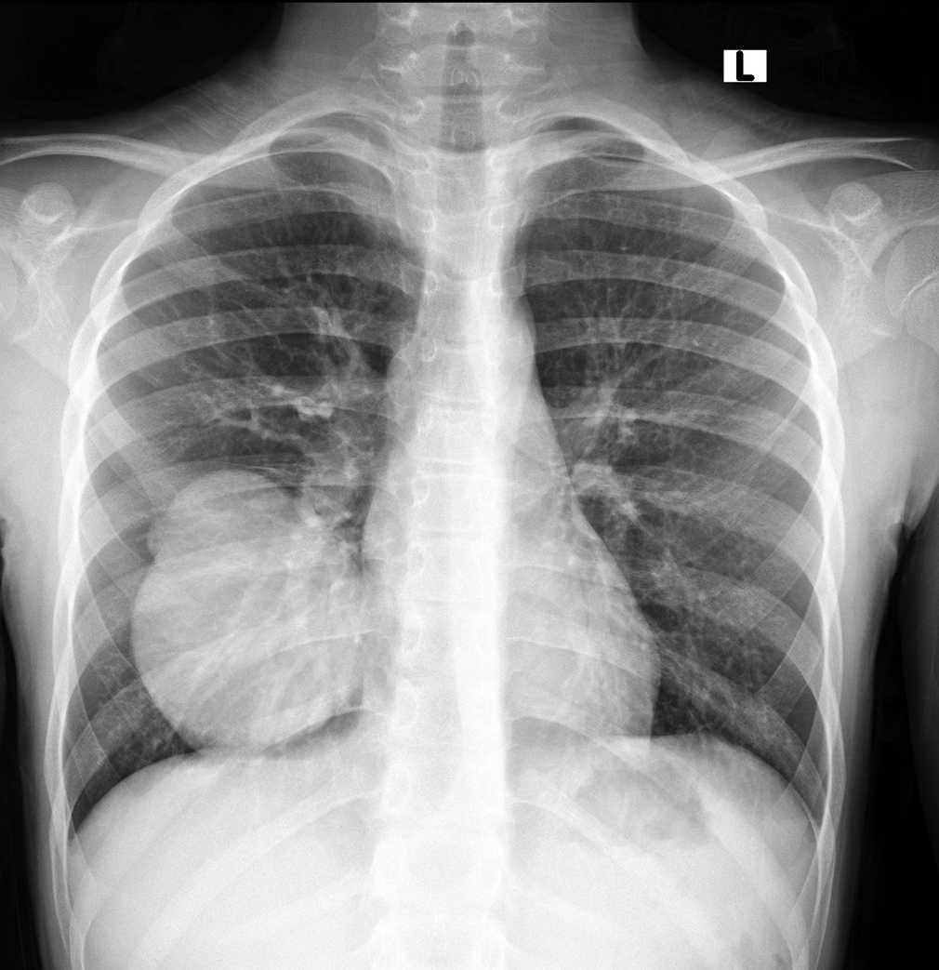
Figure 1: Anterior-posterior view of chest X-ray showing well- circumscribed right-middle lobe mass with no attenuation of the airway.

right lower lobe measuring 7.1 x 6.7 x 8.6 cm (see Figure 2). Echinococcus IHA was negative but in light of the features of a well-circumscribed mass on CT, a travel history to the Eastern Cape, and a lack of constitutional symptoms or contacts to suggest TB, a diagnosis of pulmonary echinococcosis was made.

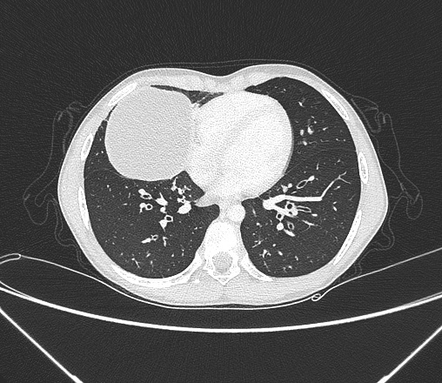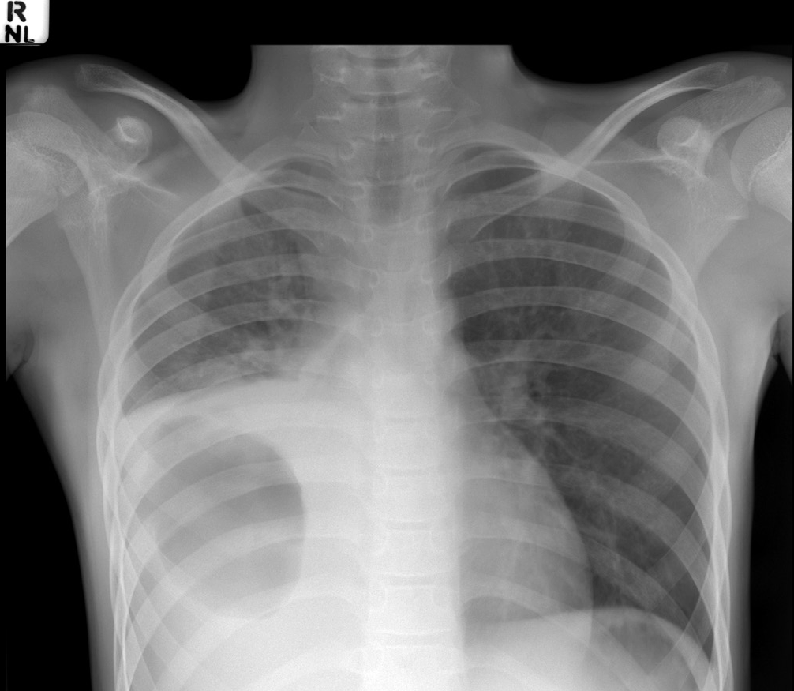

Figure 2: Axial view of CT chest showing well-circumscribed cystic mass in the right-middle lobe of the lung measuring 7.1 x 6.7 x 8.6cm
[insert Figure 2?]
Figure 3: Anterior-posterior view of chest X-ray showing right-sided cystic lesion accompanied by a pleural effusion

At this time, the previous symptoms had resolved, so it was decided to commence medical treatment with Albendazole. After receiving Albendazole for one week, the patient presented to casualty reporting a one-day history of fever, shortness of breath, abdominal cramps, non-projectile vomiting and dizziness. On examination, the child was alert but tachypneic, tachycardic, pyrexial with a temperature of 38.5 ºC and hypoxic with oxygen saturations of 80% in room air. On respiratory examination, there was dullness to percussion and decreased air entry on the right as well as bilateral wheezes. He had generalised abdominal tenderness but no rebound tenderness or guarding. Cardiovascular and neurological examinations were normal.
A chest X-ray revealed that the patient had a right-sided cystic lesion accompanied by a pleural effusion (see Figure 3).

INVESTIGATIONS
A number of investigations relevant to the patient’s condition were performed between May and August 2019. They are summarised in Table I.

MANAGEMENT
The patient was admitted and placed on supplemental oxygen via a polymask to maintain oxygen saturations > 92%. In view of the underlying history of asthma and the presence of bilateral chest wheezing, he was started on nebulised short-acting beta- 2-agonists and intravenous hydrocortisone. Empiric antibiotics were commenced for pneumonia in view of the elevated CRP. A consideration of the unusual combination of clinical symptoms – respiratory distress, wheezing, abdominal cramps and vomiting
– prompted a diagnosis of anaphylaxis, secondary to the rupture of the hydatid cyst. Intravenous antihistamines were added and Albendazole was continued. He did not receive intramuscular Adrenalin. The patient continued to have wheezing and abdominal pain in the ward throughout the night, but all the signs had improved remarkably by the next morning. A repeat Echinococcus IHA came back negative. At this stage, after consulting with infectious disease specialists and paediatric surgeons, it was decided to add Praziqauntel to the treatment regimen. One week later, he was discharged on weaning doses

TABLE I: RELEVANT INVESTIGATIONS
INVESTIGATION | DATE PERFORMED
 | May 2019 | July 2019 | August 2019 | Reference values
Echinococcus indirect hemagglutination assay (IHA) | Negative | Negative
White cell count (×109/L) |  | 14.8 |  | 3.90–12.60
Neutrophils (%) |  | 67.4 |  | 55–70
Lymphocytes (%) |  | 21.7 |  | 20–40
Monocytes (%) |  | 7.50 |  | 2–8
Eosinophils (%) |  | 2.60 |  | 1–4
Basophils (%) |  | 0.30 |  | 0/5–1
C-reactive protein (CRP) mg/L |  | 146 |  | <10
Lung histology |  |  | E granulosus

CASE REPORT

of Prednisone and continued on Albendazole, Praziquantel and maintenance asthma therapy. He was booked for a thoracotomy and cyst removal a month later. The surgery was successful, and the histology of the specimen confirmed E granulosus. The patient was managed in the paediatric intensive care unit for eight days post-operation. He was then discharged to the general paediatric ward and was regularly consulted by the pulmonology team while receiving continued Albendazole and Praziquantel. The patient was discharged once the intercostal chest drain was removed and he was stable in the ward. Albendazole and Praziquantel were continued for three months.
The patient now follows up at the pulmonology out-patient department and is doing well, with no clinical or radiological evidence of cyst recurrence.

DISCUSSION
Cystic echinococcosis (CE) is a zoonotic parasitic disease caused by E granulosus; it is endemic to South Africa, particularly in sheep-farming areas such as the Eastern Cape.1,2 The infection of human beings with the parasite occurs faeco- orally via food or water that is contaminated by the faeces of the definitive host (most often dogs), who themselves acquire infection via the ingestion of cyst-contaminated organs of the intermediate host (sheep, cattle, donkeys, etc).2,3 Infestation in the human host may occur via penetration of oncospheres through the intestinal wall and subsequent spread to organs – the liver being the most commonly affected organ in adults and the lungs in the paediatric population.2,3 In a South African study conducted by Ndlovu et al, males were found to present more commonly than females with hydatid cysts at a ratio of 6 : 1.2
Pulmonary echinococcosis has a range of clinical manifestations depending on the location, size and whether or not the cyst has complicated. Smaller cysts tend to remain asymptomatic, but those larger than 5 cm (as with the cyst in this case) tend to produce symptoms either via compression of neighbouring structures or complication.3
On initial presentation when the hydatid cyst was first suspected, the patient in our case report had a non-productive cough and was experiencing fever, dyspnoea and chest pain. In their retrospective study, Kuzucu et al report that 26.5% of patients with pulmonary hydatid cysts were asymptomatic, whereas 50% presented with chest pain, 26.5% with cough, 17.6% with dyspnoea and 11.8% with fever. Therefore, the initial symptoms of the patient in this instance were in keeping with those commonly reported in patients presenting with pulmonary hydatid cysts.4
However, various features of the patient’s second presentation were atypical. The patient had presented with a spontaneously ruptured cyst. Cysts can complicate via rupture, pneumothorax, suppuration or secondary infection. Rupture of the cyst does not occur commonly and is usually caused iatrogenically as a complication during surgical removal or percutaneous drainage of the cyst. Spontaneous rupture occurs at a rate of 0.36%.5 The clinical presentation of the rupture is further determined by whether it ruptures into the tracheobronchial system, which may cause a productive cough with salty-tasting fluid, or into
the pleura, which may result in a pneumothorax, tension pneumothorax, empyema or pleural effusion.6 Studies show that rupture into the pleural space occurs in between 3.4% and 13.4% of cases.4,6 Our patient’s cyst spontaneously ruptured into the pleural space – described in the literature as an uncommon complication.
Serological testing, based on detecting the presence of antibodies, is often used in diagnosing the presence of E granulosis. The results of IHA tests in our case report were negative twice, and definitive diagnosis was made only after histological evidence of the surgically removed cyst was obtained. This can be explained by the fact that seropositivity is dependent on multiple factors, including the number, location and viability of larval cysts. Sensitivity is higher in hepatic cysts (85–98%) versus 50–60% in pulmonary cysts. False negatives are common in intact cysts where antigens remain confined, leading to a minimal host antibody response.3
Anaphylaxis is a well-documented complication of hydatid cyst rupture. The contents of the cyst are highly antigenic and hypersensitivity reactions have been described if ruptured contents enter the bloodstream. In a review of the records of 446 patients who received surgical treatment, Li et al found that anaphylaxis was significantly higher in younger populations as well as those with pulmonary cysts compared to cysts in other organs.7 These findings are in keeping with our patient.
When the patient presented to casualty, the initial differential was asthma versus pneumonia in light of the shortness of breath and wheezing. Anaphylaxis was not considered initially. The patient, however, also presented with abdominal cramps, vomiting and fever. A study by Grabenhenrich et al reported that, although most cases of anaphylaxis present with skin symptoms (92.3% of patients in their study), gastrointestinal symptoms are not uncommon. Of the patients in their cohort, 44.5% presented with some form of gastrointestinal symptoms, with vomiting being reported in 27% of cases and abdominal pain in 15.5%.8
The patient in our case report also matched the revised World Allergy Organisation’s criteria for anaphylaxis. The first criterion states that anaphylaxis is highly likely when there is an acute onset of illness involving the skin or mucosal tissue, with the addition of respiratory complications, gastrointestinal symptoms or haemodynamic instability. The second criterion for anaphylaxis is the occurrence of sudden hypotension, bronchospasm or laryngeal involvement after exposure to an allergen, even without skin or mucosal involvement.9 This highlights the importance of keeping anaphylaxis top of mind when patients with hydatid disease present with similar symptoms. Fever, however, is not a commonly reported symptom in anaphylaxis.8 The patient in our case report was pyrexial on presentation and continued to have swinging fevers for 24 hours after presentation.
Beta-tryptase is released in anaphylaxis as a result of mast cell activation. Tryptase levels can therefore be used to support a diagnosis of anaphylaxis. Levels usually increase 15 minutes to three hours after the onset of anaphylaxis and peak at one to two hours after the onset of symptoms. Normal levels, however, do not exclude a diagnosis of anaphylaxis, but could have been

used by the clinician to help make a definitive diagnosis of anaphylaxis.9
Treatment options for hydatid cyst include chemotherapeutic treatment with anti-parasitics of the benzimidazole class (e.g. Albendazole) or trematodicides (e.g. Praziquantal). Percutaneous drainage can also be performed using a puncture, aspiration, injection and re-aspiration (PAIR) procedure with scolicidal solutions such as hypertonic saline. Surgery can be used to remove the cyst, but the multiple surgical approaches available are beyond the scope of this case report. In the above case report a conservative approach was opted for initially, and the patient was treated with a combination of Albendazole and Praziqauntal.
There is contention in the literature whether early surgery is preferred to a conservative medical approach. Doğru et al reported that in selected paediatric patients with pulmonary echinococcosis, medical treatment can be successful.10 In their study, cysts with a mean size of 5.3 ± 3.4 cm responded successfully to benzimidazoles, and they suggested using medical treatment for cysts sized 5 cm or less. However, in a study by Balci et al looking at the result of surgery in children with ruptured hydatid cysts, lower morbidity and mortality rates
of 14.4% and 1.5% respectively were reported when surgery was performed on intact rather than ruptured cysts.11

CONCLUSION
Pulmonary hydatid cysts rarely rupture spontaneously but when they do, they may cause serious complications, including anaphylaxis. The symptoms of anaphylaxis vary widely, and although gastrointestinal symptoms occur commonly, they are often not as well recognised. Anaphylaxis and pulmonary cyst rupture are more likely in the paediatric than the adult population, so it is important to keep this in mind when treating paediatric patients with pulmonary hydatid disease. Whether medical or surgical treatment is best remains contentious, but it would appear that larger cysts, which are more likely to present with complications such as rupture, are best treated surgically to avoid complication and a potentially fatal outcome.
ETHICS
Ethics approval has been obtained from the University of the Witwatersrand Human Research Ethics Committee (R14/49).
DECLARATION OF CONFLICT OF INTEREST
The authors declare no conflict of interest.
This article has been peer reviewed.

REFERENCES
- Wahlers K, Menezes C, Wong M, et al. Cystic echinococcosis in sub-Saharan Africa. Lancet Infect Dis 2012;12(11):871-880. https://doi.org/10.1016/S1473- 3099(12)70155-X.
- Ndlovu M, Masekela R, Thuli S, Mphahlele R. Pulmonary hydatidosis – still unrecognised in endemic regions: A 10-year review. S Afr J Child Health 2018;12(2):47-50. https://doi.org/10.7196/SAJCH.2018.v12i2.1433.
- Sarkar M, Pathania R, Jhobta A, Thakur B, Chopra R. Cystic pulmonary hydatidosis. Lung India 2016;33(2):179. https://doi.org/10.4103/0970- 2113.177449.
- Kuzucu A, Soysal Ö, Özgel M, Yologlu S. Complicated hydatid cysts of the lung: Clinical and therapeutic issues. Ann Thorac Surg 2004;77(4):1200-1204. https://doi.org/10.1016/j.athoracsur.2003.09.046.
- Aydogdu B, Sander S, Demirali O, et al. Treatment of spontaneous rupture of lung hydatid cysts into a bronchus in children. J Pediatr Surg 2015;50(9):1481- 1483. https://doi.org/10.1016/j.jpedsurg.2015.01.010.
- Akgul Ozmen C, Onat S. Computed tomography (CT) findings of pulmonary hydatid cysts in children and the factors related to cyst rupture. Med Sci Monit 2017;23:3679-3686. https://doi.org/10.12659/MSM.906163.

- Li Y, Cao X, Chen L, Zheng H, Liu Z. Demographic and clinical characteristics of patients with anaphylactic shock after surgery for cystic echinococcosis. Am J Trop Med Hyg 2011;85(3):452-455. https://doi.org/10.4269/ ajtmh.2011.10-0448.
- Grabenhenrich L, Dölle S, Moneret-Vautrin A, et al. Anaphylaxis in children and adolescents: The European Anaphylaxis Registry. J Allergy Clin Immunol 2016;137(4):1128-1137.e1. https://doi.org/10.1016/j.jaci.2015.11.015.
- Cardona V, Ansotegui IJ, Ebisawa M, et al. World allergy organization anaphylaxis guidance 2020. World Allergy Organ J 2020;13(10):100472. https://doi.org/10.1016/j.waojou.2020.100472.
- Doğru D, Kiper N, Özçelik U, Yalçın E, Göçmen A. Medical treatment of pulmonary hydatid disease: For which child? Parasitol Int 2005;54(2):135-138. https://doi.org/10.1016/j.parint.2005.02.003.
- Balci A, Eren N, Eren Ş, Ülkü R. Ruptured hydatid cysts of the lung in children: Clinical review and results of surgery. Ann Thorac Surg 2002;74(3):889-892. https://doi.org/10.1016/S0003-4975(02)03785-2.

