Rate settings and ventilation during nasal intermittent positive pressure ventilation (NIPPV) in premature infants: A prospective, controlled, crossover study.

Hochwald Ori, Borenstein-Levin Liron, Dinur Gil, Kugelman Amir

Abstract
Objective: To examine the change in CO2, when applying NIPPV with either a low or a high rate in stable premature infants.
Study design: Single center, prospective, controlled, crossover study. Preterm infants on NIPPV were monitored by transcutaneous CO2 monitor (tcCO2) during three consecutive time periods of one hour each on a high (30 bpm) and low (10 bpm) set rate of NIPPV. NIPPV rate was randomly set as high/low, changed to low/high and vice versa. tcCO2 was documented 1 hour after each change. We considered a clinically significant change in CO2 level as 5 mmHg.
Results: Fifty premature infants (mean±SD: 28.3±2.4 weeks’ gestation) were enrolled. Each infant had two rate changes; therefore, a hundred rate changes were studied. The mean change in tcCO2, i.e., ΔtcCO2 (95% confidence-interval), was -1.1 (-2.3 to 0.1) mmHg for increasing rate from low to high, and 0.46 (-0.49 to 1.41) mmHg for decreasing rate from high to low (figure, B). There was no significant change in spontaneous respiratory rate, FiO2, desaturations, apnea and bradycardia events, but mean airway pressure and oxygen spO2 increased (p<0.05).
Conclusion: Multiplying or dividing the rate settings by three did not significantly change the tcCO2 readings an hour after the change. These findings could affect the management of ventilation settings of NIPPV in premature infants.

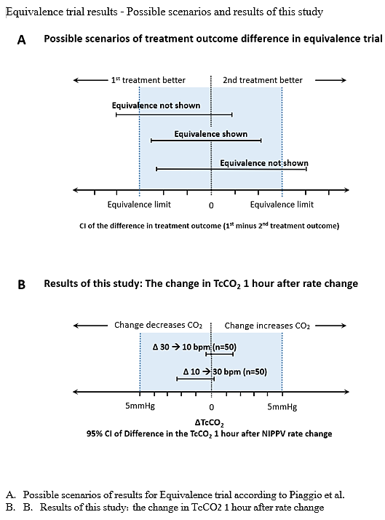

Ori Hochwald, head of NICU in Rambam medical center, Haifa, Israel

Email: ori.hochwald@gmail.com

Presenting author details
Full name: Ori Hochwald
Contact number: +972502062110
Session name/ number:
Category: (Oral presentation/ Poster presentation)

