Synthesis, characterization, and evaluation of melamine foam decorated by rGO/ZnO nanoparticles as catalysts for photodegradation of methylene blue dye.
Ruba AlShaikhEid,
Al-Azhar University, Gaza-Palestine.

Abstract:
Methylene blue (MB) plays a significant part in the textile, paper, leather, and dyeing sectors. However, it causes serious harm to the health of people, animals, and plants, thus it is necessary to remove methylene blue (MB) dye from dye company wastewater in order to strike a balance between environmental pollution and industry output. The photodegradation process is among the most efficient ways to eliminate more than 90% of methylene blue (MB). The high surface area of nanomaterials, however, not only allows for strong dye adsorption on their surfaces, but also for photocatalysis for photodegradation, which adds further value to the removal of methylene blue (MB) dye from the wastewater produced by the dye industry. The lack of clean water is one of the problems the world is now facing, hence water purification is essential. In this study, melamine foam decorated by rGO/ZnO nanoparticles has been synthesized and characterized by Raman, SEM, TEM, XRD, and UV. XRD and Raman illustrate their synthesis of them. SEM and TEM images achieved the synthesis of rGO nanosheet, ZnO nanoparticles, and melamine foam decorated by rGO/ZnO nanoparticles with homogenous distribution without any agglomeration. Photodegradation studies under different conditions of initial dye concentration, irradiation time, pH of the dye solution, catalyst dosage, and radiation energy. Photodegradation studies illustrate an increased removal percent of methylene blue (MB) by increasing photocatalyst and PH toward alkaline and radiation energy. Melamine foam decorated by rGO/ZnO nanoparticles is the best photocatalyst for methylene blue (MB) degradation at pH 11 and a catalyst dosage of 0.0125mg.

graphical abstract:
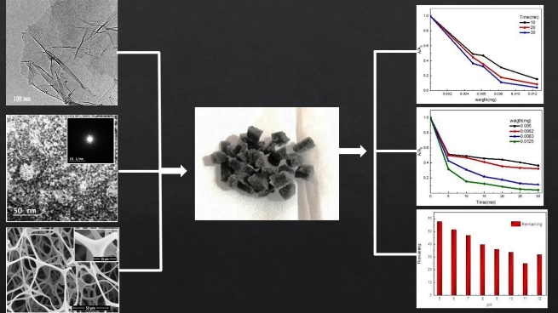
Illustrate the synthesis of melamine foam decorated by rGO/ZnO nanoparticles and its photodegradation for methylene blue (MB).

Biography:
Ruba is a Ph.D. student in physics at Ain Shams University in Egypt. Ruba holds a master's degree in physics in water purification using nanotechnology from Al-Azhar University in Gaza, Palestine. Ruba can overcome challenges to accomplish her goals. She sought to fund this research to be able to complete it. Indeed, she obtained funding from UNDP Palestinians to complete her master's thesis.

Email: Robasoliman_p@sci.asu.edu.eg

Presenting author details
Full name: Ruba Suleiman Mohammed AlShaikhEid
Contact number: 00970597682200
Mail id: Robasoliman_p@sci.asu.edu.eg
Category: Oral presentation

