Dual Ceramic Composed By Organic-Inorganic Functional Polymer Gel Electrolyte For Dendritic-Free And Robust Lithium Metal Batteries
Sajid Hussain Siyal^{ab}, Muhammad Sufyan Javed^{c,}, Yunhua Yu^{b},

ªDepartment of Metallurgy and Materials Engineering, Dawood University of Engineering and Technology, Karachi 74800, Sindh, Pakistan
^{b}State Key Laboratory of Organic-Inorganic Composite, College of Materials Science and
Engineering, Beijing University of Chemical Technology, Beijing 100029, People's Republic of China.
^{c}Siyuan Laboratory, Guangzhou Key Laboratory of Vacuum Coating Technologies and New Energy Materials, Guangdong Provincial Engineering Technology Research Center of Vacuum
Coating Technologies and New Energy Materials, Department of Physics, Jinan University, Guangzhou 510632, People's Republic of China.

Abstract:

Lithium-metal batteries (LiMBs) are promising energy storage devices due to the high capacity and minimum negative electrochemical potential. Nevertheless, their concrete applications remain disturbed by unbalanced electrolyte-electrode interfaces, limited electrochemical window, and high-risk. Herein, a novel strategy to obtain dual ceramic-based electrolytes that possess great potential in energy storage due to their higher level of energy densities in LiMBs. Dual-ceramic (LATP-LLTO) gel polymer electrolyte (DCGPE) film developed via the curable system, aimed to prepare flexible Li⁺ interpenetrating network film to integrate the two ceramic structures with polyethylene oxide (PEO) to yield the free-standing electrolytes film for better battery safety and desired interfacial stability. The DCGPEs films presented a satisfactory electrochemical performance, including, good ionic conductivity, large transference number, and wide electrochemical stability window (ESW) at room temperature. Most importantly, the fundamental function of LATP and LLTO is to support building a stable solid-electrolyte-interphase (SEI) and limits the growth of dendrites. Thus, prepared dual ceramic-

based electrolytes effectively renders to inhibit lithium dendrite growth in a symmetrical cell Li//PEO+10% LATP+15% LLTO//Li test during charge/discharge at a current density of 2 mA/cm² and 0.25 mA/cm² above 2400 h without short-circuiting occurrence at room temperature. Besides, the battery assembled of LiFePO₄/PEO+10% LATP+20% LLTO/Li exhibits superior cyclic stability with high Coulombic efficiency. This study recommends that the binary network structures of Li-ion conductor help to design a prime solution of promising electrolyte for high- performance LiMBs applications.
Keywords: Dual ceramic gel polymer electrolytes, LATP, LLTO, PEO, PVP, lithium-metal

batteries, Li-dendrites.

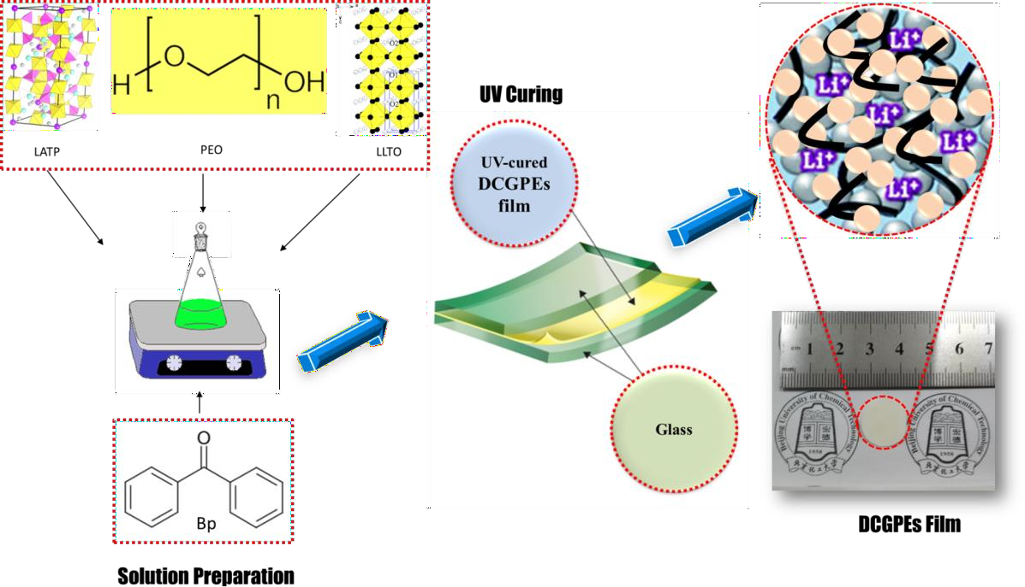

Fig.1 Design of ceramic-ceramic dual composite gel polymer electrolytes film (DCGPE).

References
- Siyal, Sajid Hussain, et al. "Significant Reduction in Interface Resistance and Super-Enhanced Performance of Lithium-Metal Battery by In Situ Construction of Poly (vinylidene fluoride)-Based Solid-
State Membrane with Dual Ceramic Fillers." ACS Applied Energy Materials (2021).

- Siyal, Sajid Hussain, et al. "In Situ Curing Technology for Dual Ceramic Composed by Organic– Inorganic Functional Polymer Gel Electrolyte for Dendritic‐Free and Robust Lithium–Metal
Batteries." Advanced Materials Interfaces 7.20 (2020): 2000830

- Siyal, Sajid Hussain, et al. "Ultraviolet irradiated PEO/LATP composite gel polymer electrolytes for lithium-metallic batteries (LMBs)." Applied Surface Science 494 (2019): 1119-1126.

