Investigating Users' Responses Toward Human-AI Interaction in the Metaverse: A NeuroIS Approach

Helmi Issa, PhD, Burgundy School of Business, France

Abstract
Statement of the Problem: The effects of digital immersion on users’ responses have been experimentally proven to be relatively more damaging than beneficial. In the Information Systems literature, investigating users’ psychological and behavioral responses within the context of digital immersion received much attention from numerous scholars, disciplines, and businesses. However, examining the neuro-physiological responses of users when connected to the metaverse has been nonexistent despite its recent excessive use by teens and young adults.
Methodology & Theoretical Orientation: Through the lens of cybernetic theory, this research experimented with two neuro tools (i.e., electrocardiogram [EKG/ECG] and electroencephalography [EEG]) to examine the users’ biometrics (heart activities and brain waves) when interacting on the metaverse.
Expected Findings: The researchers expect to reveal the role of immersive innovations as a potential source of stress to users (elevated heart rates and rapid brain waves) and thus diffusing the concept of technostress into the field of artificial intelligence.
Conclusion & Significance: Big tech companies have already set ambitious plans for the metaverse. Nevertheless, a lack of understanding of their users’ (consumers’) neuro-physiological responses toward their immersive technologies may create unexpected concerns for the future. When developing their products, big tech giants are advised to consider the human side of the interaction rather than focusing strictly on the technology itself.

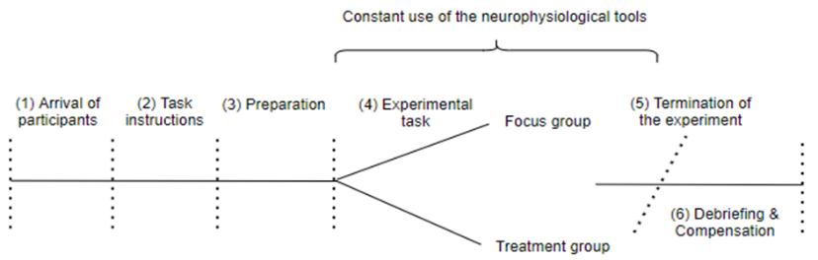
Experimental protocol

Recent Publications

- Riedl, R., Fischer, T., Leger, P. M., & Davis, F. D. (2020). A decade of NeuroIS research: Progress, challenges, and future directions. Data Base for Advances in Information Systems. DOI: 10.1145/3410977.3410980.
- Teubner, T., Adam, M. T. P., & Riordan, R. (2015). The impact of computerized agents on immediate emotions, overall arousal and bidding behavior in electronic auctions. Journal of the Association for Information Systems, 16(10), 838-879.
- DeBoer, J., Haney, C., Atiq, Z., Smith, C., & Cox, D. (2017). Hands-on engagement online: Using a randomised control trial to estimate the impact of an at-home lab kit on student attitudes and achievement in a MOOC. European Journal of Engineering Education, 44, 1-2. https://doi.org/10.1080/03043797.2017.1378170.
- Fischer, T., & Riedl, R. (2018). Lifelogging for organizational stress measurement: Theory and Applications. New York NY: Springer Berlin Heidelberg.
- Issa, H., & Jabbouri, R. (2022). The "infamous" Like feature: A neuro perspective. International Journal of Technology & Human Interaction, 18(1).



Biography

Helmi Issa obtained his PhD diploma in management from Rennes School of Business. He worked at several business schools in France as a lecturer. He currently holds the position of an assistant professor in digital management at Burgundy School of Business. He recently been nominated for 2022 Best Researcher Award in Artificial Intelligence.
Email: helmi.issa@bsb-education.com

Notes/Comments:

Presenting author details
Full name: Helmi Issa
Contact number: 07-82895983
Twitter account: N/A
Linked In account: N/A
Session name/ number: N/A
Category: Poster presentation

