Title: My 32 years of ophthalmic journey as a pan-ophthalmologist

K.M.Suresh
Vidya Eye Hospital, India

Abstract

Statement of the Problem: Most of the ophthalmologist’s world over are always of the opinion that one should concentrate on only one sub-speciality of ophthalmology and he/she should never enter the quarters of other subspecialities. Many of us are shy to project ourselves as a general ophthalmologist, with a rejuvenated knowledge in all the subspecialities and more often than not, we try to shirk our innate responsibility of taking committed and personal care of our faithful patients, by referring our own patients to some other ophthalmic subspecialists or super specialists. The circumstances and working conditions in my private practice and my ophthalmology teaching profession, has forced me to become a pan-ophthalmologist. Hence this clinical study consists of a collection of various clinical cases treated by me starting from simple refraction cases to complicated orbitotomies, performed by me. . Methodology & Theoretical Orientation: It is a detailed retrospective study of the efficient management of ophthalmic cases, which were missed by oversight by the superspeciality centres, by virtue of their in depth concentration in their superspeciality. I have compiled the cases, which are not only missed by them but also my own cases which I have solved by entering into the arena of other super specialities. The study has got an exhaustive compilation of personal experience in solving refraction cases, anterior segment cases, performing Deep Anterior Lamellar Keratoplasty procedures and Penetrating Keratoplasty cases, cataract cases, posterior capsular opacification cases, strabismus cases, LASIK cases, green laser photocoagulation and intravitreal injection of avastine for diabetic retinopathy cases, vitreoretinal surgical cases, management of ocular trauma and traumatic optic neuropathy cases, management of ocular neoplasms by orbitotomies, and orbital prosthesis for exenterated cases. Finally, contains, some easy remedies for otherwise cumbersome and complicated procedures. Findings: The study taught us that simplicity in ophthalmology, is far better than the dependency on the sophisticated high end gadgets, it also taught us that by hard work, dedication and proper insight, any general ophthalmologist will be able achieve satisfactorily good results in super specialities too. I am sure that the ideologies explained in this study are highly debatable, but all the more they have been effective in treating various eye diseases efficiently.. Conclusion & Significance: Many a times, I have seen that my postgraduate students, when they start practicing ophthalmology, afresh are hesitant to move even a wee bit into other super specialities. Such fresh ophthalmologists can definitely accumulate courage and build up their surgical acumen with their hard work.

Image
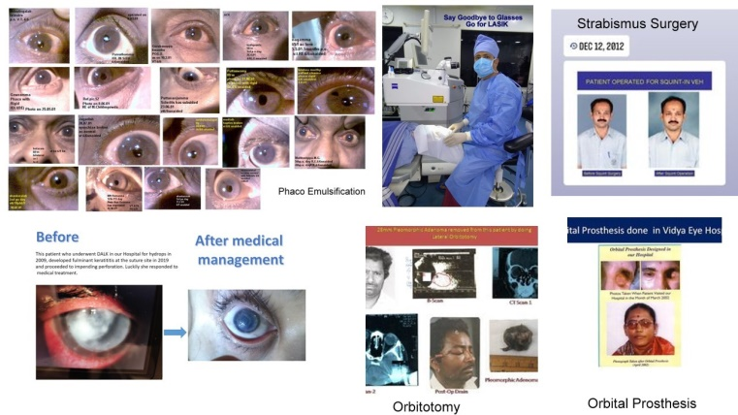

Recent Publications
1. Parsons Diseases of the Eye – A text book for undergraduate ophthalmology students
2. Comprehensive ophthalmology 7th edition by AK KHURANA
3. Kanski's Clinical Ophthalmology
4. The Duke Manual of Pediatric Ophthalmology and Strabismus Surgery 1st Edition
5. AAO 12/Retina and Vitreous 2020-2021BCSC Basic and Clinical Science course.

Biography

Km Suresh did MBBS from Kasturba Medical College Mangalore in the year 1985. He did his M.S (OPH) from Regional Institute of Ophthalmology - Minto Ophthalmic Hospital attached to Bangalore Medical College. In the year 1990, under Prof. S Chandrashekara Shetty. He won Gold Medal for his paper "Role of Argon Laser Photocoagulation in Diabetic Retinopathy" in the year 1992. He passed his theory exams of the first part of F.R.C Ophthal in U.K and did his Viteoretinal Surgery higher training in Moorfields Eye Hospital London - University of London in the year 1995. Later he has served Kempegowda Institute of Medical Sciences - Bangalore as Lecturer and subsequently as Asst. Professor from 1990 to 1998. He opened Vidya Eye Clinic on 18th Oct 1991 and expanded it to 15 bedded Vidya Eye Hospital in the year 1991.

