Reticulated Platelets: A Key to Platelet Heterogeneity
Nikita Ilkevich Msc, United Kingdom
Under supervision of Dr Alastair Barr
Abstract
Primary function of platelets is the formation of a protective barrier against blood loss. Secondary but no less important functions of platelets are tissue repair and immunity. Similar to the functioning of much of the rest of biology the exchange of phosphate groups plays a key role in the functioning of platelets. This exchange is potentiated by phosphatase and kinase enzymes. The CD148 encoded by PTPRJ is a phosphatase that is implicated both positive and negative regulation of platelet activation. Despite recent advances in understanding of CD148 the exact level of expression, structure, mechanism of action and precise role in the functioning of platelets are still not one hundred percent clear. The level of expression was the focus of the study. Finding the optimal method of visualising CD148 expression was the initial aim of the study. In the process of investigation, the varying levels of CD148 expression have pointed the researchers to the possibility that different subpopulations of platelets express CD148 at a varying level. Reticulated platelets (younger subset of the platelet population) were picked as most promising subpopulation. Syto 13 a nucleic dye was used distinguish reticulated platelets rather than a more traditional thiazole orange. The study proved successful in confirming the differences in the level of expression of CD148. Reticulated platelets were shown statistically and graphically to express more CD148 then the rest of the population. Suggestions for further research and modalities of possible therapies were made.
Biography:
Nikita Ilkevich from United Kingdom. He is pursuing Msc and presently working on Reticulated Platelets research under the supervision of Dr Alastair Barr. He was expertised in Biomarkers in Hematology and Oncology
Notes/Comments: None
Presenting author details
Full name: Nikita Ilkevich
Email id: ilkevichnikita@gmail.com
Session name/ number: Reticulated Platelets
Category: (Oral presentation/ Poster presentation): Poster presentation

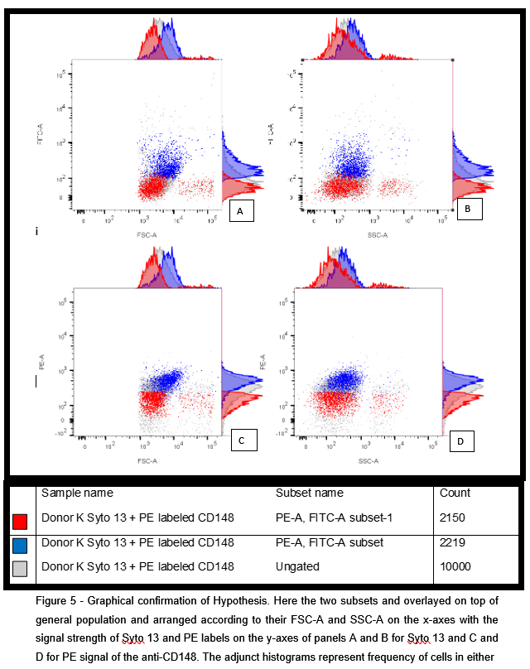
Image

Recent publications
Mori, J., Nagy, Z., Di Nunzio, G., Smith, C., Geer, M., Al Ghaithi, R., van Geffen, J., Heising, S., Boothman, L., Tullemans, B., Correia, J., Tee, L., Kuijpers, M., Harrison, P., Heemskerk, J., Jarvis, G., Tarakhovsky, A., Weiss, A., Mazharian, A. and Senis, Y., 2018. Maintenance of murine platelet homeostasis by the kinase Csk and phosphatase CD148. Blood, 131(10), pp.1122-1144.
Senis, Y. and Barr, A., 2018. Targeting Receptor-Type Protein Tyrosine Phosphatases with Biotherapeutics: Is Outside-in Better than Inside-Out?. Molecules, 23(3), p.569.
Baaten, C., ten Cate, H., van der Meijden, P. and Heemskerk, J., 2017. Platelet populations and priming in hematological diseases. Blood Reviews, 31(6), pp.389-399.
Marconi, C., Di Buduo, C., LeVine, K., Barozzi, S., Faleschini, M., Bozzi, V., Palombo, F., McKinstry, S., Lassandro, G., Giordano, P., Noris, P., Balduini, C., Savoia, A., Balduini, A., Pippucci, T., Seri, M., Katsanis, N. and Pecci, A., 2019. Loss-of-function mutations in PTPRJ cause a new form of inherited thrombocytopenia. Blood, 133(12), pp.1346-1357.
Hille, L., Cederqvist, M., Hromek, J., Stratz, C., Trenk, D. and Nührenberg, T., 2019. Evaluation of an Alternative Staining Method Using SYTO 13 to Determine Reticulated Platelets. Thrombosis and Haemostasis, 119(05), pp.779-785.
Biography
Nikita has his expertise in flow cytometry. Combined with evolutionary biology new insight has been made into the expression of CD148 and into the way in which it relates to platelet subpopulations. The work was mainly based on the Mori et al 2018.
Presenting author details
Full name – Nikita Ilkevich
Contact number – 07453421838
Mail id – ilkevichnikita@gmail.com
Category – oral presentation

