Bipolar affective disorder in a patient with Fahr’s disease: The first recorded case in Bhutan
Bikram Chhetri*
Khesar Gyalpo University, Bhutan
Abstract
Fahr’s disease is a rare neurological disease that typically presents with neurological manifestations such as movement disorders. In a first recorded patient with Fahr’s disease in Bhutan, psychiatric diagnosis of bipolar affective disorder with current episode of severe depression was made, which is also a known manifestation of Fahr’s disease. Diagnosing a first case of Fahr’s disease is important for Bhutan because, though, it is a rare disease and it emphasizes the importance of recognizing other rare causes of psychiatric illness to tailor the treatment to the individual.

Images
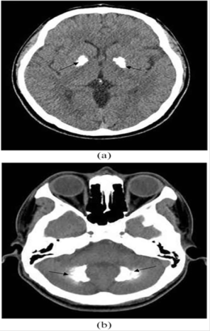
1(a) and 1(b) below shows bilateral basal ganglia calcification and cerebellar calcification of the index case respectively.
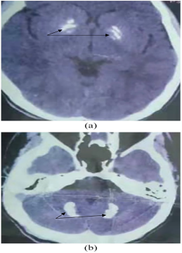
Image
2 (a) and 2 (b) shows bilateral basal ganglia calcification and cerebellar folia calcification of the index’s brother respectively.
References:
- Chhetri B, Gyeltshen D, Letho Z. Bipolar affective disorder in a patient with Fahr's disease: The first recorded case in Bhutan. SAGE Open Med Case Rep. 2022 Sep 15;10:2050313X221125324. doi: 10.1177/2050313X221125324. PMID: 36147593; PMCID: PMC9486261.
Biography:
Bikram Chhetri is a Psychiatrist working in the department of Psychiatry, Jigme Dorji Wangcuck National Referral Hospital in Thimphu Bhutan. He is the first Psychiatrist trained in Bhutan from the Faculty of Postgraduate Medicine, Khesar Gyalpo University of Medical Sciences of Bhutan. Bhutan is a small landlocked country sandwiched between two giant nations, India and China. Psychiatry in Bhutan is still in infancy stage and there are only 4 Psychiatrist for the entire 700,000 population, Bikram is interested in teaching, learning about researches and conducting researches. He is actively involved in teaching residents, medical interns and counseling students when they come for their clinical practices in the department. Besides his academic life, he likes watching football especially the English Premier league.

