Title: Innervational Surgery for Supranuclear Monocular Elevation Deficiency with horizontal strabismus：a paediatric case report and review of the literature
Lin Chen
Children's Hospital of Chongqing Medical University, China
Abstract
Monocular elevation deficiency (MED) is an ocular motility disorder characterized by the inability to elevate one eye in abduction, adduction, and primary gaze, previously known as double elevator palsy (DEP). Various surgeries include Knapp procedure or modified Knapp, inferior rectus recession, Modified Nishida’s procedure and superior rectus recession on the contralateral eye depending on the classification.
A paediatric case of supranuclear palsy (SNP) MED associated with significant horizontal deviation and co-existent the inferior oblique muscle overaction (IOOA) in the contralateral eye is described. We corrected 40 prism diopter(PD) of horizontal deviation and 25 PD of vertical deviation, and simultaneously corrected IOOA with a innervational surgery combination with horizontal rectus recession.
Contralateral superior rectus recession based on innervational principle provides an appealing alternative treatment for SNP MED and MED with significant horizontal deviation cases.
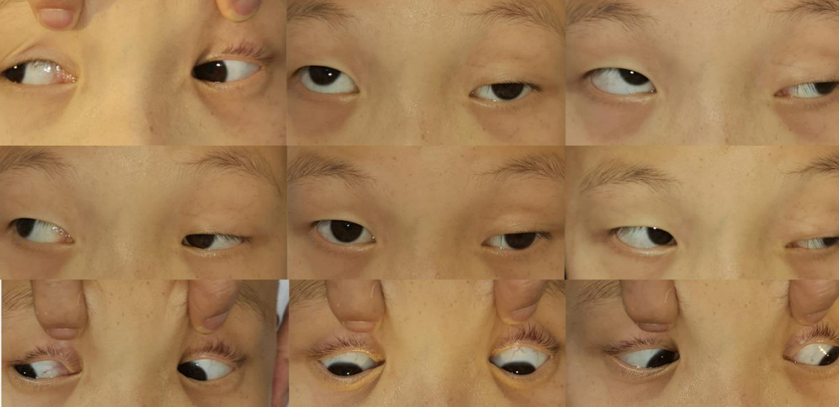
Fig.1 Figure 1 Preoperative photos demonstrating a left hypotropia in primary gaze with −4 deficit of elevation in primary gaze, abduction, and adduction, with a moderate ptosis.

Figure 2 Postoperative photos demonstrating correction of hypotropia and exotropia in primary
gaze with no deficit of elevation in primary gaze, abduction, and adduction and partial
improvement ptosis.

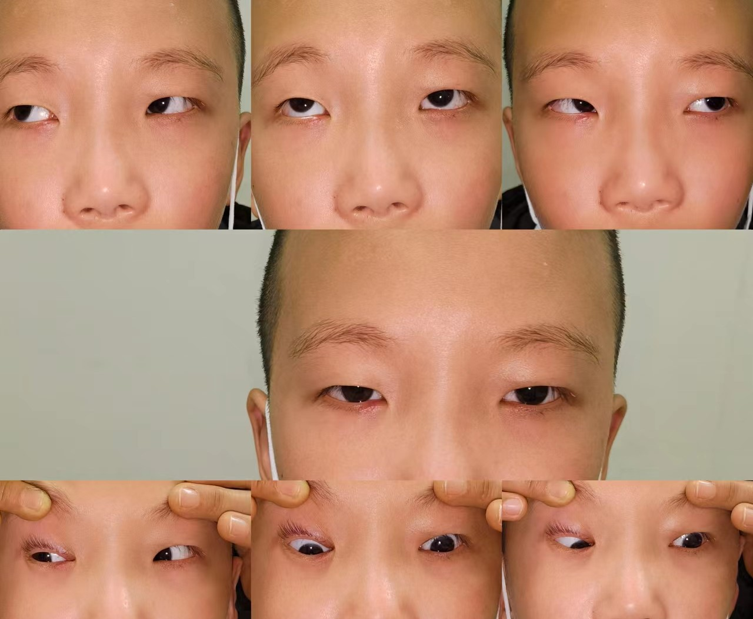
Figure 3 Photos after the left eye ptosis correction 6 months later（provided by the parents）

Biography:
Department of Ophthalmology, Children's Hospital of Chongqing Medical University, Ministry of Education Key Laboratory of Child Development and Disorders, China International Science and Technology Cooperation Base of Child Development and Critical Disorders, 136, Zhongshan 2nd Rd, Yuzhong District, Chongqing, 400014, China.

