Positively charged nanoplastics inhibit Bacillus subtilis planktonic and biofilm formation
Franklin Perez and Sullan
University of Toronto, Canada

Abstract
Nanoplastics (< 1 μm) are small, plastic particles that have been discovered in soil. Due to their small size, chemical and physical diversity, nanoplastics are potentially the most dangerous kind of plastic towards biodiversity. Since the success of biodiversity depends largely on microorganisms, the effects of plastics towards microorganisms has been intensely studied. Yet, majority of studies on plastics and microorganisms focused on aquatic environments with larger, plastic particles, known as microplastics (1 - 5000 μm). To address the impact of nanoplastic in a soil microorganism, we used a suite of analytical tools and microbiological methods to ascertain how nanoplastics of different sizes and functional groups impact a model soil bacteria, Bacillus subtilis. Positively charged nanoplastics were found to have the greatest effect on B. subtilis in both its planktonic free-living and surface-associated biofilm forms of life. These effects are detrimental and include cell death, slower growth and a reduction in biomass and changes in its surface-associated structure which could potentially affect its performance in the natural environment. As Bacillus subtilis is known to symbiotically associate with plant roots, the negative effects of positively charged nanoplastics might inhibit the ecologically significant relationship between B. subtilis and plant health.

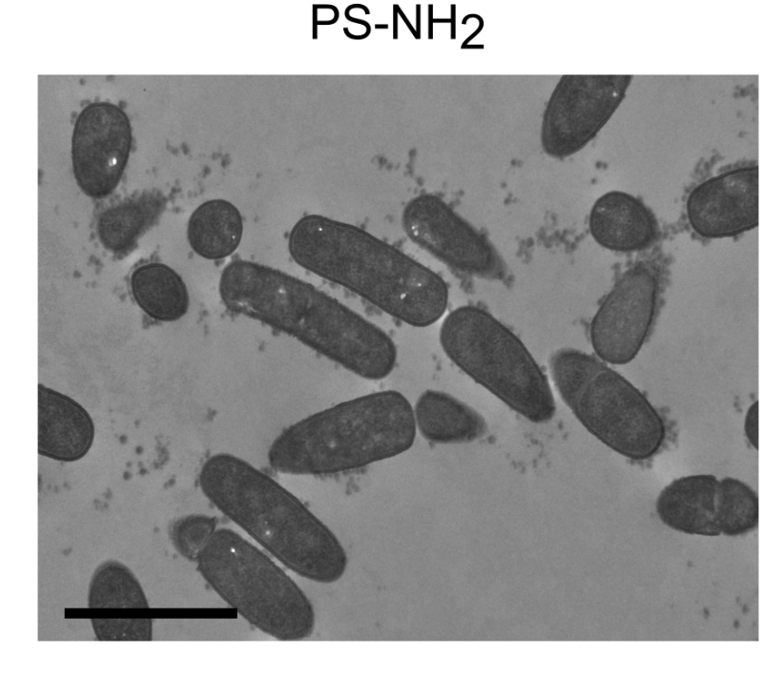
Figure 1. Positively charged nanoplastics associating with B. subtilis. Scale = 2µm
Recent Publications
- Dai S, Ye R, Huang J, Wang B, Zhenming X, Xinwen O, Ning Y, Cheng H, Yuejin H, Zhou R, Tian B. Distinct lipid membrane interaction and uptake of differentially charged nanoplastics in bacteria. J Nanobiotechnol 20, 191 (2022).
- Xu S, Wu C, Guo WB, Yang L, Ji R, Pan K, Miao AJ. Polystyrene Nanoplastics Inhibit the Transformation of Tetrabromobisphenol A by the Bacterium Rhodococcus jostii. ACS Nano. 2022 Jan 25;16(1):405-414.
- Wang L, Wu WM, Bolan NS, Tsang DCW, Li Y, Qin M, Hou D. Environmental Fate, Toxicity and Risk Management Strategies of Nanoplastics in the Environment: Current Status and Future Perspectives. J. Hazard. Mater. 2021, 401, 123415.
- Fringer VS, Fawcett LP, Mitrano DM, Maurer-Jones MA. Impacts of Nanoplastics on the Viability and Riboflavin Secretion in the Model Bacteria Shewanella Oneidensis. Front. Environ. Sci. 2020 8, 97.
- Nomura T, Fujisawa E, Itoh S, Konishi Y. Comparison of the Cytotoxic Effect of Polystyrene Latex Nanoparticles on Planktonic Cells and Bacterial Biofilms. J. Nanoparticle Res. 2016, 18 (6), 1–9.

Biography
Franklin Perez is in his third year of his PhD at the University of Toronto in the Mechano-microbiology Lab. His overarching research goal is to understand the interactions and effects of nanoplastics towards soil-associated biofilms. He is currently working with polystyrene nanoplastics as well as two bacteria: Bacillus subtilis and Stenotrophomonas rhizophila. Aside from his experiments, he enjoys being an active member of his graduate community, having served four terms as Vice-President of his student association and contributing to campus curriculum developments. He also enjoys baseball, cycling, swimming and watching good movies.

