Contribution of elastin peptides to the regulation of innate lymphoid cells during Chronic Obstructive Pulmonary Disease
Sarah Lahire, MSc, Universite de Reims Champagne Ardenne, France
Caroline Fichel, Universite de Reims Champagne Ardenne, France
Sandra Audonnet, PhD, Universite de Reims Champagne Ardenne, France
Manon Siino, CHU de Reims, France
Gaetan Deslee, MD, PhD, CHU de Reims, France
Richard Le Naour, PharmD, PhD, Universite de Reims Champagne Ardenne, France
Arnaud Pommer, PhD, Universite de Reims Champagne Ardenne
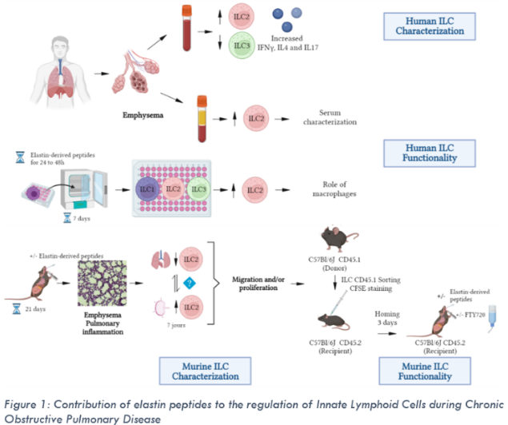

Abstract (300 word limit)
Chronic Obstructive Pulmonary Disease (COPD) is characterized by chronic bronchitis associated with emphysema that generates elastin-derived peptides (EP) impacting many immune populations. Innate Lymphoid Cells (ILC) play a role in many pathologies including COPD. However, the mechanisms regulating their functionalities, especially linked to EP, are not yet known. Moreover, while ILC are predominantly resident, recruitment from other sites is possible under inflammatory conditions and their origin in COPD remains to be elucidated. Our goal is to understand the mechanisms of ILC regulation and orientation induced by EP in COPD. Our results demonstrated that the proportion of ILC2 was increased and the proportion of ILC3 was decreased in the blood of COPD patients. In addition, we observed a significant increase in the expression of cytokines associated with the different types of ILC in COPD patients indicating an increase in activation. Moreover, ILC cultured with serum from COPD patients with emphysema or with supernatants of EP-stimulated macrophages showed an increase in the proportion of ILC2. In a mouse model of emphysema, we observed a decrease in the number of lung ILC2 concomitant with an increase in the mediastinal draining lymph nodes 7 days after instillation, suggesting a role of EP in the regulation of proliferation and/or migration of ILC. The human phenotypic and functional studies indicate an orientation of ILC towards an ILC2 profile in COPD patients as well as a general activation of ILC represented by an increase in their cytokine secretion capacity. Moreover, in vitro culture experiments suggest a role of EP, via their impact on macrophage, in the regulation of ILC during COPD. Finally, in vivo studies performed in mice suggest a role of EP on the migration and/or proliferation of ILC in the context of COPD.

Image
Recent Publications (minimum 5)
- De Grove KC, Provoost S, Verhamme FM, Bracke KR, Joos GF, Maes T, et al. 2016. Characterization and quantification of innate lymphoid cell subsets in human lung. PLoS ONE 11:e0145961.
- Houghton, A. M., P. A. Quintero, D. L. Perkins, D. K. Kobayashi, D. G. Kelley, L. A. Marconcini, R. P. Mecham, R. M. Senior, and S. D. Shapiro. 2006. Elastin fragments drive disease progression in a murine model of emphysema. J Clin Invest 116:753-759.
- Lemaire F, Audonnet S, Perotin JM, Gaudry P, Dury S, Ancel J, Lebargy F, Antonicelli F, Deslée G, Le Naour R. The elastin peptide VGVAPG increases CD4+ T-cell IL-4 production in patients with chronic obstructive pulmonary disease. Respir Res. 2021
- Meghraoui-Kheddar, Aïda & Pierre, Alexandre & Sellami, Mehdi & Audonnet, Sandra & Lemaire, Flora & Naour, Richard. (2017). Elastin receptor (S-gal) occupancy by elastin peptides modulates T cell response during murine emphysema. American Journal of Physiology - Lung Cellular and Molecular Physiology. 313. ajplung.00465.2016. 10.1152/ajplung.00465.2016.
- Watanabe, Naoaki & Nakayama, Jun & Fujita, Yu & Mori, Yutaro & Kadota, Tsukasa & Shimomura, Iwao & Ohtsuka, Takashi & Okamoto, Koji & Araya, Jun & Kuwano, Kazuyoshi & Yamamoto, Yusuke. (2020). Single-cell Transcriptome Analysis Reveals an Anomalous Epithelial Variation and Ectopic Inflammatory Response in Chronic Obstructive Pulmonary Disease. 10.1101/2020.12.03.20242412.

Biography (150 word limit)
Sarah Lahire is a French a third-year PhD student in Immunology. After graduating with a Bachelor and a Master’s degree in Science at the University of Reims Champagne Ardenne, she started her PhD in Immunology in 2020. Her translational project focuses on human and mice experiments to establish the link between Innate Lymphoid Cells and elastin-derived peptides during Chronic Obstructive Disease.

