Does immunological memory stand behind onset of human parturition?
Olena Getsko, MD, PhD candidate, CUHK, Hong Kong
Chi Chiu Wang, MD, PhD, CUHK, Hong Kong
Tak Yeung Leung, MD, CUHK, Hong Kong

Abstract
Statement of the Problem: The immune system plays a crucial role in establishing and maintaining pregnancy. Adaptation of the maternal immune response is essential for good pregnancy outcomes. Conversely, insufficient immune adaption is associated with pregnancy pathologies such as recurrent miscarriage, fetal growth restriction, preterm birth, and preeclampsia. Memory T cells are responsible for fetal-maternal tolerance. Recent data showed that a delicate balance of memory T cells is necessary for reproductive success. Parturition is the final step of a reproduction cycle. However, the role of memory T cells in human parturition remains unknown. This study aims to investigate differences and changes in CD8+ memory T cells and exhausted molecules expression in groups with spontaneous labor and induction of labor. Methodology & Theoretical Orientation: A prospective longitudinal study was conducted on women whose labors are induced compared to spontaneous ones. Maternal blood was collected before onset and during latent and active phases of the labor. In addition, cord blood, decidua basalis and parietalis were collected after birth. CD8+ memory T cells and exhausted molecules expression were measured using multicolour flow cytometry, 3 panels, each of them contained 12 markers. The longitudinal and cross-sectional comparison was made between spontaneous labor and induction of labor groups. Findings: CD8+ memory T cells activation status and exhausted molecules expression were significantly lower in spontaneous labor group. The changes were found most pronounced in decidua parietalis. Conclusion & Significance: CD8+ T memory cells and exhausted molecules might contribute to human parturition and appear as a potential therapeutic target at the onset of labor.

Image
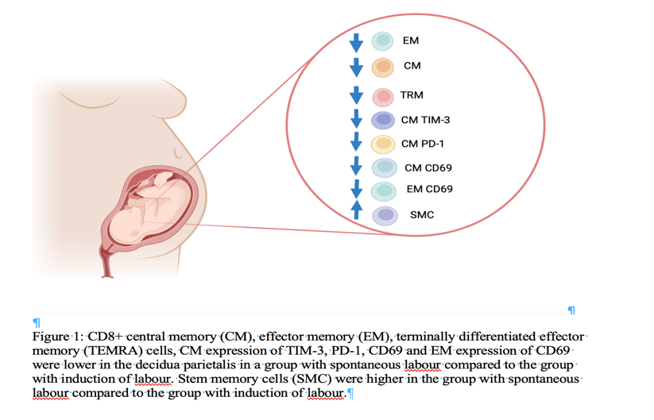
Recent Publications
- Kwak-Kim J (2022) Clinical reproductive immunology: a window to understanding reproduction and immunology. In: Immunology of Recurrent Pregnancy Loss and Implantation Failure. 3-5.
- Kinder JM, et al. (2020) CD8(+) T Cell Functional Exhaustion Overrides Pregnancy-Induced Fetal Antigen Alloimmunization. Cell Rep 31(12): 107784.
- Zhang YJ, et al. (2022) Immunologic Memory in Pregnancy: Focusing on Memory Regulatory T Cells. Int J Biol Sci 18(6): 2406-2418.
- Huang, X., et al. (2020). "Tissue-resident CD8(+) T memory cells with unique properties are present in human decidua during early pregnancy." Am J Reprod Immunol 84(1): e13254.
- Kieffer TEC, et al. (2019) Memory T Cells in Pregnancy. Front Immunol 10: 625.

 Biography

Olena Getsko graduated from Donetsk National Medical University, Ukraine in 2012. She obtained specialization in Obstetrics and Gynaecology at the Department of Obstetrics, Gynaecology and Perinatology, Donetsk National Medical University in 2015 and worked as a MD and as an Assistant to Professor at the Department. In 2021 she started her PhD study at the Department of O&G, CUHK. Her study is focused on CD8+ memory T cells in human parturition.
Email: getskoolena@gmail.com

Notes/Comments:

Presenting author details
Full name: Olena Getsko
Contact number:+85293815524
Twitter account: @getskoolena
Linked In account: https://twitter.com/getskoolena
Session name/ number: Reproductive Immunology 17
Category: Oral presentation

