Mapping arsenic as a chemical of public health concern for further health risk assessment due to its abundance in environmental media in Serbia
Branislava Matic
Institute of Public Health of Serbia, Serbia

Statement of the problem: Exposures to chemicals are typically unevenly distributed geographically as well as temporally. Disease occurrence also shows geographically varying patterns. Geographic information systems (GIS) may be used to produce maps of exposure and/or disease to reveal spatial patterns (1). Supported by the World Health Organization (WHO) and the Ministry of Health, Institute of Public Health of Serbia (IPHS) conducted a project "Strengthening of national capacities for assessment of chemicals risks for guiding risk reduction decisions"(2). The key aim of mapping task was to demonstrate the scope of dissemination of the prioritized chemical, arsenic (As), in different environmental media, in order to emphasize the severity of the public health hazard it poses to the exposed population in Serbia. Arsenic distribution was mapped for presence in soil and PM₁₀ in the vicinity of industrially contaminated sites, and in naturally occurring water sources of the Vojvodina Region (north Serbia) (4).

Methodology & theoretical orientation: Data were obtained from the publicly available data sources: regular Annual Report on drinking water quality from public water supply systems (2018) (4); UNEP project on the status of heavily contaminated soil in Serbia (2017)(5); distribution of As in PM10 (2010 – 2020), from the regular monitoring of ambient air quality, performed by SEPA and local IPHs (6). Collated data were georeferenced and imported into the ArCGiS tool for processing.

Findings: Distribution of As in PM₁₀, measured continuously (2010-2020), depicts that As emissions to ambient air generate from: lignite coal-firing power plants, copper milling, mining and smelting, steel production, battery recycling plant and secondary lead smelter, chemical plants. GIS coordinates for air and soil arsenic pollution are strongly correlated, in most contaminated sites.

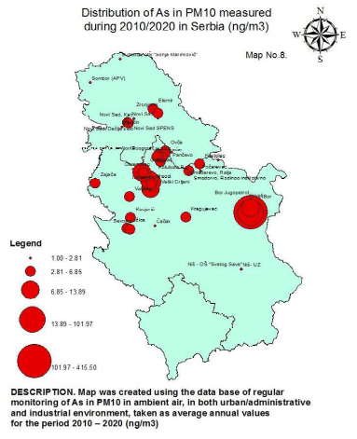
Figure 1. Distribution of As in PM10 measured during 2010-2020 in Serbia

Conclusion: Such occurrence of As in environmental media justifies need for the systematic inclusion of human biomonitoring in regular primary health care practice.

References
- Jarup L. Health and environment information systems for exposure and disease mapping, and risk assessment. Environ Health Perspect. 2004 Jun;112(9):995-7. doi: 10.1289/ehp.6736. PMID: 15198919; PMCID: PMC1247192.
- Case study: development of the national road map for enhancing health sector engagement/contribution to sound management of chemicals in Serbia till 2030 https://www.who.int/publications/i/item/9789240035881
- WHO 10 Chemicals of public health concern; https://www.who.int/news-room/photo-story/photostory-detail/10-chemicals-of-public-health-concern
- "Analysis of the hygienic quality of drinking water for the period from January to December 2018 in the municipalities of Kikinda, Čoka, Novi Kneževac, Ada, Senta and Kanjiža." IPH Kikinda https://zavodki.org.rs/wp-content/uploads/2019/09/kvalitet-vode-kikinda-godisnji-2018.pdf
- TOWARDS SOIL DECONTAMINATION IN THE REPUBLIC OF SERBIA (2018); Ministry of Environmental Protection - Environmental Protection Agency, Belgrade, ISBN: 978-86-87159-20-4 http://www.sepa.gov.rs/download/zemljiste/TowardsSoilDecontamination.pdf
- “Annual Report on the Scope of Monitoring of Urban Ambient Air Quality performed within the Network of IPHs in Serbia in 2020” https://www.batut.org.rs/download/izvestaji/higijena/Godisnji%20izvestaj%20vazduh%202020.pdf

Biography
Dr. Matić studied human medicine at the University of Belgrade, Serbia. She has been working as a public health doctor, specialist of hygiene & environmental health in the Institute of Public Health of Serbia in Belgrade since 2000. She defended her PhD thesis (2018) on Serbian results from the international SEARCH (School Environment and Respiratory Health of Children) project. She was nominated as the National Focal Point of the Ministry of Health of Serbia for Environment and Health since 2013(still is), and as the NFP at the WHO Global Chemicals and Health Network since 2017. Dr Matić has been project manager in WHO/UNEP/SAICM projects (innitiated by the Ministry of Health of Serbia) on the issues of involving health sector of Serbia into intersectorial chemicals management and managing of industrially contaminated sites (2018-2021).

