Use of bioelectrochemical systems improve CO2 assimilation in Clostridium spp. and Ralstonia euthropha
Rosa Anna Nastro
Associate Researcher, University of Naples Parthenope, Italy
Abstract
In this work, we tested the ability of Clostridium saccharoperbutylacetonicum and Ralstonia euthropha to capture CO2 in two-chamber Microbial Fuel Cells (MFCs), under different operational conditions. We used a co-culture of Shewanella oneidensis MR1 and Pseudomonas aeruginosa PA1430/CO1 to form an anodic consortium and verify if it was able to sustain CO2 capture at the cathode by the test microorganisms, in absence of any external source of potential. In order to reduce the start-up period of the Bioelectrochemical Systems (BESs), we cultured both C. saccharoperbutylacetonicum and R. euthropha firstly in a complex culture medium, followed by a gradual transition to mineral base media with sodium bicarbonate as sole carbon and energy source. When compared to the control cultures, R. euthropha showed the highest CO2 capture rate (73%) when BESs were connected to a 1000 Ohm external resistor, while C. saccharoperbutylacetonicum achieved the maximum CO2 assimilation (78.6 %) when the BESs were kept at maximum power (i.e. no external potential applied). In both cases, the reducing power at the cathode was provided by the sole Shewanella/Pseudomonas consortium. The products of CO2 assimilation were polyhydroxybutyrates (PHBs), acetate, butyrate, and butanol. Furthermore, as we used glycerol as carbon and energy source for the anodic consortium, we also obtained biosurfactants. BESs demonstrated to effectively improve the assimilation of CO2 by the test strains, and the ability to provide renewable energy to drive the electrosynthesis of platform chemicals from inorganic carbon and glycerol.
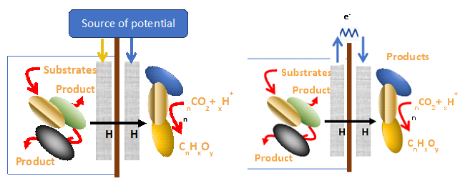
Figure 1. Schematic representation of electrosynthesis through a) MECs and b) MFCs
Keywords: Electrosynthesis, Microbial Fuel Cells, Pseudomonas consortium, Ralstonia euthropha, CO2
Biography
Rosa Anna Nastro, Associate Researcher in Environmental Microbiology at the Department of Science and Technology, University of Naples “Parthenope”, Italy. As a microbiologist, I have worked in the field of food and environmental microbiology, exploring microbial biofilm formation dynamics, antimicrobial, and antibiofilm properties of secondary metabolites produced by a Bacillus amyloliquefaciens strain isolated in a hospital environment. Since 2012, I focused my interest on Microbial Electrochemical Technology (MET) based on a renewable source of energy (the microbial metabolism) and its application to liquid and solid waste treatment, the remediation and detoxification of water, soil and sediments polluted with Polycyclic Aromatic Hydrocarbon (PAHs) and other compounds. My current research activities focus on electrosynthesis from carbon dioxide through Microbial Electrochemical Systems (MESs). Since February 2022, Dr. Rosa Anna Nastro joined the PHOENIX COST action (CA-19123) - Protection, Resilience, Rehabilitation of damaged environment (PHOENIX).

