Review on inherited functional platelet disorders

Dr Farah Aldouri, clinical hematologist
Oncology Centre, Tikrit, Iraq
Hereditary blood disorders Centre, Tikrit, Iraq

Platelets are anucleated cellular components of blood which play a fundamental role in maintaining vascular integrity following injuries through plug formation, a process referred to as primary hemostasis. Platelet adhesion, activation, secretion and aggregation are intricately connected steps involved in the process. Once formed, support to the fresh clot is required to keep it held tight in place. A cascade of chemical interactions is ignited as a consequence to primary hemostasis, the secondary hemostasis, culminates in producing fibrin mesh which provides proper scaffolding to the newly formed plug.

The normal range of platelet count in adult human is somewhere between 150x10*9/L and 450x10*9/L. Platelet abnormalities encompass a variety of disorders, and can be quantitative or qualitative. Counts above (thrombocytosis) or below normal limits (thrombocytopenia) might occur as a result of hereditary or acquired aetiology. The clinical manifestations of platelet count disorders also vary, some of them are asymptomatic others are severe, or even life threatening.

Rarely, platelets function in an abnormal way (thrombocytopathy), which also can lead to hemostatic insufficiency. Platelet function disorders can be inherited or acquired, and might coexist with abnormal platelet numbers. Such defects can arise due to recessive or dominant genetic mutations, with the majority being due to inactivating missence and loss of function mutations.

Hereditary platelet disorders include disorders of platelet adhesion, like von Willebrand's disease and Bernard-Soulier syndrome. Disorders of platelet aggregation include congenital afibrinogenemia and Glanzmann thrombasthenia. Defects of platelet storage pool are gray platelet syndrome and Quebec platelet disorder. Dozens have been mentioned and described in the literature, yet the most frequent hereditary encounters in clinical practice will be the focus of this comprehensive review, with their underlying pathophysiology, presentation and treatment.

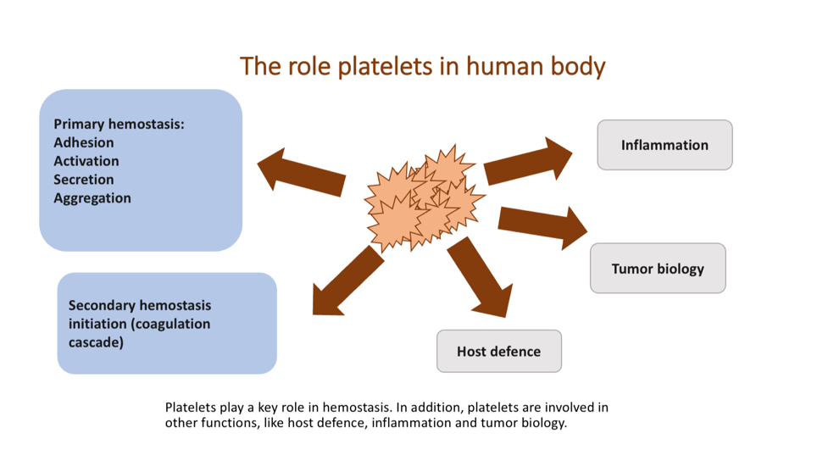

References

1.George JN, Caen JP, Nurden AT (1990) Glanzmann’s thrombasthenia: the spectrum of clinical disease. Blood 75(7):1383-1395.

2.Heremans J, Freson K (2018) High-throughput sequencing for diagnosing platelet disorders: lessons learned from exploring the causes of bleeding disorders. Int J Lab Hematology ;40:89-96.

3.Lentaigne C, Freson K, Laffan MA, et al (2016) Inherited platelet disorders: toward DNAbased diagnosis. Blood 127(23):2814-2823.

4. Megy K, Downes K, Simeoni I, et al (2019) Curated disease-causing genes for bleeding, thrombotic, and platelet disorders: communication from the SSC of the ISTH. Journal of Thrombosis and Haemostasis 17(8):1253-1260.

5. Nurden AT, Pillois X, Wilcox DA (2013) Glanzmann thrombasthenia: state of the art and future directions. Semin Thromb Hemost 39(6):642-655.

Biography

Farah Aldouri is a clinical hematologist who has a great interest in hereditary hematological disorders, precisely thalassemias and bleeding disorders. She has expertise in managing and follow up of cases and works in collaboration with other specialists and other centres in Iraq in order to deliver the best to patients in the country.

