Title: The effect of use digital devices on eyes during covid-19 period

Abdulrahman a. Almuhawwis
King Saud bin Abdulaziz University for Health Sciences (KSAU-HS), Saudi Arabia

Abstract
The coronavirus disease 2019 (COVID-19) pandemic has had a tremendous impact on our everyday lives. Home quarantine has led to an increase in near work and the use of smart devices, both of which are responsible for visual difficulties. Computer vision syndrome (CVS) has been identified in roughly 60 million people worldwide, according to a 2016 study [1]. CVS is a group of visual and extraocular symptoms associated with the continued use of visual display terminals (VDTs) [2]. People who spend more than 4 hours every day in front of a VDT are more likely to develop dry eye diseases.
Asthenopia is considered the most common complaint in patients with CVS.
Asthenopia symptoms include eye strain and tired eyes, ocular surface-related problems, including dry eyes, watery eyes, irritation, foreign body sensation, and redness, and visual related symptoms (blurred vision, double vision). According to previous studies, the prevalence of asthenopia is estimated to be approximately 55% and 81% among gadget users, making it an extremely common problem]3,4[. In 2008, questionnaire results of over 400 computer operators in India revealed asthenopic symptoms in 46.3% of participants [5].
Therefore, the current study aimed to assess the impact of excessive use of digital devices during the coronavirus pandemic in the Saudi population.
2.1. Sampling:
The inclusion criteria included subjects living in Saudi Arabia during the pandemic, aged between 10 to 70 years. Both males and females were included. Electronic device users were included as well. The exclusion criteria were any subjects suffering from the following:
Rheumatology disease.
Any systemic problems and ocular surgery.
Age younger than 10 and above 70 years.
Any refractive surgery.
2.2. Survey:
A validated questionnaire consisting of 35 questions was administered. It included questions pertaining to the signs and symptoms related to eye dryness, digital eye strain, and some general symptoms related to musculoskeletal symptoms and the participant’s medical history
2.3. Design and setting:
A community-based cross-sectional questionnaire was administered between November 2020 and January 2021 to the Saudi Arabian population. Informed consent was obtained from each participant.
Results
A total of 1573 approved to fill our online self-administered questionnaire that assesses the prevalence and risk factors for dry eye.
Table 1 represents the demographic data for the participants; 56% were female, 44% were male, Most of the participants (93.8%) used mobile, while 79.4% did not use the computer.
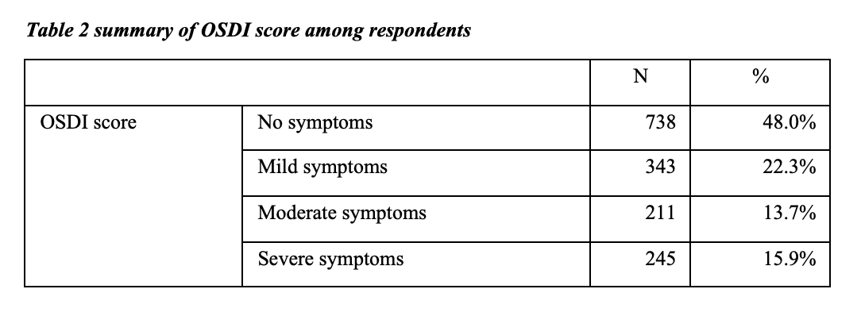
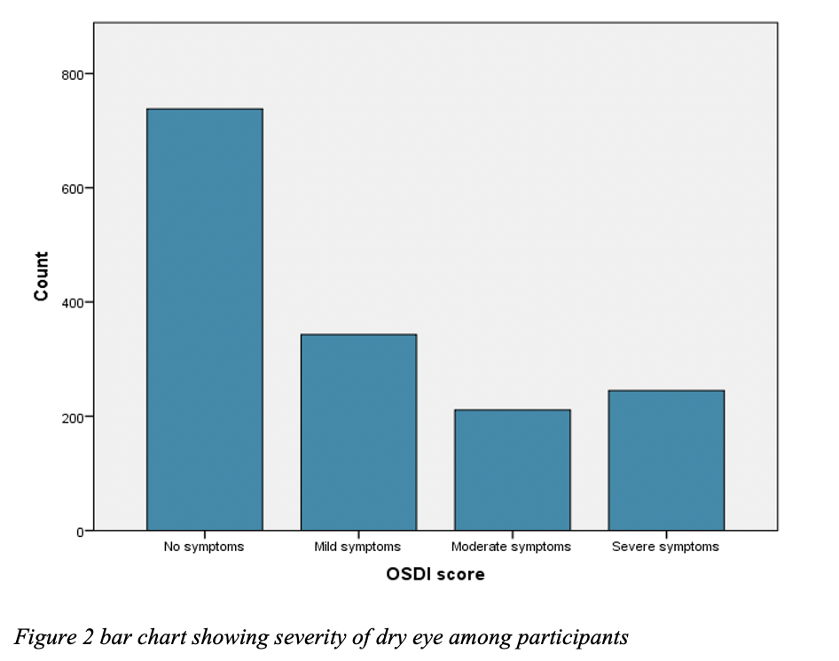
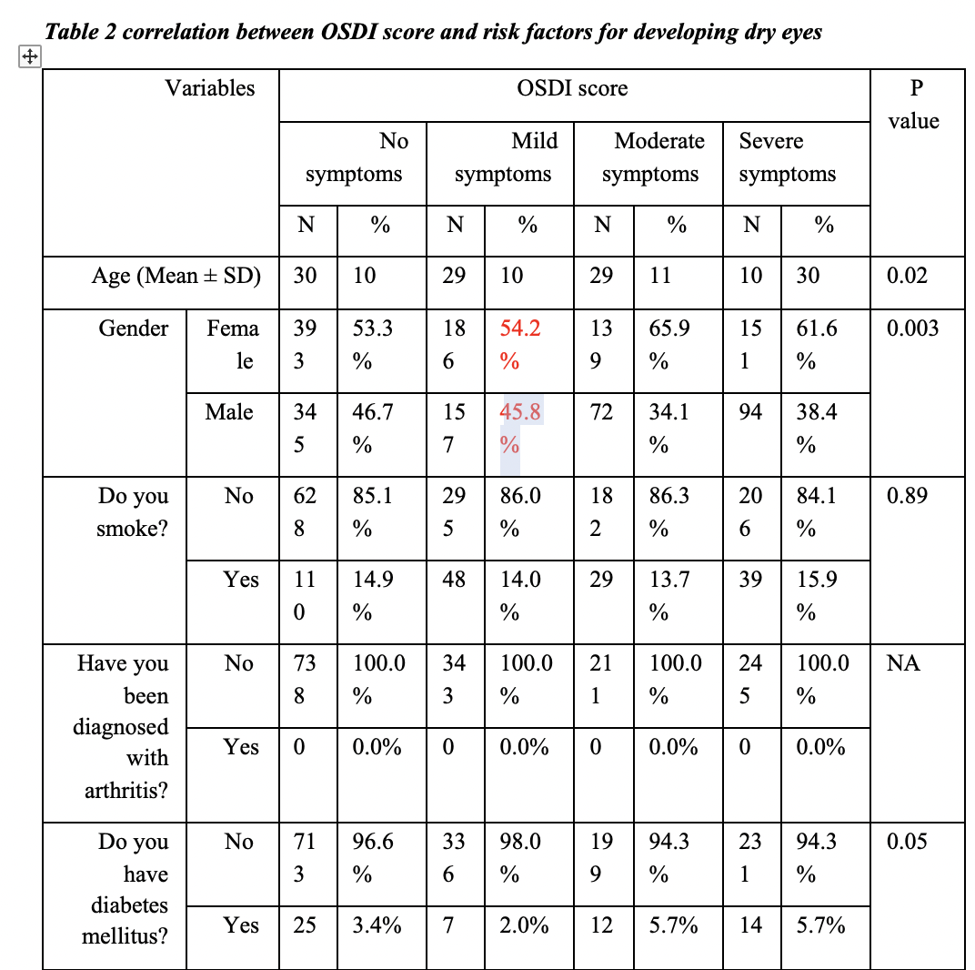
Table 3 represents the correlation between OSDI score and risk factors for developing dry eyes, significant correlation was found between OSDI and age, gender .
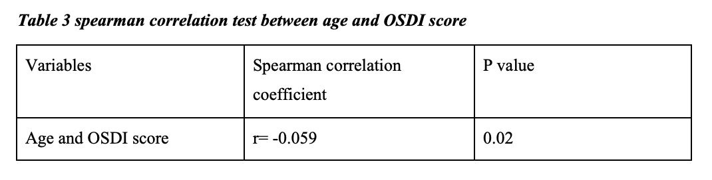A significant correlation was found between age and the OSDI score (p=0.02)
Region of subjects
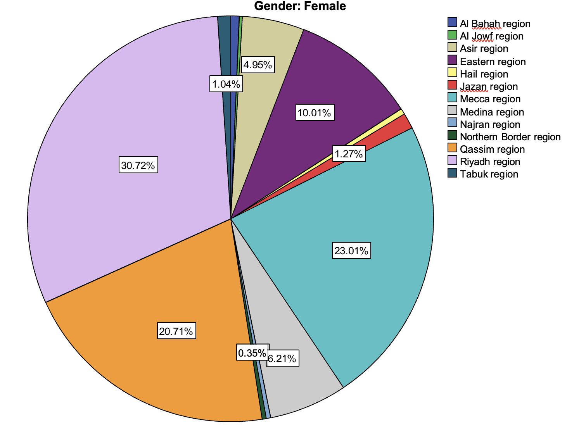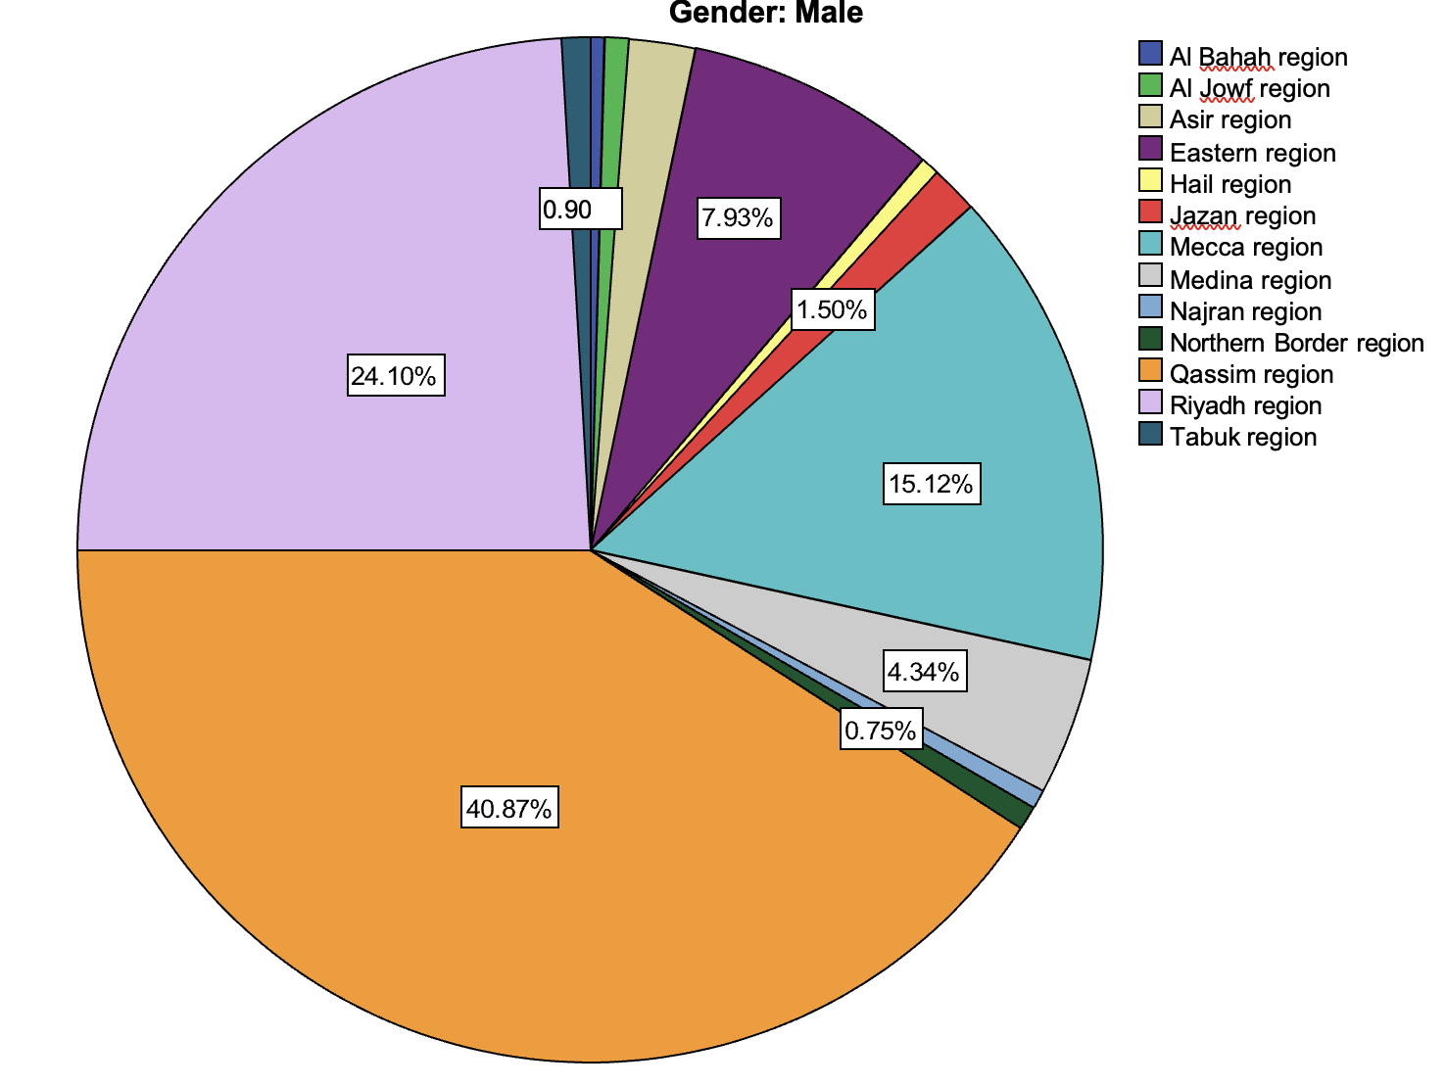

Discusion
During the coronavirus pandemic, many people quarantined at home to maintain social distance and avoid spreading the disease.
The results of the present study showed that 93.8% of the participants used a mobile phone. Nearly half of the participants (48%) did not have any symptoms of eye dryness while 52% experienced eye dryness symptoms (22.3% had mild symptoms, 13.7% had moderate symptoms, and 15.9% had severe symptoms), according to the OSDI score.
These findings agree with previous studies that reported that mobile phones were the most used digital devices among all age groups during the coronavirus lockdown [6,7].

Biography
Abdulrahman Almuhawwis
Farhan.med011@gmail.com
+966 55 719 1881
Saudi Arabia

