Evidence and practical wound care – An all-inclusive approach
Ron Legerstee MSc
Wound healing & tissue repair, Scientific lecturer Erasmus Medical Center Rotterdam Netherlands

Abstract
Aim: Health Care Professionals and patients should be fully informed on the best way care can be provided for the individual patient’s situation. Meta-analyses of randomised controlled trials exclude other forms of evidence, putting patients and carers in hazardous situations^{1,2,3}
Method: Reviewing the literature on wound dressings and evidence based medicine⁴, ample arguments are found to put forth a critique to the suggestion of a hierarchy in the “pyramid of clinical evidence”. The authors have not found the source, nor justification or validation for this hierarchy. Doubt on a hierarchy was cast as early as in 1989⁵, years before the term EBM was first coined⁶.
Results / Discussion: Replacing this pyramid by a circular model⁷, incorporating ALL types of evidence⁸ at equal value⁹, the health care professional can appraise the evidence to reach best practice. Modifying an earlier published set of (pre-)clinical evidence types¹⁰, the authors propose to expand these with PROM’s and COHORT. The meta-analysis and consensus statement are types of analysis rather than a form of clinical study. They should not be part of the circle (input), but follow (output) on what evidence was found in the circle.
Conclusion: To assist the consideration of as much as possible from the “real life experience” of a patient, the authors put forth an all-inclusive approach to visualise how health care professionals can deal with all available evidence.
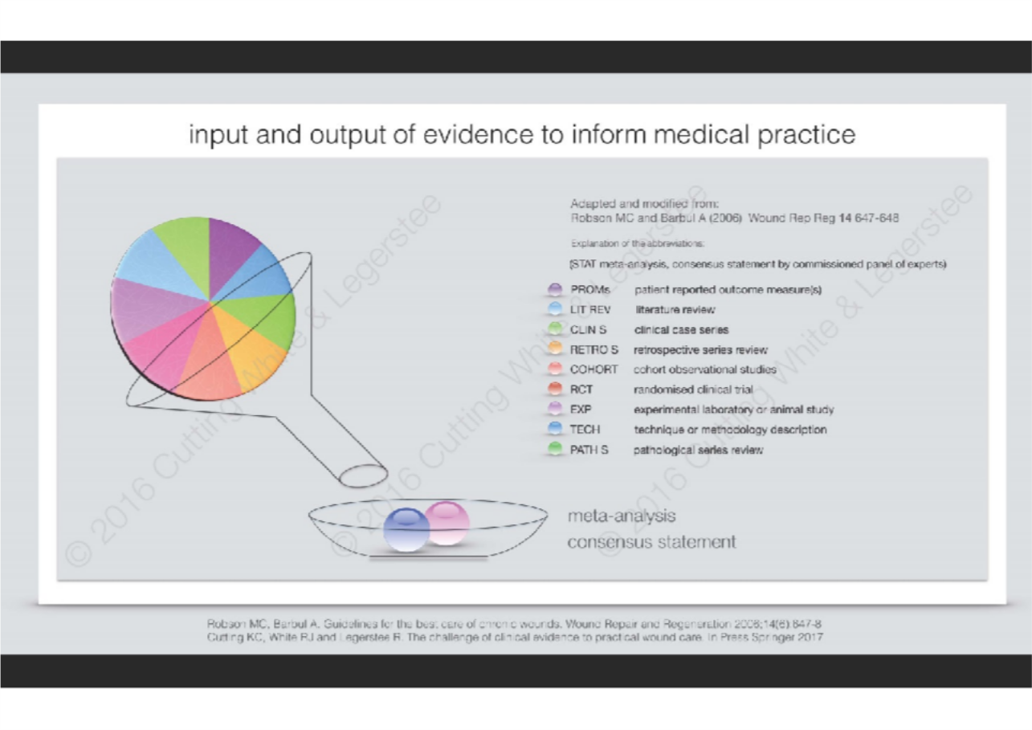
Reference
- White R, Legerstee R. Evidence-biased medicine and the availability of silver wound dressings: A topical issue. J Wound Care 2013, Aug;22(8):440-1.
- Legerstee R. Evidence-based medicine - Bella luna. Nederlands Tijdschrift voor Wondzorg 2016;Aug;11(8):6-9
- de Jonge, E. Antiseptische wondbedekkers bij complexe wonden. Geneesmiddelenbulletin 2016;Aug;50(8)89-98
- Cutting, White and Legerstee. The challenge of clinical evidence to practical wound care. Springer. In press 2017
- Vandenbroucke JP. On the new clinical fashion in epidemiology. Epidemiol Infect 1989;102(02):191-8.
- Guyatt G, Cairns J, Churchill D, Cook D, Haynes B, Hirsh J, et al. Evidence-based medicine: A new approach to teaching the practice of medicine. JAMA 1992;268(17):2420-5
- Cutting White and Legerstee (2016) Art Work Model “input and output of evidence to inform medical practice”
- Zuiderent-Jerak T, Forland F, Macbeth F. Guidelines should reflect all knowledge, not just clinical trials. BMJ 2012;345:e6702
- Vandenbroucke JP. When are observational studies as credible as randomised trials? The Lancet 2004;363(9422):1728-31
- Robson MC, Barbul A. Guidelines for the best care of chronic wounds. Wound Repair and Regeneration 2006;14(6):647-8.

