Investigation of The Oncolytic Effects of Myxoma Virus in Multiple Myeloma Cells
MD.PhD Yesilaltay A¹ ,PhD.Muz D² , PhD.Erdal B³ PhD.Bilgen T⁴ , PhD.Batar B⁵, MD.Altındağ Avcı B⁶ MD.Turgut B⁶
1. Baskent University, Faculty of Medicine, Hematology Department Istanbul2. Namik Kemal University, Faculty of Veterinary Medicine, Virology Department Tekirdağ 3. Namık Kemal University, Faculty of Medicine, Microbiology Department Tekirdag 4. Namik Kemal University, Department of Nutrition and Dietetics Tekirdag 5- Namik Kemal University, Faculty of Medicine, Genetic Department Tekirdag 6. Namık Kemal University, Faculty of Medicine, Hematology Department Tekirdag

İntroduction: Multiple Myeloma (MM) is a malignant disease of plasma cells. Oncolytic viruses do not infect healthy cells , cause selective death of cancer cells.. MYXV is more effective in its oncolytic capacity and seems to have minimal adverse effects. It has been proven in vitro that MYXV cause apoptozis in malign plasma cells .it was aimed to investigate both the oncolytic effect of MYXV and its effect with drug combinations in patient-derived MM cells.Methodology :In the study, two commercially different MM cell lines and cultures prepared from a total of 30 patients with newly diagnosed MM (n=15) and relapsed refractory MM (n=15) specimens will be prepared from bone marrow samples of patients. Patient-derived primary MM cell and MOPC-315, U266 cell lines were used. In infecting MM cells with MYXV at different doses, and in differing combinations of PZI/IMID drugs; cell viability was assessed using WST-1 test and apoptosis analysis was assessed using flow cytometry techniques. Finding:it was observed that MYXV infects cells with different titers (5,10, 20 and 50 moi) both in patient and continuous cell lines. The increase in virus quantity was linearly correlated with the number of cells infected and with the degree of cytotoxicity..In trials of the virus with drug combinations, apoptosis was detected in flow cytometry with Annexin-V.it was noted that apoptotic cell rates were highest with the triple drug combination. Conclusion:The oncolytic effect of MYXV was demonstrated in MM cell cultures of patients .Cellular cytotoxicity varied based on the amount of the virus. In trials with drug combinations used in the routine treatment of MM, it was noted that addition of the virus increased apoptotic changes. This finding suggests that the use of this particular oncolytic virus in routine treatment protocols, especially in these patients, may reduce the amount of medication.

İmage:Schematic map of the vector to be used in the hTERT immobilization protocol

R 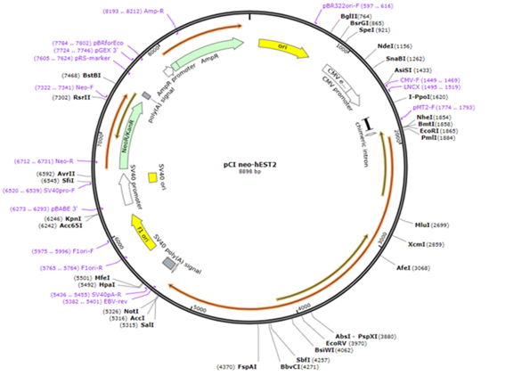

Publications:

1.Bartee, E. 2009/a. “Human cancer cells have specifically lost the ability to induce the synergistic state caused by tumor necrosis factor plus interferon-beta”, Cytokine, 47(3), 199–205.
2.Bartee, E. 2009/b. “The addition of tumor necrosis factor plus beta interferon induces a novel synergistic antiviral state against poxviruses in primary human fibroblasts”, Journal Of Vırology, 83(2), 498–511.
3.Bartee, E. 2012. “Selective Purging of Human Multiple Myeloma Cells from Autologous Stem Cell Transplantation Grafts using Oncolytic Myxoma Virus, Biol Blood Marrow Transplant”, 18, 1540–51.
4.Chan, WM. 2013. “Oncolytic myxoma virus: the path to clinic”, Vaccine, 31(39), 4252-4258
5.Christos, F., Sukeshi, P. 2017. “Review: Oncolytic virotherapy, updates and future directions”, Oncotarget, 8, 102617-102639.
6.Kim, M. 2009. “Myxoma virus targets primary human leukemic stem and progenitor cells while sparing normal hematopoietic stem and progenitor cells”, Leukemia, 23(12), 2313–2317.
7.Nancy, Y. 2011. “Myxoma and vaccinia virus exploit different mechanisms to enter and infect human cancer cells”, NIH Public Access Virology
8.Smallwood, E. 2010. “Myxoma Virus: Propagation, Purification, Quantification, and Storage”, Curr Protoc Microbiology, Chapter: Unit–14A.1. doi:10.1002/9780471729259.mc14a01s17.
9.Sypula, J. 2004. “Myxoma virus tropism in human tumor cells”, Gene therapy and Molecular biology, (8), 103–14.
10.Villa, NY. 2010. “Myxoma and vaccinia viruses exploit different mechanisms to enter and infect human

Biography
Alpay Yesilaltay is an Internal Diseases and Hematology specialist and PhD in Cancer Immunology. He received his Internal Medicine and Hamatology specializations after MD certificate from Istanbul University Cerrahpaşa Faculty of Medicine. He worked at Arkansas Medical School Myeloma Institute between 2016-2017. He is responsible for the project on the Effects of Oncolytic Viruses on Myeloma, supported by TÜBİTAK within the framework of alternative treatment studies in Multiple Myeloma. Autophagic effects of Oncolytic viruses in Myeloma continue to be studied. Myeloma Cancer Stem cell, Membrane potentials in cancer cells, oncolytic viruses, Endoplasmic reticulum stress and Autophagy are of special interest.

Full name: Alpay Yeşilaltay MD PhD
Contact number:905072404284
e-mail:alpay.yesilaltay@hotmail.com
Category: Oral presentation

Biography (150 word limit)
Paste your Logo here
Deanna Mulvihill has her expertise in evaluation and passion in improving the health and wellbeing. Her open and contextual evaluation model based on responsive constructivists creates new pathways for improving healthcare. She has built this model after years of experience in research, evaluation, teaching and administration both in hospital and education institutions. The foundation is based on fourth generation evaluation (Guba& Lincoln, 1989) which is a methodology that utilizes the previous generations of evaluation: measurement, description and judgment. It allows for value-pluralism. This approach is responsive to all stakeholders and has a different way of focusing.
Email: drXXXXXXX@xxxmail.com

Notes/Comments:

Presenting author details
Full name:
Contact number:
Mail id:
Category: (Oral presentation/ Poster presentation)

