Factors influencing blood donation among Algiers citizens
Lilia FELLA, Specialist in blood banking, University of Algiers, Faculty of pharmacy, Algeria
Oussama Tadjeddine DAHMANI, Pharmacist, University of Algiers, Faculty of pharmacy, Algeria

Abstract

Since blood is essential to life, and the decision to donate blood can save lives, the spontaneous and periodic donation is critical. In contrast, traditional methods have only a small effect on attracting and retaining donors. The enduring need for an adequate and reliable supply of safe blood has led to the exploration of psychosocial factors that may predict the probability of blood donation behaviour.

The main goal of our study is to determine Algiers citizens’ motives and deterrents for blood donation and assess their intentions towards that behaviour and assess their intentions towards donating, whereas our secondary goal is evaluating the impact of each factor of the extended model on intentions and behaviour. This study is an ambidirectional qualitative study. A survey using a multi-section anonymous questionnaire based on The Extended Theory of Planned Behaviour, was conducted during the period ranging from February2022 to June2022. Data was processed using a statistical software. The total sample consisted of 385 respondents with a sex ration of 35:100 (M/F) and ages ranging from 16 to 69 years old.

30.1% of the population have already donated blood at least once in their lives. The most frequently reported motive for blood donation was altruism, whereas the most frequently stated deterrents were fears, lack of time, lack of information, lack of possibilities and health issues. 64.7% of the participants had positive intentions towards blood donation. Age, gender, family status, past behaviour, attitude, descriptive norm, perceived behavioural control, self-efficacy and self-identity are all factors that influence intentions either directly or via other factors. In conclusion, Attitude, self-efficacy and PBC all play major roles in forming an intention to donate blood as does other factors at a lower degree, but altruism is the number one motivator to enact those intentions.
Image
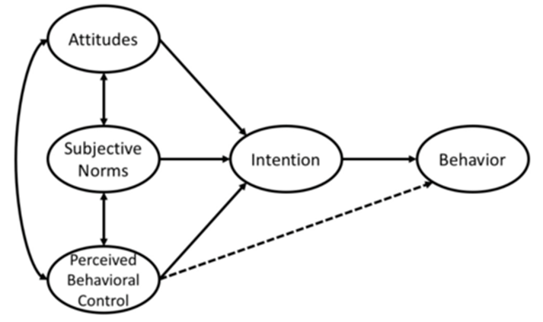
Figure 1: The Theory of planned behaviour
Recent Publications
- Charles KS, Harrilal R, Singh S, Gomez K, Hall R, Danielle Z, et al. Emotions and beliefs arising from replacement blood donation may hinder transitioning to exclusive voluntary non‐remunerated blood donation. ISBT Sci Ser. 2021 Nov;16(4):242–7.
- Allain J ‐P. Current approaches to increase blood donations in resource‐limited countries. Transfus Med. 2019 Oct;29(5):297–310.
- Roberts N, James S, Delaney M, Fitzmaurice C. The global need and availability of blood products: a modelling study. Lancet Haematol. 2019 Dec;6(12):e606–15.
- Greinacher A, Weitmann K, Lebsa A, Alpen U, Gloger D, Stangenberg W, et al. A population-based longitudinal study on the implications of demographics on future blood supply: DEMOGRAPHICS AND BLOOD SUPPLY. Transfusion (Paris). 2016 Dec;56(12):2986–94.
- Greffin K, Schmidt S, Schönborn L, Muehlan H. “Blood for Blood”? Personal Motives and Deterrents for Blood Donation in the German Population. Int J Environ Res Public Health. 2021 Apr 16;18(8):4238.

Biography

Lilia FELLA: pharmacist specialized in haemobiology and blood transfusion. Passionate about immunohematology, especially to solve transfusion issues in particular those related to complex red cell immunization to ensure the transfusion safety of the recipients. She cares about blood donation and recruitment of donors, to have a regular supply of blood.
Email: dr.fellalilia@gmail.com

Notes/Comments: None

Presenting author details
Full name: LILIA FELLA
Contact number: 213664065756
Twitter account:
Linked In account: www.linkedin.com/in/lilia-fella-268702197
Session name/ number: Transfusion medicine and blood donation
Category: (Oral presentation/ Poster presentation): Poster presentation

