Art is Fun, Serious Business, and Everything in between:
Presenting lessons from Art Therapy with Children and Teens Einat S. Metzl
LMFT, ATR-BC, Bar Ilan University,

Abstract (300 word limit)
The purpose of this study was to review some of the main art therapy models (e.g. Gavron & Mayseless, 2018; Landgraten, 2013; Linesch, 2016) and research findings (e.g. Metzl, 2015; Nissimov-Nahum, 2008; Moriyah, 206) that have informed my work with children and teens over the years and organize art therapy considerations from my clinical experience. Admittedly, compared to the growing body of research practices in our field, this report is more anecdotal, and thus likely to be less generalizable to a particular mental health challenge or specific age group. However, it is my hope and belief that it articulates a working frame that is easily applicable for art therapists that are working with children and adolescents, allowing them to benefit from some our research findings and theories while particularizing the work with young clients in different settings. I specifically attempt to illustrate the usefulness of art materials, processes, and products for children and adolescents based on my clinical experiences in school settings, mental health hospitals, community clinics, and private practice. In preparing to write this paper, I reviewed my clinical files and considered my work with children and adolescents over the years. Specifically, as I looked over my clinical files, I considered my different roles as an art therapist working with children, adolescents, and families in different settings. I then looked at the theoretical models that have grounded my work and recent publications on effectiveness and relevant interventions, as discussed above. Table 1 summarizes some of the overarching considerations that might be useful for other art therapists. Conclusion & Significance: This presentation thus explores current theoretical frames of child and adolescent art therapy practice, the socio-political and developmental considerations for art therapy practice within the contexts and systems in which children are embedded. A brief illustration of the use of art materials, processes, and products based my clinical experience in school settings, mental health hospital, adolescents’ clinic, and private practice then follows
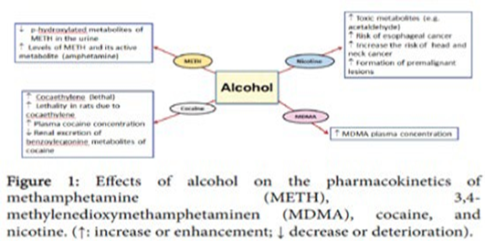
Biography
Einat S. Metzl Einat Metzl is a board certified, registered art therapist, a licensed marital and family therapist and associate professor of Art Therapy and Marital and Therapy, previously at Loyola Marymount University, CA, USA, and currently teaching at Bar Ilan University's Graduate Art Therapy program. Main research foci include resilience, creative thinking, creativity, art therapy with children and adolescents, grief and loss, couples' work, and cultural considerations in therapy.

