Updated Loss Function for Accurate Tumor Segmentation from Breast MRIs

Xiao-Xia Yina*

a Cyberspace Institute of Advanced Technology, Guangzhou University, Guangzhou 510006, China

Abstract
We present Focal Boundary Dice, a new segmentation evaluation measure focused on boundary quality and class imbalance. We perform an extensive analysis across different error types and object sizes of imaged tumors from MRI scan and show that Focal Boundary Dice is significantly more sensitive than the standard Focal and Dice measures to boundary errors for imaged tumors from MRI scans and does not over-penalize errors on division of the boundary, including smaller imaged objects. The new quality measure displays several desirable characteristics, like higher accuracy in the selection of hard samples, prediction/ground truth pairs, and balanced responsiveness across scales, which makes it more suitable for segmentation evaluation than other classification focused measures such as combined IoU [1] and BCE loss [2], Boundary BCE loss and Shape-aware Loss [3].
Methods: Based on Boundary Dice, we update the standard evaluation protocols for tumor segmentation tasks by proposing the Focal Boundary Dice. We mainly solves the contradiction between target and background area and the contradiction between the importance and attention of boundary features. Meanwhile, a boundary attention module is introduced to further extract tumor edge features.
Results: Our experiments show that the new evaluation metrics

Image

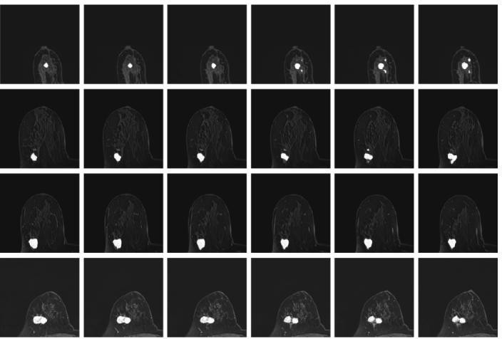Fig. 1 The resultant segments of imaged tumors under the Focal boundary dice loss. The segmented tumors are overlayed on the original data.

Table 1. Resultant segmentation using different loss functions based deep learning models.

allow boundary quality improvements and image segmentation
accuracy that are generally overlooked by current Mask Dice based evaluation metrics and deep learning models. The adoption of the new boundary-sensitive evaluation metrics leads to rapid progress in segmentation methods that enables the improvement of boundary quality.The optimal configuration of focal boundary dice loss is performed for the resultant segments of imaged tumors as shown in Fig. 1. This focal boundary dice loss enables the construction of the deep learning network for good segmentation performance in all tested MRIs [4-5]. The quantification results are listed in Table
Precision | Specificity
0.81 | 0.99
0.82 | 0.99
0.78 | 0.99
0.80 | 0.99
0.84 | 0.99
0.80 | 0.99
0.94 | 0.98

Model | Dice
U-Net | 0.73
ResUNet | 0.76
Pix2pix | 0.58
Att-UNet | 0.76
2D-VNet | 0.74

Conclusion: The proposed deep learning model enables to achieve efficient discrimination between healthy and diseased tissues, and paves the way for the automatic diagnosis of breast cancer.
DenseUNet 0.76
Our 0.82

Recent Publications (minimum 5)

- Cheng B. and Girshick R.B., Doll'ar P. and Berg A.C. and Kirillov A. (2021). Boundary IoU: Improving Object- Centric Image Segmentation Evaluation, 2021 IEEE/CVF Conference on Computer Vision and Pattern Recognition (CVPR), 2021: 15329-15337.
- Taghanaki S.A., Zheng,Y. Zhou S.K.,Georgescu B., Sharma P., Xu D., Comaniciu D., and Hamarneh G. (2019). Combo loss: Handling input and output imbalance in multi-organ segmentation. Computerized Medical Imaging and Graphics, 75:24–33.
- Yeung M., Sala E., Schönlieb C.B., Rundo L. (2022). Unified Focal loss: Generalising Dice and cross entropy- based losses to handle class imbalanced medical image segmentation. Computerized medical imaging and graphic, 95:102026.
- Yin, X.X., Ng, B.WH., Yang, Q. et al. (2012) Anatomical landmark localization in breast dynamic contrast-enhanced MR imaging. Med Biol Eng Comput 50: 91–101

- Yin X.X., Hadjiloucas S., Zhang Y., Su M.Y., Miao Y., Abbott
D. (2016). Pattern identification of biomedical images with time series: Contrasting THz pulse imaging with DCE-MRIs. Artificial intelligence in medicine, 67:1-23

- Yin X.X., Hadjiloucas S., Zhang Y. (2016). Pattern classification of medical images: computer aided diagnosis, Springer International Publishing.




Biography (150 word limit)
XIAO-XIA YIN received the Ph.D. degree in electronics engineering from The University of Adelaide, Australia. She was a Visiting Scholar with the University of Reading, Reading, U.K., under the supervision of S. Hadjiloucas, and with the University of Cambridge, Cambridge, U.K., under the supervision of L. F. Gladden. She involved in tumor detection via DCE-MRI with The University of Melbourne, Australia, under the supervision of Prof. Kotagiri. She has an existing collaboration with Prof. M.-Y. Su with the Center for Functional Onco Imaging, University of California at Irvine, USA, and with Prof. T. Kron with the Peter MacCallum Cancer Centre, Australia. She is currently a professor in University of Guangzhou, China and her major is in high-dimensional medical image analysis. Her research interests include multiresolution analysis, segmentation, image reconstruction and classifification, and their applications to high-dimensional medical imaging. She received the Postdoctoral Research Fellowship from the Australian Research Council, in 2009. She was a member of the Organizing Committee and the Publication Chairperson of the 3rd International Conference of Health Information Science, and a member of the Organizing Committee and the Program Co-Chairperson of the 4th and 5th International Conference of Health Information Science. .
Email: xiaoxia.yin@gzhu.edu.cn

Notes/Comments:

Presenting author details

Full name: Xiaoxia Yin
Contact number: 0061490132477 Twitter account:
Linked In account:
Session name/ number:
Category: (Oral presentation/ Poster presentation) Oral Presentation

