Assessment of iron status among infants aged six to nine months at soy division Keiyo South subcounty

Onyangore, F.O.
University of Kabianga, Kenya
Abstract

The increased prevalence of iron deficiency among infants aged 6 and 24 months can be attributed to the consumption of an iron deficient diet or a diet that interferes with iron absorption at the critical time of infancy. The objectives of the study were to determine iron status among infants, to determine dietary intake of complementary foods by the infants and to ascertain the complementary feeding in Keiyo South Sub County. The cross-sectional study design was adopted. The study was conducted at Soy division in Keiyo South Sub County at Biretwo, Cheptebo and Sego health facilities. Systematic sampling procedure was used to select 136 subjects. In the second year, 54 mothers were followed up due to loss of subjects. The 24 -hour recall generated data on dietary iron intake. Biochemical tests were carried out by use of the portable Hemo_ Control Photochrometer device at the health facilities. Data was analyzed using SPSS computer software version 17, 2009.
Results showed that 28.7% of the infants had mild anemia whereas 23.5% had moderate anemia. The mean iron intake was 10.59±1.71 mg/day. Most (94.1%) of the mothers were still breastfeeding but on the contrary, 45.6 % of all the mothers fed their infants on tea which is an iron inhibitor. None of the infants had received iron supplements. Policies for screening infants for iron deficiency during the first year of life should be developed as the iron deficiency anemia is a problem in Kenya.

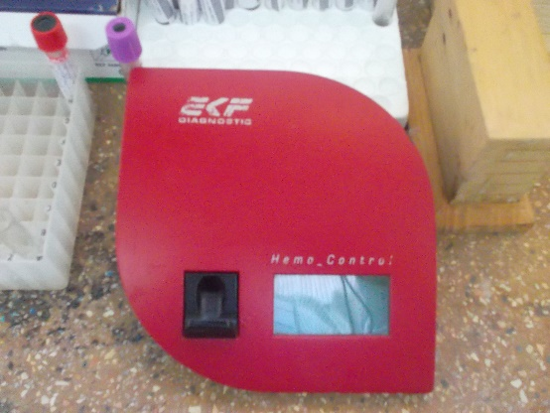
Hemo_ Control Photochrometer @ Biretwo Health Center

Recent Publications
- Omondi C, Raburu PO, Okeyo JB, Ramesh F Onyangore FO(2016). Concentration of selected heavy metals in sediments and liver of wild African Catfish (Clariasgaripepinus) in Lake Kanyaboli, Kenya. Annual Research and Review Biology II,1-8
- Onyangore FO, Ochuodho JO, Odipo O, Omondi CS (2018). Abberation of metals competing for iron exposure to lambda cyhalothrin and aflatoxins in dietary fish from selected aquatic sources. Food Science and Nutritional Studies, 2,41-68
- Onyangore FO, Ochuodho JO, Odipo O, Omondi CS, Sage PO (2018). Growth and survival on exposure lambda cyhalothrin and aflatoxins in dietary fish from selected aquatic sourcesin Kenya. -Journal of Advanced research in Food, Agriculture and Environmental Science5, 2208-2224
- Anino C, Onyango NA, Imathiu S, Maina J, Onyangore FO(2019) Chemical composition of the seed and ‘milk’ of three common bean (Phaseolus vulgaris ) varieties. Journal of Food Measurement and Characterization,Vol 7 ,3 ,1-10
- Isinta M Elijah,Endawoke Amsalu,Xuening Jian,Mingyang Cao,Eric K Mibei,Danvas O Kerosi,Francis G Mwatsahu,Wei Wang, Onyangore FO,Youxin Wang (2022). Characterization and Determinant Factors of Critical Illness and In-Hospital Mortality of COVID-19 Patients: A Retrospective Cohort of 1792 Patients in Kenya. Biosafety and Health:Elsevier. https://s100.copyright.com/AppDispatchServlet?publisherName=ELS&contentID=S2590053622000763&orderBeanReset=true
Biography

Faith is currently undertaking her postdoc at Nottingham, UK. Faith holds a PhD in Environmental Health (Food Toxicology and Nutrition), Master of Science in Community Nutrition and Bachelor of Science in Environmental Health. Faith has practiced as a public health officer in the Ministry of Health and is a lecturer and Head of Department Public health at the school of Health science, University of Kabianga, Kenya. Her research interests focus on iron and other micronutrients, considering their interactions with toxins and toxicants and how this may impact upon maternal and child health and has vastly published. She has further been a health consultant in various organizations including the Africa Medical Research Foundation (AMREF). Faith does community service in maternal and child health and nutrition and hopes that she will further translate her current research findings into policies. Faith networks widely in institutions, individuals from different disciplines, backgrounds and nationality.

