Multidisciplinary approach in managing dental trauma in combination with anterior crossbite
Feras Aldhafr
Pediatric Dental resident at National Guard Hospital, Saudi Arabia

Introduction:
The incidence of dental traumatic injuries globally is around 5%, The main types of injury to permanent teeth were uncomplicated crown fractures (20.8%). (1,2) Management of tooth fracture requires an accurate diagnosis, treatment planning, and regular follow-ups. Tooth fractures mostly involve front teeth in the upper jaw because of their position in the oral cavity. The most common causes are sports activities, traffic accidents, and physical violence. (3) Dental aesthetics have become highly important in recent years. More patients seek a visually pleasing smile, and the perception in the media about the concept of beauty has improved. Nowadays, patients’ demands for invisible restorations which provide a natural look have increased. (4) Anterior crossbite is a malocclusion that takes place for various reasons, leads to major problems, and may be fixed using various methods. Its prevalence in different countries around the world varies between 2.2% and 36%. (5) Previous trauma may be predictive of an increased risk of root resorption during orthodontic treatment; thus, an appropriate observation period should be taken prior to the start of the orthodontic treatment depending on the type of the injury. (6)

Objectives:
To present the principles in managing dental trauma with anterior crossbite and describe the multidisciplinary approach followed to provide the optimum care for such patient.

Case report:
A 7 years old female patient came to the emergency room with her mother with a chief complaint according to the mother ‘’My daughter fell down and broke her teeth’’ and chief complaint according to the child: “I have extra teeth please remove it”.
Clinical examination:
Patient presented with poor oral hygiene, multiple carious teeth, uncomplicated crown fracture involving enamel and dentin in teeth #11,21, retained teeth #52,62 and anterior crossbite of teeth #12,22. This clinical situation often requires a multidisciplinary approach to provide a functional and esthetic resolution.

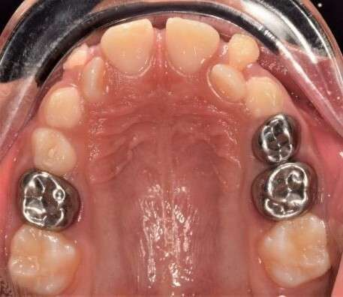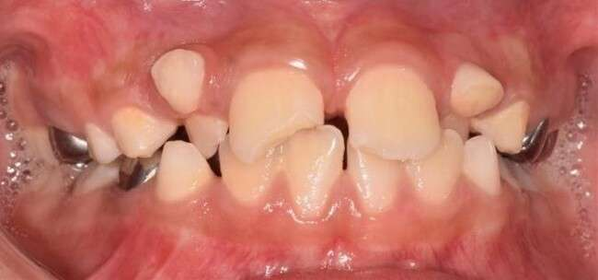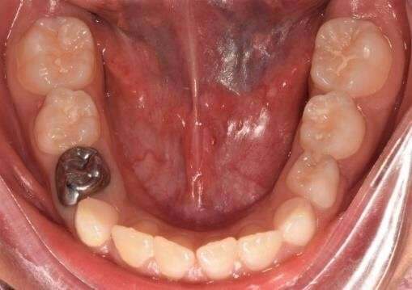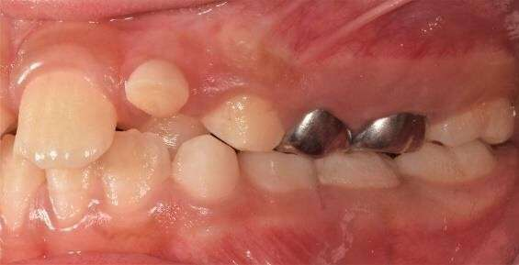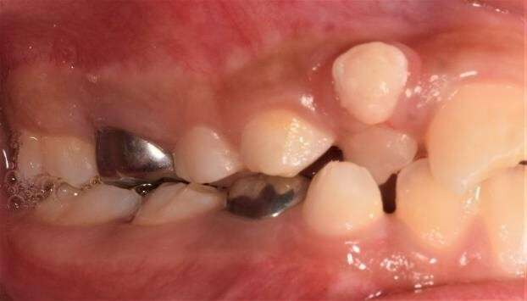
Pretreatment photographs

Treatment:
Dental treatment was done in the dental clinic using Local anesthesia. In E.R visit teeth #11,21 was restored with direct composite restoration and teeth #52,62 were extracted. In the following dental visits restorative treatment was done as shown in table (1) Teeth #11,21 were kept under regular follow up. Orthodontic treatment was then started to correct the anterior crossbite and provide space for the permanent canine by bonding 2*4 fixed orthodontic appliance and 0.014 NITI was inserted and upgraded to 0.016 NITI and then to 0.016 stainless steel wire and Elastomeric chain #12-22 to close the diastema and provide space for permanent canines to erupt.

Tooth No. |  | Treatment | Tooth No. | Treatment
16 |  | Class II composite resto | 63 | Extraction
54 |  | Class II composite resto | 65 | Extraction
53 |  | Extraction | 26 | Class II composite resto
52 |  | Extraction | 36 | PFS
11 |  | Class IV composite  resto | 74 | Class II composite resto
21 |  | Class IV composite  resto | 46 | PFS
62 |  | Extraction
Table 1

Pre Treatment
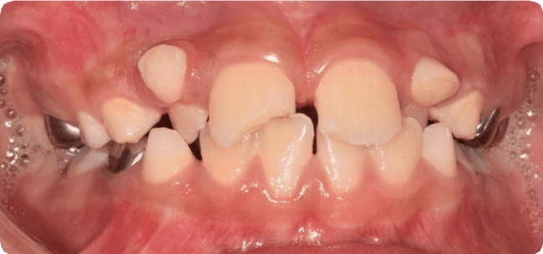
After crossbite correction

6 weeks post trauma

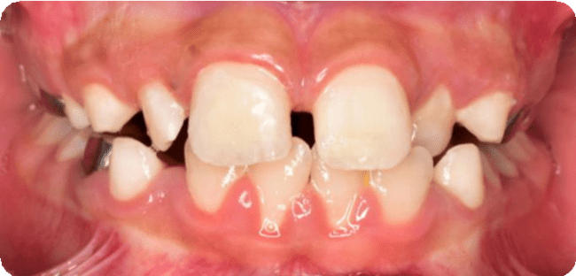
Post treatment

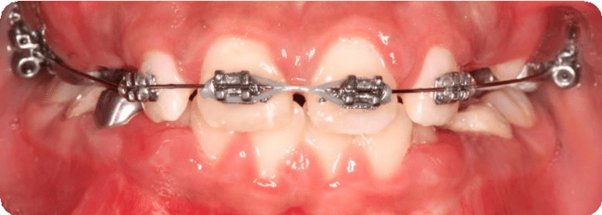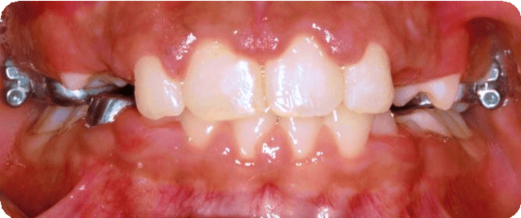

Pre Treatment Post treatment
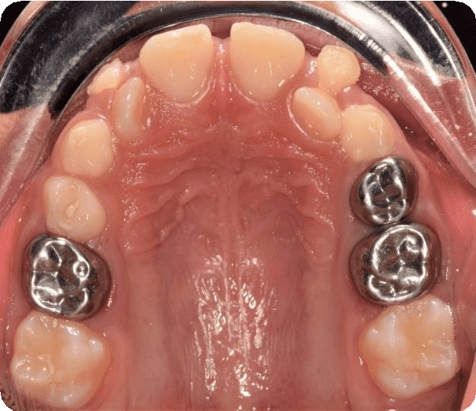
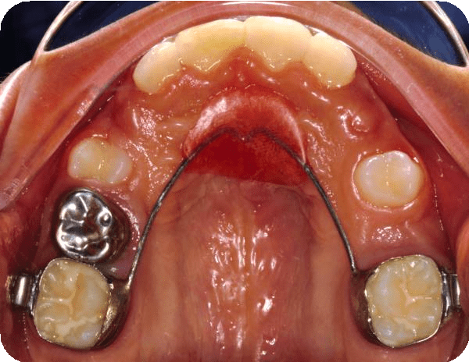
Conclusion:
Because of the patients’ demands for invisible restorations which provide a natural look have increased. And while anterior crossbite might lead to numerous potential problems, proper management will dramatically improve the quality of life and eliminate possible future consequences. To achieve optimum treatment outcomes for patients with dental trauma and anterior crossbite, working in multidisciplinary team is highly recommended.

References:

- Petti, S., Glendor, U. and Andersson, L. (2018) "World traumatic dental injury prevalence and incidence, a meta-analysis-One billion living people have had traumatic dental injuries", Dental Traumatology, 34(2), pp. 71-86. doi: 10.1111/edt.12389.
- Gong Y, Xue L, Wang N, Wu C. Emergency dental injuries presented at the Beijing
Stomatological Hospital in China. Dent Traumatol 2011
- Patnana, A. and Kanchan, T. (2021) "Tooth Fracture", StatPearls Publishing, p. Available at: https://www.ncbi.nlm.nih.gov/books/NBK551650/ (Accessed: 18 April 2022).
- Bahadır, H., Karadağ, G. and Bayraktar, Y. (2018) "Minimally Invasive Approach for Improving Anterior Dental Aesthetics: Case Report with 1-Year Follow-Up", Case Reports in Dentistry, 2018, pp. 1-5. doi: 10.1155/2018/4601795.

- Ceyhan, D. and Akdik, C. (2017) "Taking a glance at anterior crossbite in children: Case series", Contemporary Clinical Dentistry, 8(4), p. 679. doi: 10.4103/ccd.ccd_633_17.

- Kindelan, S. et al. (2008) "Dental trauma: an overview of its influence on the management of orthodontic treatment. Part 1", Journal of Orthodontics, 35(2), pp. 68-78. doi: 10.1179/146531207225022482.

Biography:
My name is Feras AlDhafr, currently Saudi board Pediatric dental resident at national guard hospital, I have multiple research publications, I won third place award in case presentation at national guard hospital resident retreat day.

