13th International Conference on Liver Diseases & Heapatology November 14-15, 2022 Amsterdam, Netherlands

Journal of Clinical Gastroenterology & Hepatology ISSN : 2575-7733

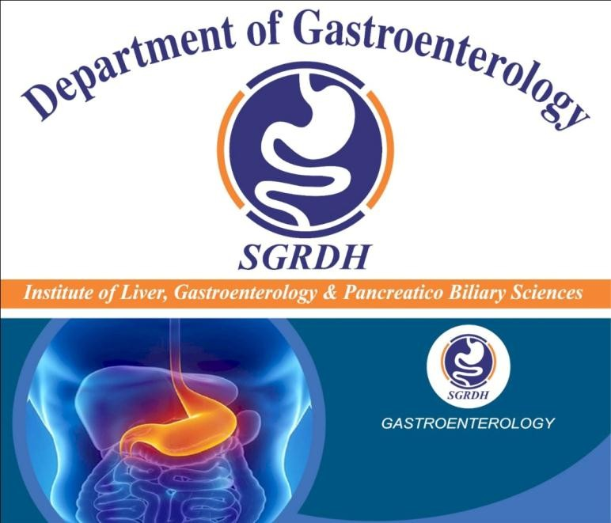
Presenting Author Details :
Full Name as per the passport: Balwant Singh Gill, MD, DNB(Gastroenterology) Date of birth as per the passport: 09/11/1986
Designation/Affiliation: Dr.(Consultant : Gastroenterologist, Hepatologist & Interventional Endoscopist) / SGRD HOSPITAL, Bathinda, Punjab, India.
Email: dr.bsgill1@gmail.com Phone Number: +91-9417562956

Dr.Balwant Singh Gill
Institute of Liver, Gastroenterology & Pancreatico Biliary Sciences, SGRDH, Bathinda, Punjab, India
Presentation title : Pathophysiology and management of “Esophageal Varices” in current practice Abstract(300 words limit)
Pathophysiology and management of “Esophageal Varices” in current practice
Esophageal Varices : Esophageal varices are dilated submucosal distal esophageal veins connecting the portal and systemic circulations. This happens due to portal hypertension (most commonly a result of cirrhosis), resistance to portal blood flow, and increased portal venous blood inflow. The most common fatal complication of cirrhosis is variceal rupture; the severity of liver disease correlates with the presence of varices and risk of bleeding.
- Bleeding esophageal varices : No single treatment for bleeding esophageal varices is appropriate for all patients and situations. An algorithm for management of the patient with acute bleeding is presented in this article. The options for long-term, definitive therapy and the criteria for selection of each are discussed.
- Pathophysiology and management of esophageal varices : Esophageal varices are one of the most common and severe complications of chronic liver disease. New aspects in epidemiology, pathogenesis, and treatment of varices are reviewed. Sclerotherapy is the first-line treatment for acute hemorrhage. Prevention of first or recurrent bleeding is still unsatisfactory. β-Blockers are slightly superior to sclerotherapy with regard to prophylaxis of first bleeding. β-Blockers or sclerotherapy may be used for prophylaxis of recurrent bleeding.

However, prophylactic treatment regimens do not have a major impact on survival. Combination treatment, new drugs, or new devices may help to improve the efficacy of prophylactic measures.
- Endoscopic Therapy for Esophageal Varices : Among therapeutic endoscopic options for esophageal varices (EV), endoscopic variceal ligation (EVL) has proven more effectiveness and safety compared with endoscopic sclerotherapy and is currently considered as the first choice. In acute EV bleeding, vasoactive therapy (either with terlipressin or somatostatin) prior to endoscopy improves outcomes; moreover, antibiotic prophylaxis has to be generally adopted. Variceal glue injection (cyanoacrylates) seems to be effective in the treatment of esophageal as well as in gastric varices. Prevention of rebleeding can be provided both by EVL alone or combined with non-selective β-blockers. Moreover, EVL can be adopted for primary prophylaxis, with no differences in mortality compared with drugs, in subjects with large varices and unfit for a β-blocker regimen.
- A meta‐analysis of endoscopic variceal ligation for primary prophylaxis of esophageal variceal bleeding : Despite publication of several randomized trials of prophylactic variceal ligation, the effect on bleeding‐ related outcomes is unclear. We performed a meta‐analysis of the trials, as identified by electronic database searching and cross‐referencing. Both investigators independently applied inclusion and exclusion criteria, and abstracted data from each trial. Standard meta‐analytic techniques were used to compute relative risks and the number needed to treat (NNT) for first variceal bleed, bleed‐related mortality, and all‐cause mortality. Among 601 patients in 5 homogeneous trials comparing prophylactic ligation with untreated controls, relative risks of first variceal bleed, bleed‐related mortality, and all‐cause mortality were 0.36 (0.26‐ 0.50), 0.20 (0.11‐0.39), and 0.55 (0.43‐0.71), with respective NNTs of 4.1, 6.7, and 5.3. Among 283 subjects from 4 trials comparing ligation with β‐blocker therapy, the relative risk of first variceal bleed was 0.48 (0.24‐ 0.96), with NNT of 13; however, there was no effect on either bleed‐related mortality (relative risk [RR], 0.61; confidence interval [CI], 0.20‐1.88) or all‐cause mortality (RR, 0.95; CI, 0.56‐1.62). In conclusion, compared with untreated controls, prophylactic ligation reduces the risks of variceal bleeding and mortality. Compared with β‐blockers, ligation reduces the risk for first variceal bleed but has no effect on mortality. Prophylactic ligation should be considered for patients with large esophageal varices who cannot tolerate β‐blockers.
Subsequent research should further compare ligation and β‐blockers to determine the effect on mortality, and measure ligation's cost‐effectiveness

Biography
Dr.Balwant Singh Gill has completed his MD from Dr.MGR Medical University in 2011 and DNB from Delhi from NBE in 2014. He is the Director & Head of Institute of Liver, Gastroenterology & Pancreatico Biliary Sciences, SGRD HOSPITAL (India) an advanced Endoscopy Center. He has published more than 5 papers in reputed journals and has been serving as an consultant Gastroenterologist, Hepatologist & Interventional Endoscopist at their center of gastroenterology from July, 2015.
He has associated with few national and international associations as follows :

  - Member : ACG(American College of Gastroenterology)

  - Member : ASGE(American Society for Gastrointestinal Endoscopy)

  - Member : CAG(Canadian Association of Gastroenterology)

  - Member : AASLD(American Association for the Study of Liver Diseases)

  - Member : EASL(European Association for the Study of the Liver)

  - Member : APASL(Assain Pacific Association for Study of the Liver)

  - Life Member : INASL(Indian National Association for Study of the Liver)

  - Life Member : GISI (Gastrointestinal Infection Society of India)

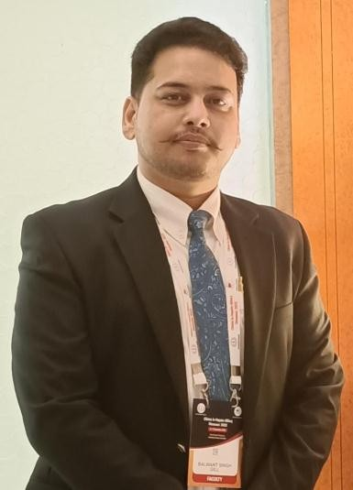

Type of Presentation: Oral Session name:
Research interests: Esophageal disorders, Hepatocelular carcinoma, IBD, Pancreatic diseases and Colon cancer. Funding Source (If any):
Your profile page URL in your department:
Linked In/Facebook/twitter account:
Postal address: Official : Institute of Liver, Gastroenterology & Pancreatico Biliary Sciences, SGRDH, Bathinda, Punjab, India.
Residential : Balwant Singh Gill, H.No.128, Patti Masse Ki, VPO – Thulliwal-148025, Barnala, Punjab, India. Comments:

