Neuroinflammation as the link between modifiable risk factors and Alzheimer’s disease
Andis Klegeris*
Faculty of Science, University of British Columbia Okanagan Campus, Kelowna, BC, Canada

Abstract
Alzheimer’s Disease (AD) is the most common causes of senile dementia. Due to the aging human population and lack of effective treatments, AD increasingly contributes to morbidity and mortality worldwide. In addition to neuronal loss and hallmark biochemical abnormalities, including excess deposition of amyloid beta and tau proteins, AD pathogenesis is characterized by chronic neuroinflammation. This response is driven by persistent and aberrant activation of microglia, which are the professional immunocytes of the brain. Microglial response is initially triggered by the pathological structures associated with AD, such as amyloid plaques and tau-containing tangles, and is aimed at removal of these abnormal structures; however, if this acute response is not resolved, microglial activation converts to chronic and pro-inflammatory resulting in excess production of inflammatory mediators and neurotoxins, which leads to damage and death of neighboring cells, including neurons and non-neuronal glial cells. Both non-modifiable and modifiable risk factors contribute to onset and progression of AD. Nonmodifiable risk factors include certain mutations and genetic variations that increase individual risk of developing AD, whereas modifiable risk factors comprise a wide variety of health- and lifestyle-related aspects that can be altered by adjusting individual behaviors. This presentation will focus on three groups of modifiable factors including obesity and type two diabetes, physical inactivity, and imbalance of gut microbiota, all of which have been identified as risk factors for the development of AD. Data will be presented implicating neuroimmune responses as the common link between these diverse risk factors and the pathogenetic mechanism of AD. Understanding these mechanisms and processes could help identify novel therapeutic targets for combating AD and other neurodegenerative diseases. It will also be highlighted that controlling the modifiable risk factors is a valid approach for managing the increased incidence of AD.

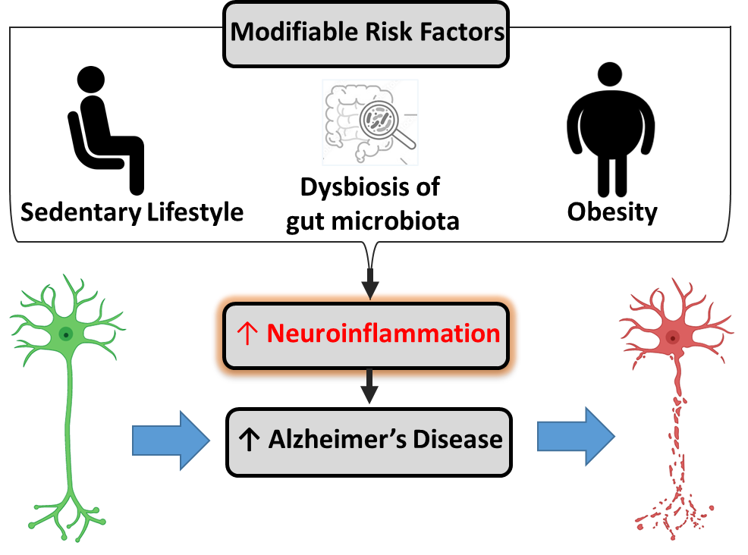
Figure 1. Neuroinflammation represents a common mechanism linking three distinct groups of modifiable risk factors with Alzheimer’s disease pathogenesis.
References
- Wenzel TJ, Haskey N, Kwong E, Greuel BK, Gates EJ, Gibson DL, Klegeris A. Dietary fats modulate neuroinflammation in mucin 2 knock out mice model of spontaneous colitis. Biochim. Biophys. Acta Mol. Basis Dis. 2022;1868:166336.
- Bernath A, Gates EJ, Klegeris A. Modifying the diet and gut microbiota to prevent and manage neurodegenerative diseases. Rev. Neurosci. 2022;33:767-78.
- Bajwa E, Klegeris A. Neuroinflammation as the key mechanism linking hypertension with the increased risk of Alzheimer’s disease. Neural Regen. Res. 2022;17:2342-46.
- Wenzel TJ, Gates EJ, Ranger AL, Klegeris A. Short-chain fatty acids (SCFAs) alone or in combination regulate select immune functions of microglia-like cells Mol. Cell. Neurosci. 2020;105:103493.
- Spielman LJ, Gibson DL, Klegeris A. Unhealthy gut, unhealthy brain: The role of the intestinal microbiota in neurodegenerative diseases. Neurochem. Int. 2018;120:149-63.
Biography
Andis Klegeris obtained a D.Phil. degree from the University of Oxford in England, and completed his post-doctoral training at the University of British Columbia (UBC) in Vancouver, Canada. Currently he is a Professor of Pharmacology at the Faculty of Science and a head of Laboratory of Cellular and Molecular Pharmacology at the UBC Okanagan campus. His research is focused on neuroimmune signaling mechanisms between the different types of brain cells and the pathogenesis of neurodegenerative diseases. Prof. Klegeris is also engaged in undergraduate teaching and pedagogical research. He studies the effects that alternative instructional techniques, such as problem-based learning, have on the problem-solving and critical-thinking skills of students. He has authored more than 100 peer-reviewed research articles.

