Aerobic Exercise Training: Prevention of Atherogenesis Induced by Low-Sodium Diet in LDL Receptor Knockout Mice
Ana Paula Garcia Bochi¹
University of Sao Paulo (Brazil)

¹Laboratorio de Lipides (LIM-10), Hospital das Clinicas (HCFMUSP) da Faculdade de Medicina da Universidade de São Paulo, São Paulo, Brazil; ²Laboratory of Renal Pathophysiology, Department of Internal Medicine, School of Medicine, University of São Paulo, São Paulo, Brazil; ³Department of Pathology, University of São Paulo Medical School, São Paulo, Brazil; ⁴Department of Physiology and Biophysics, Mississippi Center for Obesity Research, Cardiorenal and Metabolic Diseases Research Center, University of Mississippi Medical Center, Jackson, USA; ⁵Rheumatology Division of the Hospital das Clinicas, University of São Paulo Medical School, São Paulo, Brazil; ⁶Department of Physiology and Biophysics, Institute of Biomedical Sciences, University of São Paulo, São Paulo, Brazil; ⁷Programa de Pós-Graduação em Medicina, Universidade Nove de Julho (UNINOVE), São Paulo, Brazil. *Correspondence to: Ana Paula Garcia Bochi, email: bochianapaula@gmail.com

Abstract (300 word limit)
Objective: To investigate the efficacy of aerobic exercise training (AET) in the prevention of dyslipidemia, insulin resistance (IR), and atherogenesis induced by severe low-sodium (LS) diet.
Approach and results: LDL receptor knockout (LDLR KO) mice were fed a low-sodium (LS) (0.15% NaCl) or normal-sodium (NS; 1.27% NaCl) diet, submitted to AET in a treadmill, 5 times/week, 60 min/day, 15 m/min, for 90 days, or kept sedentary. Blood pressure (BP), plasma total cholesterol (TC) and triglyceride (TG) concentrations, lipoprotein profile, and insulin sensitivity were evaluated at the end of the AET protocol. Lipid infiltration, angiotensin II type 1 receptor (AT1), receptor for advanced glycation end products (RAGE), carboxymethyllysine (CML), and 4-hydroxynonenal (4-HNE) contents as well as gene expression were determined in the brachiocephalic trunk. BP and TC and gene expression were similar among groups. Compared to the NS diet, the LS diet increased vascular lipid infiltration, CML, RAGE, 4-HNE, plasma TG, LDL-cholesterol, and VLDL-TG. Conversely, the LS diet reduced vascular AT1 receptor, insulin sensitivity, HDL-cholesterol, and HDL-TG. AET prevented arterial lipid infiltration; increases in CML, RAGE, and 4-HNE contents; and reduced AT1 levels and improved LS-induced peripheral IR. Figure 1.
Conclusions: The current study showed that AET counteracted the deleterious effects of chronic LS diet in an atherogenesis-prone model by ameliorating peripheral IR, lipid infiltration, CML, RAGE, 4-HNE, and AT1 receptor in the intima-media of the brachiocephalic trunk. These events occurred independently of the amelioration of plasma-lipid profile, which was negatively affected by the severe dietary-sodium restriction.

Image
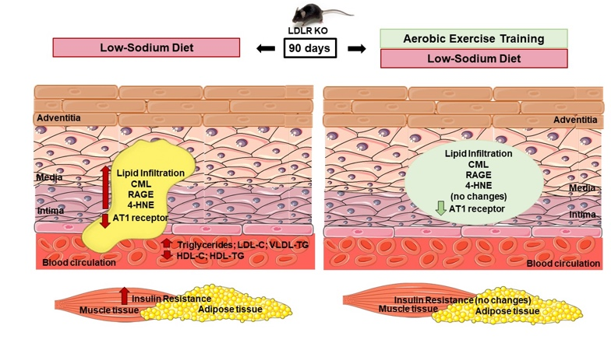
Figure 1: Effects of low-salt diet and aerobic exercise training on arterial wall, muscle and adipose tissue in LDLR KO mice. On the left side: low-sodium (LS) diet increased vascular lipid infiltration, CML, RAGE, 4-HNE, plasma TG, LDL-C, VLDL-TG and peripheral IR in LDLR KO mice. Conversely, LS diet reduced vascular AT1 receptor, HDL-C and HDL-TG. On the right side: AET prevented the LS-induced arterial lipid infiltration, the increase in CML, RAGE and 4-HNE contents, reduced AT1 receptor level and improved LS-induced peripheral IR, after 90 days of intervention.
Recent Publications (minimum 5)
- Bochi APG, Ferreira GDS, Del Bianco V, Pinto PR, Rodrigues LG, Trevisani MDS, Furukawa LNS, Bispo KCS, da Silva AA, Velosa APP, Nakandakare ER, et al (2022) Aerobic Exercise Training Reduces Atherogenesis Induced by Low-Sodium Diet in LDL Receptor Knockout Mice. Antioxidants 13;11:2023.
- da Silva Ferreira G, Bochi APG, Pinto PR, Del Bianco V, Rodrigues LG, Morais MRPT, Nakandakare ER, et al (2021) Aerobic exercise training prevents insulin resistance and hepatic lipid accumulation in LDL receptor knockout mice chronically fed a low-sodium diet. Nutrients 13, 2174.
- Pinto P R, Yoshinaga M Y, Del Bianco V, Bochi A P, Ferreira G S, Pinto I F, Rodrigues L G, Nakandakare E R, Okamoto, M M, Machado U F, et al (2021) Dietary sodium restriction alters muscle lipidomics that relates to insulin resistance in mice. J. Biol. Chem 296, 100344.
- Nickenig G, Strehlow K, Bäumer AT, Baudler S, Waßmann S, SAUER H, Böhm M (2000) Negative feedback regulation of reactive oxygen species on AT1 receptor genes expression. Br. J. Pharmacol. 131: 795-803.
- Pellegrin M, Alonso F, Aubert JF, Bouzourene K, Braunersreuther V, Mach F, Haefliger J A, Hayoz D, Berthelot A, Nussberger, J, et al (2009) Swimming prevents vulnerable atherosclerotic plaque development in hypertensive 2-kidney, 1-clip mice by modulating angiotensin II type 1 receptor expression independently from hemodynamic changes. Hypertension 53: 782–789.

 Biography

Ana Paula Garcia Bochi studied veterinary medicine with a specialization in endocrinology and metabology in dogs and cats. She holds a master's degree in science from the endocrinology program of the medicine department of the University of Sao Paulo. She has been working as a veterinary doctor at her own clinic. She has been working on research at University of Sao Paulo (Brazil) in the area of low-salt diet, atherogenesis and physical exercise, since 2014. She has published in co-authorship on this line of research in hepatic and muscular tissue.

Email: bochianapaula@gmail.com

Notes/Comments:

Presenting author details
Full name: Ana Paula Garcia Bochi
Contact number: 55 11 99990-3130
Twitter account:
Linked In account:
Session name/ number:
Category: (Oral presentation/ Poster presentation)

