Survey and Molecular detection of two viroids associated with fruit and vegetable crops in six states in Sudan
Faris Ibrahim, MSc, University of Khartoum, Sudan

Abstract
Viroids are serious pathogens of vegetable and fruit crops which are circular, 246-401 nucleotide long, and composed of non-protein coding ssRNA with autonomous replication. The most recent study on viroids diseases in Sudan dated back to 2010. The objective of this study was to explore the prevalence of Citrus Cachexia viroid (CVD-IIb) and Citrus Exocrotis Viroid (CEVd) in vegetables and fruit crops. During field surveys targeting vegetable and fruit crops showing viroid-like symptoms, samples were collected from 13 locations in six states of Sudan. Plant tissues were examined visually or with the aid of a hand lens. Total RNA was extracted from leaves and young plant tissues. Complementary DNA (cDNA) was synthesized from total RNA extracted from plant tissues. Amplification of cDNA was carried out using Pospi primer. The amplified products were visualized by standard gel electrophoresis. cDNA samples which were positive for pospiviroidae were then amplified with CVD-IIb and CEVd primers and visualized as for Pospi primer. During the field survey, 254 samples showing viroid-like symptoms were collected from 7 types of fruit crops and 13 types of vegetable crops. For fruit samples (n=82) the incidence was 34.1% and the overall (n=254) incidence level was 42.35%. Among pospiviroidae positive vegetable samples (n=84) the prevalence of CVD-IIb was 48.8%. With the exception of eggplant and American cucumber, all other tested vegetable crops were found to harbour CVD-IIb. CVD-IIb was detected in 38.9%, 27%, 17.6% and 6% of citrus samples collected from different States. The prevalence of CEVd among pospiviroidae-positive vegetable samples was 13.1%. CEVd was not detected in any of the 28 pospiviroidae-positive fruit samples. However, a set of different bands nonspecific for CEVd was detected in citrus. During the field survey, it was noticed that most Jbain (Solanum dopium) shrubs growing widely by the side of vegetable fields were showing typical viroid-like symptoms. Upon investigation, this plant was found to harbour CVD-IIb and maybe two other pospiviroidae species. Results generated in this study form baseline data for the distribution of CVD-IIb and CEVd viroids infecting vegetables and fruits in the studied areas. A similar shady on other pospiviroidae species is required as many bands non-specific for either CVD-IIb or CEVd were detected. Also, it is recommended that the perennial shrub Solanum dopium should be eradicated from vegetable fields as it can be an agent of CVD-IIb transmission to vegetable crops from season to season.

Pospivirodae genome:
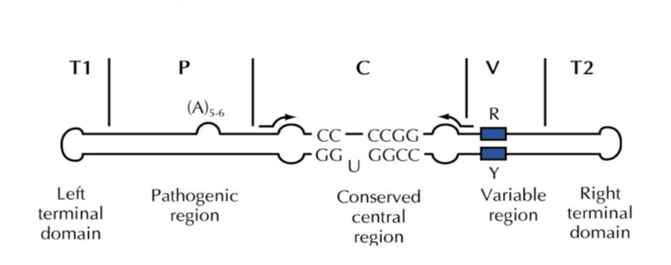
Recent Publications

- H. S. Mohammed, M. A. El Siddig, A. A. El Hussein, F. A. Ibrahim, J. Navas-Castillo and E. Fiallo-Olive. (2017). First report of Sweet potato leaf curl virus infection Sweet potato in Sudan. Plant disease 101 849. DOI: PDIS-12-16-1705-PDN.
- Ibrahim-Elkhalil M Adam, Isam Abdokashif, Asia Elrashid, Hiba Bayoumi, Ahmed Musa, Eithar Abdulgyom, Safaa Mamoun, Sitana Elnagar, Wafaa Mohammed, Amna El-khateeb, Musaab Oshi, Faris El-bakri. (2020). Novel Algorithms for PFGE Bacterial Typing: Number of Co-Migrated DNA Fragments, Linking PFGE to WGS Results and Computer simulations for Evaluation of PulseNet International Typing Protocols. Journal of Applied Microbiological Research 2581-7566. DOI: 10.3619/2581-7566.1000138



Mr.Ibrahim is 30 years old researcher, he is highly trained microbiology and molecular biology & field agent for plant collection, preservation and molecular analysis, with strong background of quality control analysis, recently obtained his MSc degree from University of Khartoum which involves viroid detection in cultivated crops and vegetables in Sudan.

Email: albakrifaris@hotmail.com

Notes/Comments:

Presenting author details
Full name: Faris Albakri Ibrahim Alsaid
Contact number: +249915959852
Twitter account: Faris Albakri
Linked In account: https://www.linkedin.com/in/faris-ibrahim-134b3886/
Session name/ number: Track 2
Category: Oral presentation

