Investigation of Tandoor Ovens and Tandoor Smoke as a Public Health Problem: An Epidemiological Study in the Province of Van, Turkey
Sebahattin Çelik MD. MSc, Van Turkey
Serpil Sevimli Deniz Phd, Van Turkey
Hakan Köksal MD. Van Turkey
Osman Abbasoğlu MD. Ankara Turkey

Abstract
Statement of the Problem: Indoor air pollution occurs as a result of different circumstances in different parts of the world. The smoke produced by tandoor ovens represents a major source of indoor airpollution in rural areas of the Middle East and South Asia. Although the use of tandoor ovens has serious effects on public health, scientific data on their prevalence, the chemical properties of the biofuels used in them, and the contents of tandoor smoke are almost non-existent.
The purpose of this study: we determined three main objectives for the present study. Our first objective was to determine the number of tandoors in a specific location (prevalence). The second objective was the analysis of the chemical contents of the tandoor smoke with regard to the biofuels used. Our third and final objective was to examine the severity of the burns caused by tandoor ovens.
Methodology & Theoretical Orientation: Concerning the first objective, a field study was conducted to determine the number of tandoor ovens existing in a predetermined area (in this case, the province of Van in Turkey). The next step was the chemical analysis of the tandoor smoke from the biofuels, which included dung and wood. Both organic and inorganic molecules were analyzed using internationally accepted and validated methods.Finally, the data collected by the burn unit of a tertiary hospital were analyzed with respect to burn injuries caused by tandoor ovens.
Findings: Almost all of the tandoors (99%) identified in the study were indoor. Dung and wood constituted the main biofuels used in the tandoors. inorganic components identified in the chemical analysis are presented in Table 1. Our analysis found polyaromatic hydrocarbons (PAH), among the most carcinogenic organic compounds, at levels of 0.0049 mg/m3 for the dung + wood tandoor and 0.0005 mg/m3 for the dung-only tandoor. A total of 301 patients with tandoor-related burns (6.7% of all burn injuries) over a period of 10 years were admitted to the burn unit of Van Training and Research Hospital
Conclusion&Significance:The smoke from dung + wood biofuel is potentially dangerous in terms of inorganic molecules and PAH. Tandoor burns are more common in children and women and are more serious compared with other types of burns.

Image
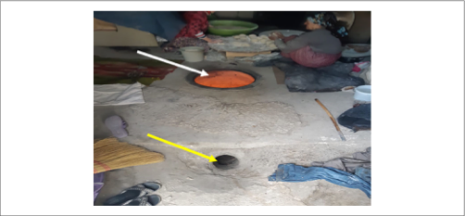

Figure 1. Women preparing dough for baking bread. The white arrow shows the underground tandoor, the yellow arrow indicates the ventilation hole.

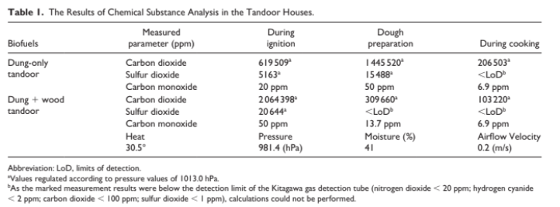
Recent Publications (minimum 5)

1. Gautam S, Edwards R, Yadav A, et al. Probe-based mea- surements of moisture in dung fuel for emissions measure- ments. Energy Sustain Dev. 2016;35:1-6. doi:10.1016/j. esd.2016.09.003.
2. Miglani K, Kumar S, Yadav A, Aggarwal N, Ahmad I, Gupta R. A multibiomarker approach to evaluate the effect of polyaro- matic hydrocarbon exposure on oxidative and genotoxic damage in tandoor workers. Toxicol Ind Health. 2019;35(7):486-496. doi:10.1177/0748233719862728.
3. Celik S, Yılmaz EM, Özden F, Kotan C, Okut H. The rela- tionship between eating and lifestyle habits and cancer in Van Lake Region: another endemic region for esophageal and gastric cancers. J Cancer Epidemiol. 2015;2015:254823. doi:10.1155/2015/254823.
4. McCarthy CE, Duffney PF, Gelein R, et al. Dung biomass smoke activates inflammatory signaling pathways in human small airway epithelial cells. Am J Physiol Lung Cell Mol Physiol. 2016;311(6):L1222-L1233. doi:10.1152/ajplung.00183.2016.
5. Po JYT, FitzGerald JM, Carlsten C. Respiratory disease associated with solid biomass fuel exposure in rural women and children: systematic review and meta-analysis. Thorax. 2011;66(3):232-239. doi:10.1136/thx.2010.147884.


Biography (150 word limit) Dr. Sebahattin completed his medical education at Hacettepe University (Ankara/Turkiye). He became a general surgeon at the same institution (2011). He has been providing clinical service as a general surgeon for 11 years. He completed her master's degree in Biostatistics in 2018. He has been especially interested in the epidemiology of diseases for 4 years. particularly concerned with the environmental problems of women and children, who are disadvantaged groups
Email: scelik@yyu.edu.tr

Notes/Comments:
Presenting author details
Full name: Sebahattin Çelik
Contact number:+90 505 705 79 57
Twitter account:@drsebahattin
Linked In account:
Session name/ number:
Category: (Oral presentation)

