Modeling and Simulation of pollutant dispersion in urban cities: Case of the city of Douala-Cameroon.
Ivan Aquigeh Newen, E3M Laboratory. Douala university Cameroon

ABSTRACT

The use of fossil fuels in automotive vehicles is remains a major source of pollution in urban cities all over the world leading to adverse health problems depending on the concentration of the various pollutants in a particular area. This study was carried out around the campus of the Douala University where the road traffic is dense and a considerable staff and student population is considered. To meet the objectives of the research a number of computational fluid dynamic (CFD) considerations were taken such as; treating of working fluid as perfect gas, the flows as steady incompressible flows, constant heat capacities, line source, cross wind (wind normal to inlet) to name a few. The experimental test was done using the [KIMO-KIGAZ 700 (060322)]. During which we recorded stabilized values of CO₂ with respect to our models and these values are plotted with the simulated values. Five models were established to simulate pollutant dispersion. The models were generated in GAMBIT and the simulation done in FLUENT, where the K-ε equations are solved and the results are post processed. Some of the input data in FLUENT was obtained from experimental data in literature and others from default values in FLUENT. It was found that the concentrations varied with respect to the distance from the road, the number of buildings (street canyons) and the speed of wind. The model entitled CAMPUS had the highest net concentration of CO₂ 255 ppm and the least at CAMPUSBATI model 34 ppm. The study could also be extended to the other pollutants like CO, NOx and others. Also, wind tunnel modeling techniques could be employed.
- Ominaga, Y., and T. Stathopoulos. 2013. CFD simulation of near-field pollutant dispersion in the urban environment: A review of current modeling techniques. Atmos. Environ. 79:716–30.
- Ahmed, S.; Adnan, M.; Janssens, D.; Wets, G. A Route to school Informational Intervention for Air Pollution Exposure Reduction. Sustain. Cities Soc. 2019, 53, 101965
- Jamil, N.A.; Jalaludin, J.; Kamaruddin, A.S.; Ibrahim, M.H. Exposure to air pollutants PM10, NO₂, SO₂ and VOCs on the lung functions among school children living nearby the petrochemical industry area in Kemaman, Terengganu. Adv. Environ. Biol. 2015, 9, 55–64.
- Panter, J.R.; Jones, A.P.; Van Sluijs, E.M.; Griffin, S.J. Neighborhood, route, and school environments and children’s active commuting. Am. J. Prev. Med. 2010, 38, 268–278.
- Alias, A.; Latif, M.T.; Othman, M.; Azhari, A.; Wahid, N.B.A.; Aiyub, K.; Khan, M.F. Compositions, source apportionment and health risks assessment of fine particulate matter in naturally-ventilated schools. Atmos. Pollut. Res. 2021, 12, 101190.
- Periyakoil, D.; Das, H.P.; Miller, C.; Spanos, C.J.; Prata, N. Environmental Exposures in Singapore Schools: An Ecological Study. Int. J. Environ. Res. Public Health 2021, 18, 1843
- Forehead, H; N. Huynh. Review of modelling air pollution from traffic at street-level - The state of the science. Environmental Pollution.241 (2018) 775-786.
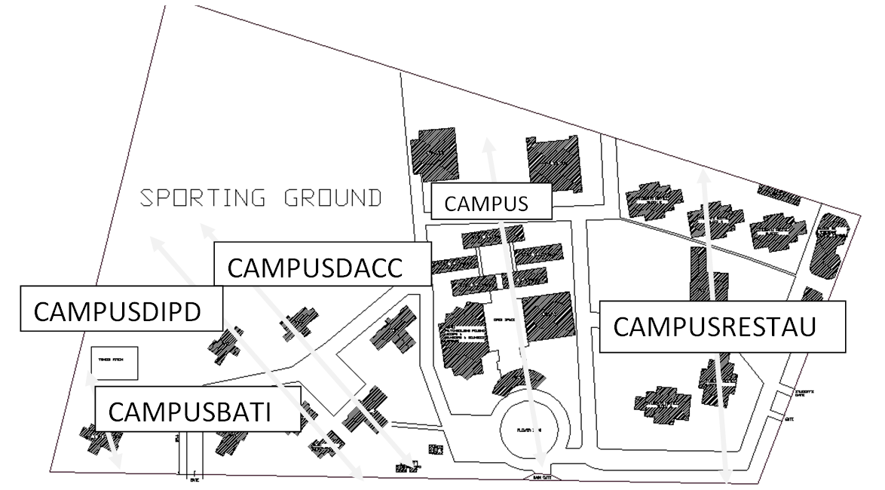
Figure 1. Chosen models in the Douala University main campus. Models are indicated by double headed arrows




Ivan Aquigeh Newen is a final year PhD student in the University of Douala. Holder of a Masters degree in engineering sciences from the same University. Holder of a teacher grate one diploma for technical education, same University. Distance course certificate on the introduction to sustainable engineering from Institute of technology Karlskrona (Sweden). This study was motivated by my broad knowledge in fluid dynamics, automotive and sustainable engineering.
Notes/Comments:
Presenting author details
Full name:
Contact number:
Twitter account:
Linked In account:
Session name/ number:
Category: (Oral presentation/ Poster presentation)

Notes/Comments:
Presenting author details
Full name: IVAN AQUIGEH NEWEN
Contact number: 237 676775566
Twitter account:
Linked In account:
Session name/ number:
Category: Oral presentation

