Early Detection of Delayed Apoptosis following Cryopreservation of MSCs using Mass Spectrometry
Joglekar, N., Loughborough University, UK;
Coopman, K., Loughborough University, UK;
Ratcliffe, E., Loughborough University, UK;
Turner, M., Loughborough University, UK

Abstract (300 word limit)

Statement of the Problem: There is currently a growing interest in the use of Mesenchymal Stem Cells (MSCs) in the development of cell therapies for the treatment of many common conditions. However, during manufacturing, apoptosis can lead to a loss of function following cryopreservation and remains an area of concern. Delayed apoptosis in which cells that appear viable immediately post-thaw undergo apoptosis in a delayed manner is a particular challenge, with no rapid method to identify such cell populations at an early stage. The aim of this work is to develop a rapid method, using metabolomics, to detect biomarkers, post-thaw, that could indicate cells undergoing apoptosis. Methodology & Theoretical Orientation: Initially, cells were cryopreserved using different freezing procedures expected to have varying impacts on the cells post-thaw (PT). These included changing the amount of DMSO concentration and freezing rate. The proliferation and viability of the cells, PT, across five days was then investigated, along with the immunomodulatory properties of MSCs PT, including their ability to reduce T cell proliferation and induce T cell differentiation into T regulatory cells (Tregs). Liquid Chromatography / Mass Spectrometry (LC/MS), and Gas Chromatography / Mass Spectrometry (LC/MS) are now being used to detect apoptotic biomarkers, PT, that could give an indication of cells undergoing apoptosis. Findings: Using detrimental freezing procedures showed a significant decrease in viability and the proliferation of the cells PT. However, cryopreservation did not affect the immunomodulatory properties of the MSCs. Initial preliminary work using GC/MS has shown that healthy MSCs reduce the amount of a specific compound in the headspace of cell cultures over 24hrs PT. Conclusion & Significance: While results are only preliminary, the decrease in the compound, PT, could be used as a biomarker for cell health. This could be used as a rapid quality control step during manufacturing.

Image
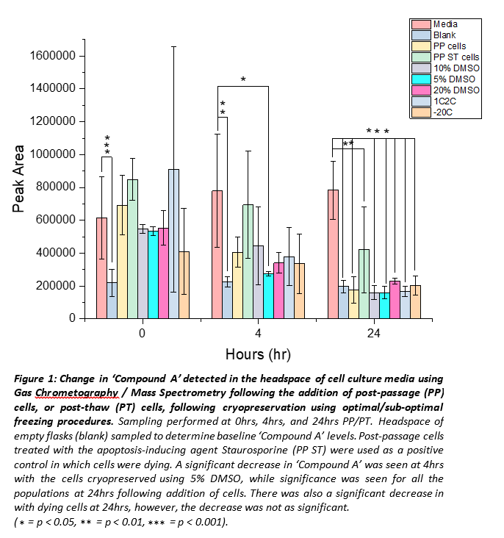
Recent Publications (minimum 5)

- Bahsoun, S., Coopman, K., & Akam, E. C. (2020). Quantitative assessment of the impact of cryopreservation on human bone marrow-derived mesenchymal stem cells: up to 24 h post-thaw and beyond. Stem Cell Research and Therapy, 11(1).

- Ock, S. A., & Rho, G. J. (2011). Effect of dimethyl sulfoxide (DMSO) on cryopreservation of porcine mesenchymal stem cells (pMSCS). Cell Transplantation, 20(8).
- Bischoff, A. C., Oertel, P., Sukul, P., Rimmbach, C., David, R., Schubert, J., & Miekisch, W. (2018). Smell of cells: Volatile profiling of stem- and non-stem cell proliferation. Journal of Breath Research, 12(2).
- Pyo, J. S., Ju, H. K., Park, J. H., & Kwon, S. W. (2008). Determination of volatile biomarkers for apoptosis and necrosis by solid-phase microextraction-gas chromatography/mass spectrometry: A pharmacometabolomic approach to cisplatin’s cytotoxicity to human lung cancer cell lines. Journal of Chromatography B: Analytical Technologies in the Biomedical and Life Sciences, 876(2).

- Filipiak, W., Mochalski, P., Filipiak, A., Ager, C., Cumeras, R., E. Davis, C., Agapiou, A., Unterkofler, K., & Troppmair, J. (2016). A Compendium of Volatile Organic Compounds (VOCs) Released By Human Cell Lines. Current Medicinal Chemistry, 23(20).


Biography (150 word limit)
Nishant Joglekar is a final year doctoral researcher from Loughborough University, UK. His PhD is focused on addressing the effects of cryopreservation during the manufacturing of stem cell-based cell therapies, developing a rapid method to identify biomarkers that could be used to detect dying cells, post-thaw, during manufacturing. Nishant is skilled in cell culture (T cells and stem cells), and numerous other cell-based techniques including flow cytometry, qPCR, and fluorescence microscopy.

Email: n.joglekar@lboro.ac.uk

