Routine Care versus Initial Steps at Birth in Moderate to Late Preterm Neonates-A Randomized Controlled Trial
Dr. Kuldeep Singh¹, Dr. Suksham Jain², Dr. Deepak Chawla³
¹DM Resident, Department of Neonatology, Government Medical College Hospital, Chandigarh, India
²Professor and Head, Department of Neonatology, Government Medical College Hospital, Chandigarh, India
³Professor, Department of Neonatology, Government Medical College Hospital, Chandigarh, India

Abstract
Background: Routine care and skin-to-skin contact at birth promote physiological stability and facilitate the early initiation of breastfeeding. However, in absence of evidence, preterm neonates receive initial steps under a radiant warmer even if no resuscitation is needed.
Objective: To compare the effect of routine care and initial steps on cardiorespiratory stability at 60 minutes after birth among preterm neonates born at 33^{0/7}-36^{6/7} weeks of gestation
Material and methods: In this open-label, parallel-group, randomized controlled trial, neonates born at 33^{0/7} to 36^{6/7} weeks of gestation by vaginal delivery and breathing or crying at birth were randomized to receive routine care (n=50) or initial steps (n=50). The primary outcome was the ‘stability of the cardiorespiratory system in late preterm infants’ (SCRIP) score at 60 minutes of birth.
Results: Birth weight, gestation, and incidence of maternal complications leading to preterm birth were similar in the ‘Routine care’ and ‘Initial step’ groups. The SCRIP score at 60 minutes after birth was similar in the two groups (5.3+0.8 vs. 5.0 +1.1; mean difference: 0.3, 95% CI: -0.07 to 0.67; P=0.11). Mean axillary temperature at 60 minutes after birth was significantly lower in the 'Routine care’ group (ºC; 36.4+0.4 vs. 36.6+0.4; P=0.004). Time to first breastfeeding and exclusive breastfeeding rate during the hospital stay were similar in the two groups.
Conclusion: During resuscitation of moderate and late preterm neonates, routine care in comparison to initial steps did not lead to better cardiorespiratory stability during the first 60 minutes after birth.
Trial registration: Clinical Trial Registry of India (CTRI/2021/09/036730)
Keywords: Preterm neonates, resuscitation, routine care, skin-to-skin contact
Image

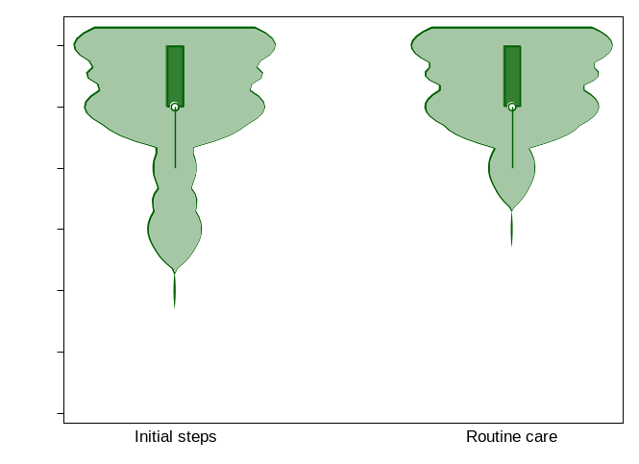
Figure. Violin plot showing SCRIP score at 60 minutes after birth




Biography
Dr. Kuldeep singh a DM neonatology resident in department of neonatology, Government Medical College Hospital, Chandigarh, India.
Email: kuldeepkk9@gmail.com

Presenting author details
Full name: Dr. Kuldeep Singh
Contact number: +918168332377
Mail id: kuldeepkk9@gmail.com
Category: Oral presentation

