Antibiotic Prescribing for Sore Throat in the United Kingdom (UK) Primary Care Practice Using Real-world Data
Oriana Pich, BsC (Honours), RD, Medical Affairs Manager, Reckitt, UK
Rita Olaniyan, MRPharmS, Medical Affairs Scientist, Reckitt, UK Graca Coutinho, MD, PhD, Global Medical Affairs Lead Respiratory, Reckitt, UK Martin Duerden, FRCGP, Medical Adviser, Centre for Medical Education, Cardiff University School of Medicine, UK Adrian Shephard, BSc (Hons) CBiol FSB, Global Medical Marketing Director, Reckitt, UK

Abstract
Statement of the Problem: One of the main areas where antibiotic overuse occurs is within primary care. Although most respiratory tract infections (RTIs) e.g. pharyngitis (sore throat) are self-limiting viral infections, antibiotic use persists. Real-world evidence was used to gather insight into antibiotic use in the UK for RTIs, specifically sore throats, and whether prescribing has changed over time. Methodology & Theoretical Orientation: Prescribing data were extracted from >8 million de-identified electronic health records from ≈8,500 UK primary care practices, between October 2017 – October 2021. The real-world longitudinal patient dataset used a representative demographic proportion (150 practices) of the UK population, filtered to identify patients with a diagnosis of sore throat, tonsillitis, laryngitis, or, glandular fever within 14 days of an antibiotic prescription. Findings: ≈72% of patients with sore throat prescribed antibiotics were over 18 years. Overall, there was only a 2% reduction in the percentage of patients diagnosed with sore throat that received a prescription between 2017 (45%) and 2021 (43%). Despite a decline in absolute number of sore throat patients over the 5 years, the percentage of ‘treated’ sore throat patients with a diagnosis increased in the last 2 years. For sore throat patients, there was an apparent reduction of ≈52% in the number of antibiotic prescriptions from March 2020 vs. April 2020, coinciding with the COVID-19 pandemic. A gradual increase was noted from May 2021; this increase became more noticeable in September 2021, by 58% vs. August 2021. Conclusion & Significance: Within the diagnoses analysed, the number of antibiotic prescriptions issued was the second highest in patients with sore throat. With a gradual return to pre-COVID-19 primary care consultations for sore throat, an increasing trend of antibiotic prescribing is apparent, offering opportunities for greater interventions.
Image

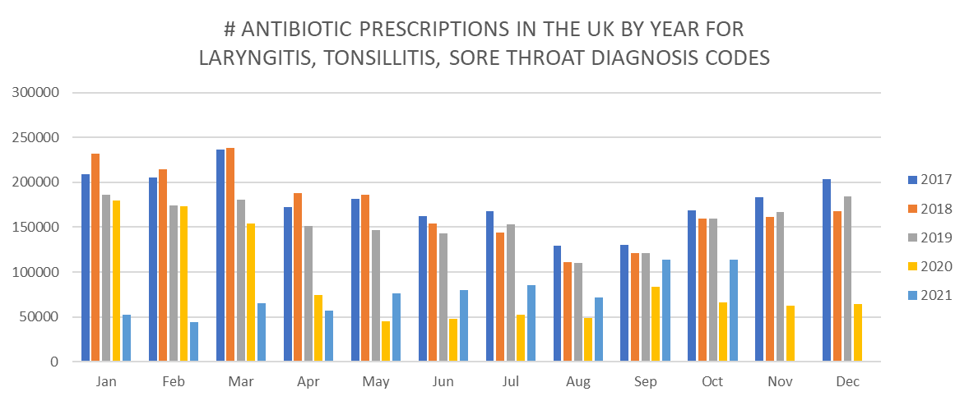
Figure 1: Number of antibiotic prescriptions in the UK by year issued to patients with sore throat, tonsillitis, and laryngitis.

Recent Publications (minimum 5)
- Coutinho, G., Duerden, M., Sessa, A., Caretta‐Barradas, S., & Altiner, A. (2021). Worldwide comparison of treatment guidelines for sore throat. International Journal of Clinical Practice, 75(5), e13879.
- Essack, S., Bell, J., Burgoyne, D., Tongrod, W., Duerden, M., Sessa, A., Altiner, A., & Shephard, A. (2020). Point-of-Care Testing for Pharyngitis in the Pharmacy. Antibiotics, 9(11), 743.


Biography (150 word limit)

Rita Olaniyan is a GPhC qualified pharmacist with experience in community and clinical pharmacy, and data analysis. Her experience to date has enabled her to nurture her desire for improving the quality of medical care and make a difference in the lives of others. Oriana Pich is a registered dietitian with both clinical and industry experience in a wide range of therapy areas in domestic and international settings. Dr Martin Duerden is a GP with an academic interest in antimicrobial prescribing. Adrian Shephard is a microbiologist, chartered biologist and fellow of the Society of Biology with more than 25 years industry experience and a special interest in countering inappropriate antibiotic usage to preserve the efficacy of antibiotics for future generations.

Email: Oriana.pich@reckitt.com
Rita.olaniyan@reckitt.com

Notes/Comments:

Presenting author details
Full name:
Contact number:
Twitter account:
Linked In account:
Session name/ number:
Category: (Oral presentation/ Poster presentation

