NDM, the key mediator of carbapenem resistance: Acute threat to public health in India

Surojit Das*

Vidyasagar University, India

Abstract

Statement of the problem: Carbapenems are the critically important antimicrobials for human medicine used to treat severe Gram-negative bacterial infections (1). Carbapenem resistant organisms (CRO) carrying New Delhi metallo-β-lactamase (NDM) pose a potential public health emergency, especially in developing countries such as India, accounting for high morbidity, mortality, and healthcare cost (2). Several countries reported the presence of NDM-CRO at human-animal-environment interface via one health approach (3, 4). Lack of one health initiative underestimates the burden of these superbugs in India.

Methodology: A review was undertaken to unfold the research conducted on the prevalence of NDM-CRO at human-animal-environment interface in India.

Findings: NDM has been reported from Pan-India with an isolation rate up to 90% in human-derived isolates. Majority of the clinical studies were conducted from North and South India (Fig. 1) (5). Exchange of the NDM among unrelated bacterial isolates facilitates its fast dissemination. Limited studies have been conducted to capture the scenario of NDM-CRO from animal and environment origin. E. coli carrying NDM was detected in mastitis cattle milk and piglets from east and north-east India. Of note, all of these are border-states of India connecting Nepal, Bhutan, and Bangladesh. This may cause the cross-border transmission of NDM-CRO via the food-chain supply. NDM among Enterobacterales and non-fermenters was noted in river water (Yamuna), sewage treatment plants, hospital effluents, seepage and tap water from north India. Pharmaceutical- and hospital-effluents containing antibiotic residues contaminate the environment, including the water bodies by selectively promoting superbugs such as NDM-CROs. Food-producing animals, seafood and even humans are obscurely exposed to antibiotic pollution and superbugs.

Conclusion: India is the endemic country for NDM-CROs commonly circulating in humans followed by animals and environment origins. NDM-1 may serve as marker to track NDM-CROs in human-animal-environment interfaces and to map carbapenem resistance in India for effective containment of these pathogens.

Word count: 298

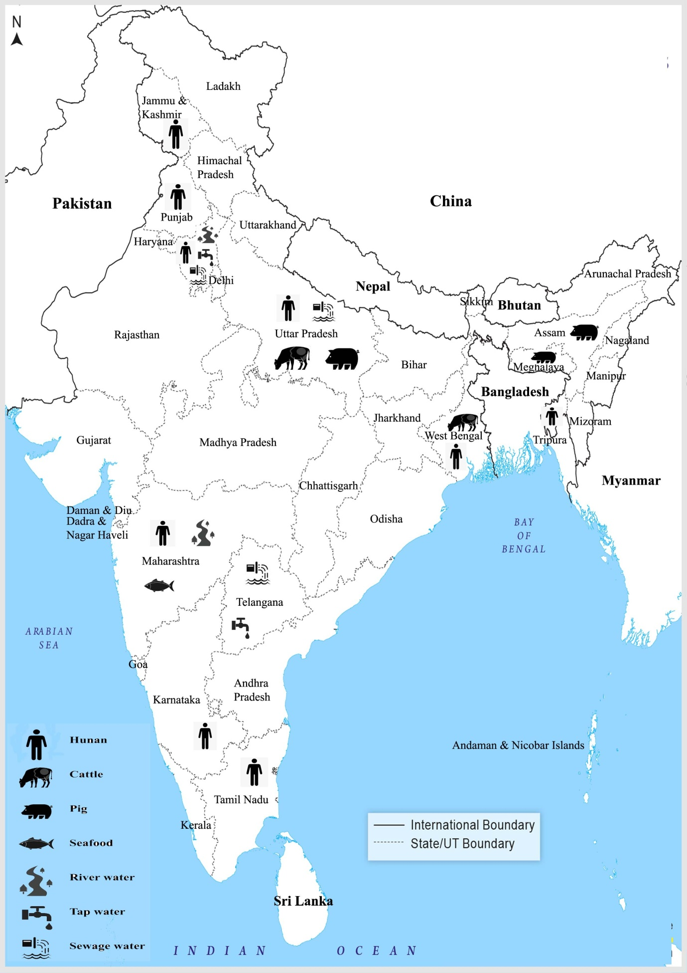
Figure 1. Presence of NDM among human, animal, and environment interfaces in India.

Reference
1. Nordmann P, Poirel L. The difficult-to-control spread of carbapenemase producers among Enterobacteriaceae worldwide. Clinical Microbiology and Infection. 2014;20:821-30. https://doi.org/10.1111/1469-0691.12719.
2. Temkin E, Adler A, Lerner A. Carbapenem-resistant Enterobacterales: biology, epidemiology, and management. Annals of the New York Academy of Sciences. 2014;1323:22-42. https://doi.org/10.1111/nyas.12537.
3. Kock R, Daniels-Haardt I, Becker K, et al. Carbapenem-resistant Enterobacteriaceae in wildlife, food-producing and companion animals– a systematic review. Clinical Microbiology and Infection. 2018;24:1241-50. https://doi.org/10.1016/j.cmi.2018.04.004.
4. Madec JY, Haenni M, Nordmann P, Poirel L. Extended-spectrum b-lactamase/AmpC- and carbapenemase-producing Enterobacteriaceae in animals: a threat for humans. Clinical Microbiology and Infection. 2017;23:826-33. https://doi.org/10.1016/j.cmi.2017.01.013.
5. S. Das. The crisis of carbapenemase-mediated carbapenem resistance across the human-animal-environmental interface in India. Infectious Diseases Now. 2017. https://doi.org/10.1016/j.idnow.2022.09.023 (Article in press)

Biography
Dr. Surojit Das studied Microbiology at the University of Calcutta, India. He completed his PhD from bacteriology division, ICMR-National Institute of Cholera and Enteric Diseases, India. After that, he had pursued post-doctoral experience at Clinical Microbiology, Tata Medical Center, India. He is continuing bacteriological research emphasizing on antimicrobial resistance (AMR), epidemiological investigations, and molecular diagnostics of infectious diseases, molecular typing and virulence. He is interested in molecular tracking and mapping of emerging bacterial AMR especially transferable resistance and high-risk clones applying one health concept. He has expertise in designing and implementing PCR assays in multiplex format for rapid and economical detection of target genes approaching in-vitro diagnostics (IVD). Dr. Das is actively engaged in surveillance of clinical Gram-negative bacteria resistant highest priority critically important antimicrobials for human medicine like extended-spectrum cephalosporins, fluoroquinolones, polymyxins, carbapenems throughout West Bengal, India. He is working on deciphering the route of clonal transmission of antibiotic-resistant Gram-negative bacteria. He is also involved in antimicrobial and infection prevention stewardships of hospitals by developing and deploying rapid molecular diagnostics. He has published over 15 articles in international peer-reviewed journals. He has engaged as member and reviewer of several prestigious learned societies especially Elsevier and Microbiology society. He is serving as associate editor-in-chief of International journal of advanced medicine sciences and technology under Lattice Science Publication.

