Food analysis
Oumou diakite*

Stanford University School of Medicine, USA

Abstract
Statement of the problem: The dominant foods were wheat flour and vegetable oil (75%) in occurrence of 25 for the first and 24 of the second, then apple jumps was the less dominant (2%, 2 in occurrence). For others like plantain bananas, poultry feed, raw vegetables, sesame oil between 70% and 45%. Infant flour, goulash hongrois, chocolate, livestock feed, miankala chips, braised fish around 25%-50% were the middle content of our research.
Methodology & theoretical orientation:
The files of the National Health Laboratory were used for our data collection. The entered data were collected by questionnaire in Excel and analyses by Sphinx.
Findings:
Food pathogens are mainly bacteria, viruses, or even parasites that are present in the food and are the cause of major diseases such as food poisoning.
The salmonella was the major germs 30% with 8% for aerobic germs, ash, Escherichia coli, germs mesophilic, and staphylococcus aureus.
The humidity was 6% with 4% dry then 2% of iron, acid, fat, calcium, iode, nitrogenous, phosphors, protein, soap, vitamin.
Graphic 1: The nature of samples NHL (National Health Laboratory).

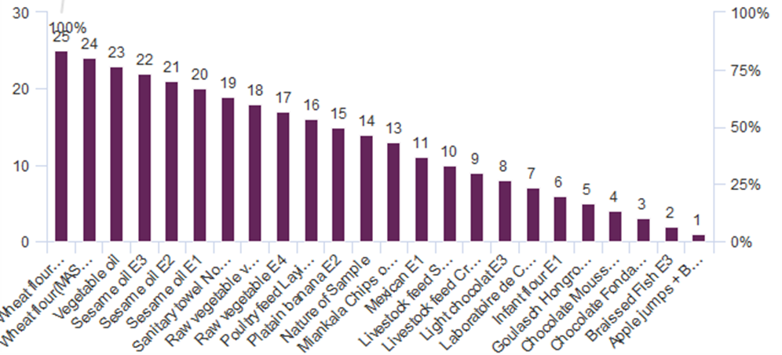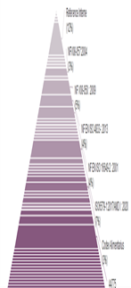

Graphic 2: The methods for the food analysis used in NHL.

Conclusion:
Many of the technique of food analyses are not available in Mali. That limits our research to provide more information about food analyses.
References:
1. The article “Food Fraud: Fake Food or Just Fake News?” appeared in the December 15, 2019 edition of the Institute of Food Technologists’ Science Meets Food. The authors Nicole Arnold, PhD candidate and Lily Yang have approved this revision; PhD. FoodInsight.org has been granted permisión to share the revision with you.
2. Food quality 4.0: From traditional approaches to digitalized automated analysis 2023, Journal of Food Engineering.
3. https://www.fao.org/food-safety/food-control...
4. The Editor of Encyclopedia Britannica. This article was most recently revised and updated by Adam Augustyn.
5. https://www.sciencedirect.com/science/article/pii/B9780128119426000133
6. https://foodprint.org/issues/pesticides
7. https://www.who.int/news-room/fact-sheets/detail/mycotoxins
8. https://www.tuvsud.com/.../food/veterinary-drug-residue-testing
9. https://www.newfoodmagazine.com/article/155869/cannabinoids-in-food
10. https://www.healthline.com/nutrition/microplastics
Biography
Doctor OUMOU DIAKITE has completed her postdoctoral studies at the age of 37 years from Alison University and her doctoral studies from Gamal Abdel Nasser University School of Medicine. She wrote ‘the micronutrients and pregnancy and the book of standard dietetic of hospital’. She participated to UNITAR, Global Symposium on Soils for Nutrition webinars and speaker in 3 RD World summit on Food and Nutrition (conference series LLC Ltd)

