What is the role of ERCP in the diagnosis of hemosuccus pancreaticus?
Kwak, Yun Mi MDª; Paik, Kyu-hyun MDª; Kim, Ji Chang MD^{b}; Park, Won SuK MD, Ph.D.ª

Abstract (300 word limit)
Hemosuccus pancreaticus (HP) is one of the rare causes of gastrointestinal bleeding, sometimes leading to a life-threatening condition. However, the diagnosis of HP is often delayed as its rarity and intermittent signs of bleeding, which still is challenging to determine the bleeding source for some patients. An 83-year-old man was transferred to our hospital to evaluate the source of intermittent upper gastrointestinal bleeding involving melena and worsening anemia. : Initial upper and lower gastrointestinal endoscopies could not reveal any source of bleeding. Emergent upper endoscopy performed with hematochezia and hypotension confirmed a spurt of bleeding from the major duodenal papilla. However, contrast-enhanced CT and angiography could not find the source of the bleeding from the major duodenal papilla. Here, endoscopic retrograde cholangiopancreatography (ERCP) for inducing the bleeding from the source and indicating the bleeding point was performed according to the decision of the multidisciplinary team. Immediately thereafter, sequential angiography was performed, and HP due to the rupture of a pseudoaneurysm of the splenic artery could be diagnosed. As a result, it was possible to avoid surgical resection of the pancreas by accurately embolizing the bleeding focus of HP under a multidisciplinary team approach. The patient was discharged in a hemodynamically stable condition. There was no further gastrointestinal bleeding or procedure-related complications till 6 months of discharge.

Image
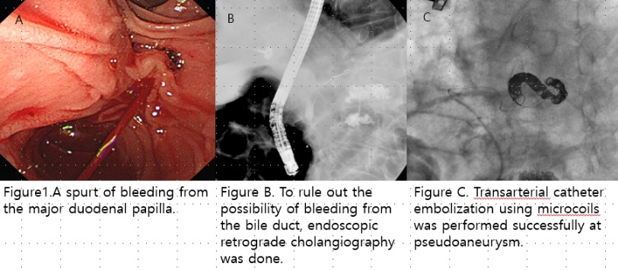
Recent Publications (minimum 5)
1 Han B, Song Z-F, Sun BJH, International PD. Hemosuccus pancreaticus: a rare cause of gastroirtestiral bleeding. 2012; 11(5): 479-488
2 Toyoki Y, Hakamada K, Narumi S, Nara M, Ishido K, Sasaki M. Hemosuccus pancreaticus: problems and pitfalls in diagnosis and treatment. World journal of gastroenterology: WJG 2008; 14(17): 2776
3 Kim SS, Roberts RR, Nagy KK, Joseph K, Bokhari F, An G, Barrett JJJoT, Surgery AC. Hemosuccus pancreaticus after penetrating trauma to the abdomen. 2000; 49(5): 948-950
4 Yu P, Gong JJAom, surgery. Hemosuccus pancreaticus: a mini-review. 2018; 28: 45-48
5 Matsumoto Y, Miyamoto H, Fukuya A, Nakamura F, Goji T, Kitamura S, Kimura T, Okamoto K, Sogabe M, Muguruma NJCjog. Hemosuccus pancreaticus caused by a mucinous cystic neoplasm of the pancreas. 2017; 10(2): 185-190



Biography (150 word limit)
I graduated medical school and trained about internal medicine until now, I am training fellowship of catholic hospital of Republic of KOREA. I’m interest in gastroenterology part of internal medicine and I hope that I will be a professional doctor of internal medicine of gastroenterology.
Email: kymtrust@naver.com

Notes/Comments:

Presenting author details
Full name: M.D.Kwak Yun Mi
Contact number: 82-10-3409-7192
Twitter account:
Linked In account:
Session name/ number: 34943
Category: Oral presentation

