Digital Hybrid Orthodontic Treatment: A Case Study
Dr Khaled Kasem, Chief Orthodontist at Impress

Abstract (300 word limit)
Hybrid application of clear aligners can be a rational and efficient approach for treating malocclusions, as compared with a clear aligner therapy alone option in which the magnitude of some movements would require a higher number of aligners and likely further refinement.

A case study patient, with no medical problems, underwent a hybrid digital treatment with two phases to treat Class II div 2, brachycephalic pattern and a retrognathic mandible: an extraction of two first premolars with fixed orthodontic as a first phase and clear alignment treatment as a second phase.

The findings? A combined use of aligners and fixed orthodontic treatment is an efficacious means of resolving orthodontic issues such as class II, dental cross-bite, and crowding within a relative short time-frame comparable to conventional orthodontic methods, and with excellent esthetics and functional results.

Image
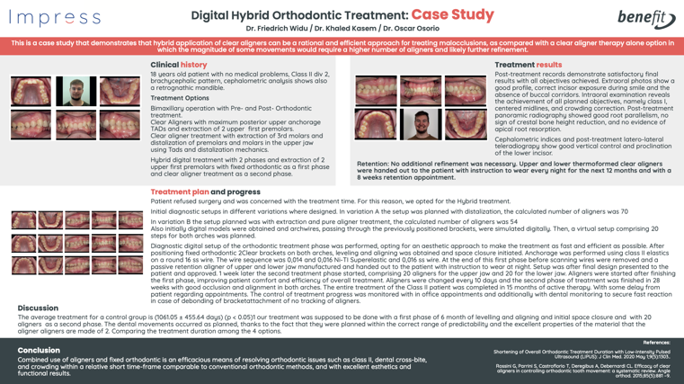
Recent Publications (minimum 5)
- Carvalho-Lobato P, Garcia VJ, Kasem K, Ustrell-Torrent JM, Tallón-Walton V, Manzanares-Céspedes MC (2014), Tooth movement in orthodontic treatment with low-level laser therapy: a systematic review of human and animal studies. Photomed Laser Surge. 2014 May; 32(5):302-9.
- Garcia VJ, López-Cancelos R, Riveiro A, Comesaña R, Ustrell I Torrent JM, Kasem K, Badaoui A, Manzanares-Céspedes MC, Carvalho-Lobato P (2017) Determination of forces on a split palatal screw after rapid maxillary expansion. J Orofac Orthop. 2017 Sep;78(5):371-384.
- Garcia VJ, Arnabat J, Comesaña R, Kasem K, Ustrell JM, Pasetto S, Segura OP, Manzanares-Céspedes MC, Carvalho-Lobato P (2016) Effect of low-level laser therapy after rapid maxillary expansion: a clinical investigation. Lasers Med Sci. 2016 Aug;31(6): 1185-94.
- Garcia VJ, Comesaña R, Kasem K, Ustrell-Torrent JM, Badaoui A, Manzanares-Céspedes MC, Carvalho-Lobato P (2015) Short-term effects of strain produced on a split palatal screw-type hyrax appliance after rapid maxillary expansion: a clinical trial. Am J Orthod Dentofacial Orthop. 2015 Dec;148(6):990-8.
- Garcia VJ, Comesaña R, Barro O, Riveiro A, Ustrell-Torrent JM, Kasem K, Badaoui A, Manzanares-Céspedes MC, Carvalho-Lobato P (2018) Strain monitoring and molar load determination during maxillary expansion. Proceedings of the 1st Iberic Conference on Theoretical and Experimental Mechanics and Materials / 11th National Congress on Experimental Mechanics. Porto/Portugal 4-7 November 2018. Ed. J.F. Silva Gomes. INEGI/FEUP (2018); ISBN: 978-989-20-8771-9; pp. 893-898.
Photograph

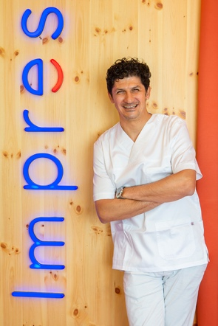
Biography (150 word limit)
Dr. Khaled Kasem has more than 15 years of experience in his field. He currently works exclusively in orthodontics being the chief of orthodontists at Impress while also combining his work at the University of Barcelona as a research coordinator in the orthodontic department. He has studied for a master's degree in Orthodontics and has a diploma in advanced techniques in dentistry. He has publications in renowned journals such as the American Journal of Orthodontics & Dentofacial Orthopedics or Photomedicine & Laser Surgery.
Impress is the #1 European digital orthodontic brand. The company was established in Barcelona in 2019, and since then it has revolutionized the invisible orthodontic sector with the best team of professionals specialized in making people smile and the latest technology applied to the diagnosis, treatment, and follow-up of all cases. In 3 years, Impress has managed to position itself as the European leader in the orthodontic sector with its award-winning invisible orthodontic treatment.
After raising $125 million earlier in 2022, the funding was earmarked to further expand its presence across Europe, as well as propel the orthodontic experience further into the digital realm. Impress is currently present in more than 130 cities in 9 different countries: Spain, Portugal, Italy, the United Kingdom, France, Ukraine, Switzerland, the United States, and Germany.
Email: impress@fullvolumepr.co.uk

