Mediating effect of resilience on the relationship between perceived social support and burnout among Chinese palliative nurses
Yalin Zhang, RN MSNc, West China School of Nursing, Sichuan University/Department of Nursing, West China Hospital, Sichuan University, Chengdu, China
Xiaolin Hu, RN, PhD, Professor, West China School of Nursing, Sichuan University/Department of Nursing, West China Hospital, Sichuan University, Chengdu, China

Abstract (300 word limit)
Statement of the Problem: Palliative nurses are a group that is vulnerable to burnout. Perceived social support may contribute to decreasing palliative nurses' burnout and facilitating their personal resilience, and resilience may be associated with lower levels of burnout. However, these relationships were unclear in the Chinese context. Methodology & Theoretical Orientation: This study was conducted based on the resilience model. A mixed sampling method including convenience sampling and stratified sampling was used to recruit participants, and a total of 319 palliative nurses completed the Nursing Burnout Scale, the Perceived Social Support Scale and the Connor–Davidson Resilience Scale from May 2021 to September 2021. Influencing factors were primarily identified using independent-sample t tests and one-way ANOVA. Bootstrap method was used to detect the mediating effect of resilience. Findings: The level of burnout in palliative nurses (23.4 ± 7.68) was higher than that of general nurses in China. Education level, health condition and monthly income were influencing factors of burnout. Resilience was detected as a mediator in the relationships between perceived social support and dimensions of burnout. Conclusion & Significance: Chinese palliative nurses experience a relatively high level of burnout, which may be influenced by several sociodemographic variables. Resilience could mediate the effect of perceived social support on the dimensions of burnout. Problem-oriented and palliative-tailored strategies should be developed to further address burnout in Chinese palliative nurses. Nurse managers and policy makers should support nurse ongoing education, adopt health-promoting interventions and optimize salary systems. In addition, perceived social support resources and resilience training programmes are also warranted.

Image
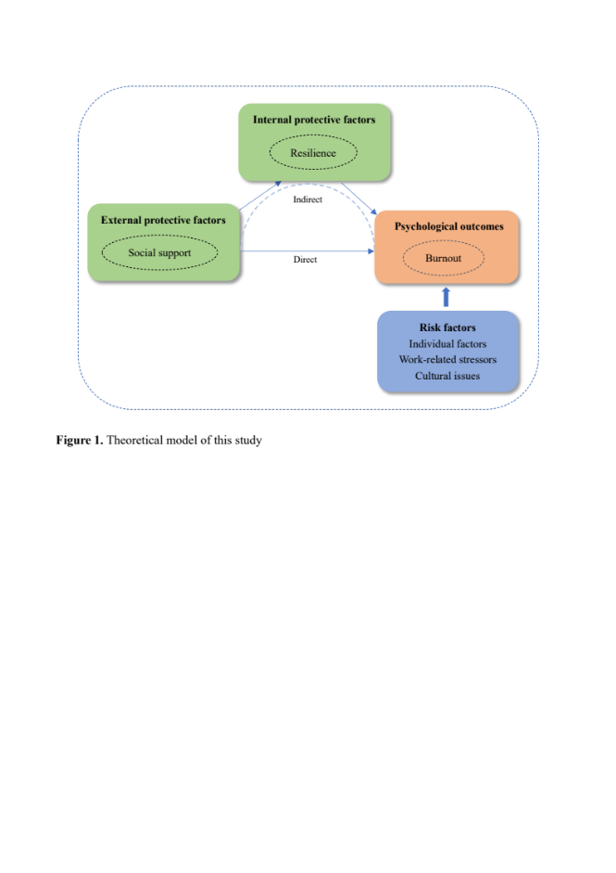
Recent Publications (minimum 5)
- Zhang, Y., Guan, C., Jiang, J., Zhu, C., & Hu, X. (2022). Mediating effect of resilience on the relationship between perceived social support and burnout among Chinese palliative nurses. Journal of clinical nursing, 10.1111/jocn.16532. Advance online publication.
- Zhang, Y., Li, J., & Hu, X. (2022). The effectiveness of dignity therapy on hope, quality of life, anxiety, and depression in cancer patients: A meta-analysis of randomized controlled trials. International journal of nursing studies, 132, 104273.
- Li, Y., Li, J., Zhang, Y., Ding, Y., & Hu, X. (2022). The effectiveness of e-Health interventions on caregiver burden, depression, and quality of life in informal caregivers of patients with cancer: A systematic review and meta-analysis of randomized controlled trials. International journal of nursing studies, 127, 104179.
- Li, J., Wang, Q., Guan, C., Luo, L., & Hu, X. (2022). Compassion fatigue and compassion satisfaction among Chinese palliative care nurses: A province-wide cross-sectional survey. Journal of nursing management, 10.1111/jonm.13708. Advance online publication.
- Li, J., Liu, Y., Jiang, J., Peng, X., & Hu, X. (2021). Effect of telehealth interventions on quality of life in cancer survivors: A systematic review and meta-analysis of randomized controlled trials. International journal of nursing studies, 122, 103970.

 Biography (150 word limit)
Yalin Zhang majored in oncology/palliative nursing, working on improving the health and wellbeing of cancer/palliative patients and their families. Her research has provided evidence on enhancing cancer patients’ end-of-life experience and strategies on improving the quality of end-of-life care. The core R&D team of MDT focuses on oncology nursing and hospice care. The team has made important progress in biological treatment of malignant tumors and has established e-Health interventions for cancer/palliative patients under the background of normalized epidemic prevention and control.
Email: zhangyalin1210@126.com

Notes/Comments: None

Presenting author details
Full name: Yalin Zhang
Contact number: +86 13072803863
Twitter account: None
Linked In account: None
Session name/ number: 7th International Conference on Palliative Care, Hospice, and Wellness
Category: (Oral presentation/ Poster presentation): Poster presentation

