Quantification of climate change impacts on future hydrological regimes in the Upper Tekeze basin with a flow-weighted ensemble strategy
Kidane Welde Reda, PhD candidate, IGSNRR, China

Abstract
General Circulation Models (GCMs) have been widely used for evaluating future hydrological changes. Ensemble means were generally used to produce future projections of hydrological regimes in combination with hydrological models. However, this method may be subject to considerable uncertainties due to the discrepancies of GCMs in reproducing regional climate changes. In this study, we used two multi-model ensemble strategies (simple-averaged and flow-based weighted) that integrates projections of GCMs with a hydrological model, to determine their capabilities to reproduce empirical flow cumulative distribution functions. Temperature and precipitation predictions from multiple-GCMs were used to drive the Soil and Water Assessment Tool (SWAT) model in the Upper Tekeze basin (UTB), Ethiopia. The results showed that, compared to the reference period (1981-2022), the long-term daily temperatures were projected to increase while no significant trend was found in precipitation in near (2040s: 2023-2061) and distant (2080s: 2062-2100) future using the two ensemble strategies. The streamflow was predicted to decrease from May to October while negligible changes were projected from December to March at three stations of the UTB during the future periods. The flow-weighted ensemble strategy outperformed the averaged in reproducing hydrological regimes and thus may produce more robust projections of hydrological changes. However, the two ensemble strategies underestimated the frequency and magnitude of flow extremes. Therefore, the range in the magnitude of extreme flow events that together defined by individual GCMs can also provide critical information on future water resources planning. A distinct level of heterogeneity in changes of hydrological components are projected across the sub-watersheds. An increase in evapotranspiration and decrease in surface runoff and soil water are observed. The vulnerability of the hydrological components to climate change showed significant spatial variation. Overall, our findings suggest that future water resources planning and development exercises need to fully consider the effects of climate change.

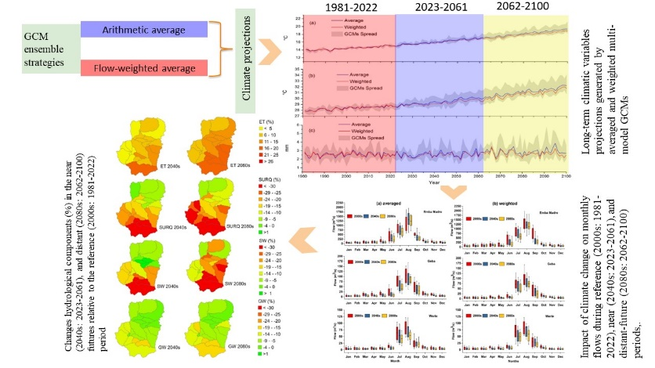
Recent Publications
- Reda, K. W., Liu, X., & Tang, Q. (2022). Intra‐Annual Variation of High and Low‐Flow Extremes Associated With Land Use and Climate Change in the Upper Tekeze of the Nile River Basin. Journal of Geophysical Research: Atmospheres, 127(8).
- Reda, K. W., Liu, X., Haile, G. G., Sun, S., & Tang, Q. (2022). Hydrological evaluation of satellite and reanalysis-based rainfall estimates over the Upper Tekeze Basin, Ethiopia. Hydrology Research, 53(4), 584-604. doi: 10.2166/nh.2022.131
- Reda, K. W., Liu, X., Tang, Q., & Gebremicael, T. G. (2021). Evaluation of Global Gridded Precipitation and Temperature Datasets against Gauged Observations over the Upper Tekeze River Basin, Ethiopia. Journal of Meteorological Research, 35(4), 673-689.
- Reda, K.W., & Gebremariam, B. (2017). Effect of land use land cover dynamics on hydrological response of watershed: Case study of Tekeze Dam watershed, northern Ethiopia. International Soil and Water Conservation Research, 5(1), 1-16.
- Reda, K.W., Gebremariam, H. L., & Kahsay, K. D. (2018). Optimizing irrigation water levels to improve yield and water use efficiency of vegetables: case study of tomato. Sustainable Water Resources Management, 5(2), 737-742.
- Reda, K.W., & Gebremariam, H. L. (2016). Effect of different furrow and plant spacing on yield and water use efficiency of maize. Agricultural Water Management, 177, 215-220.
- Reda, K.W.,. (2016). Identification and prioritization of subwatersheds for land and water management in Tekeze dam watershed, Northern Ethiopia., 4(1), 30-38.

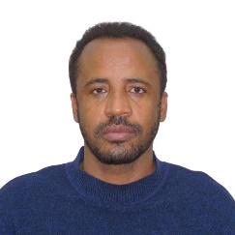 Biography

Deanna Kidane Welde Reda has expertise in hydro-climatic and watershed modeling. His open and contextual evaluation model based on climate change and asociated impact on hydrological extremes creates new pathways for improving watershed and basin management. He has built his experience in research, evaluation, and administration both in a research institution from the get-go of his career. Moreover, he has published more than 10 papers as first author in reputable SCI journals.
.
Email: kwreda2019@igsnrr.ac.cn

Notes/Comments: I hope my abstract will be selected for the conference and I will get good experience from the conference and also used as requirements for the accomplishment of my PhD successfully
Presenting author details
Full name: Kidane Welde Reda
Contact number: +8618613309241
Twitter account: @kidane82486768
Linked In account:
Session name/ number: Climate change and weather forecasting
Category: (Oral presentation/ Poster presentation)

