Discovery of novel diarylpyrimidine derivatives as potent HIV-1 non-nucleoside reverse transcriptase inhibitors through computer-aided drug design
Xiangyi Jiang, RN PhD, Shandong University, China Xinyong Liu*, Prof., Shandong University, China
Peng Zhan*, Prof., Shandong University, China

Abstract (300 word limit)

To overcome the drug resistance of HIV-1 non-nucleoside reverse transcriptase inhibitors (NNRTIs), a series of novel diarylpyrimidine derivatives with improved resistance profiles were discovered through computer aided drug design. The cocrystal structure of etravirine (ETR) and HIV-1 reverse transcriptase (RT) showed that the aminobenzonitrile moiety of etravirine pointed to an extended channel, consisting of F227 and P236, that leads to the solvent-exposed region. To enhance backbone-binding interactions with F227 and P236, we designed a series of novel diarylpyrimidine derivatives bearing piperazine sulfonyl. After virtual screening using the software Surflex-Dock SYBYL-X 2.0, series of diarylpyrimidine derivatives with high virtual score were synthesized directly. The newly synthesized compounds were evaluated for their anti-HIV activities against via the MTT method in MT-4 cells. Among them, compound 18b1 displayed excellent anti-HIV-1 activities (EC₅₀ = 1.4 - 9.9 nM) against the wild-type and five mutations, which were obviously superior to that of approved drug etravirine. HIV-1 RT inhibitory assays indicated 18b1 possessed remarkably improved activities (IC₅₀ = 0.093 μM) compared with ETR (IC₅₀ = 1.35 μM). In order to calculate the potential binding mode between compound 18b1 and HIV-1 RT, molecular dynamics (MD) simulation studies were conducted through OPENEYE scientific software. The analysis results showd that the piperazine sulfonyl of 18b1 can generate additional interactions with the main chains of F227 and V106 in binding pocket, which explained the reason why 18b1 displayed better anti-HIV-1 activities than ETR. Overall, compound 18b1 is a promising lead compound and deserves further study.

Recent Publications (minimum 5)
- Huang B, et al. (2021) Structure-Based Design and Discovery of Pyridyl-Bearing Fused Bicyclic HIV-1 Inhibitors: Synthesis, Biological Characterization, and Molecular Modeling Studies. J Med Chem 64(18):13604-13621.
- Jiang X, et al. (2021) Exploiting the tolerant region I of the non-nucleoside reverse transcriptase inhibitor (NNRTI) binding pocket. Part 2: Discovery of diarylpyrimidine derivatives as potent HIV-1 NNRTIs with high Fsp3 values and favorable drug-like properties. Eur J Med Chem 213:113051.
- Huang B, et al. (2019) Exploiting the Tolerant Region I of the Non-Nucleoside Reverse Transcriptase Inhibitor (NNRTI) Binding Pocket: Discovery of Potent Diarylpyrimidine-Typed HIV-1 NNRTIs against Wild-Type and E138K Mutant Virus with Significantly Improved Water Solubility and Favorable Safety Profiles. J Med Chem 62(4):2083-2098.
- Wang Z, et al. (2022) Contemporary Medicinal Chemistry Strategies for the Discovery and Development of Novel HIV-1 Non-nucleoside Reverse Transcriptase Inhibitors. J Med Chem 65(5):3729-3757.
- Wang Z, et al. (2021) Discovery of Novel Dihydrothiopyrano[4,3- d]pyrimidine Derivatives as Potent HIV-1 NNRTIs with Significantly Reduced hERG Inhibitory Activity and Improved Resistance Profiles. J Med Chem 64(18):13658-13675.

Image
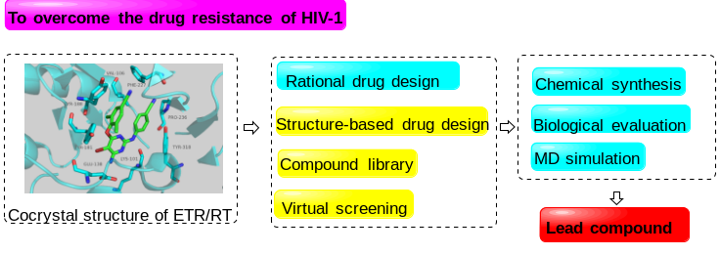

Figure 1: Discovery of novel potent HIV-1 NNRTIs through computer-aided
drug design
Paste your Logo here


Biography (150 word limit)
Xiangyi Jiang received his BS and MS degrees from the School of Pharmaceutical Sciences, Shandong University, in 2018 and 2021. He is currently pursuing a doctor degree in the Department of Medicinal Chemistry, School of Pharmaceutical Sciences Shandong University, working under the supervision of Professor Xinyong Liu and Professor Peng Zhan. His research interest focuses on the discovery of novel antiviral lead compounds, such as HIV-1, HBV and SARS-CoV-2.
Email: 1765812008@qq.com


Biography (150 word limit)
Xinyong Liu received his BS and MS degrees from the School of Pharmaceutical Sciences, Shandong University, in 1984 and 1991. From 1997 to 1999, he worked at the Instituto de Quimica Medica (CSIC) in Spain as a senior visiting scholar. He obtained his PhD from Shandong University in 2004. He is currently a full professor of the Institute of Medicinal Chemistry, Shandong University. His research interests include rational drug design, synthesis, and antiviral evaluation of a variety of molecules that interact with specific enzymes and receptors in the viral life cycle.
Email: xinyongl@sdu.edu.cn

Biography (150 word limit)
Peng Zhan obtained his BS, MS and PhD degrees in medicinal chemistry from Shandong University, China, in 2005, 2008 and 2010. He subsequently joined the research group of Professor Xinyong Liu as a lecturer (2010–2012). From 2012 to 2014, he worked as a postdoctoral fellow funded by JSPS (Japan Society for the Promotion of Science) in Japan. He is currently a full professor in the Institute of Medicinal Chemistry, Shandong University. His research interests involve the discovery of novel antiviral, anti-gout, and neurodegenerative disease-related agents.
Email: zhanpeng1982@sdu.edu.cn

Notes/Comments:

Presenting author details
Full name: Xiangyi Jiang
Contact number: +86 17865197033
Twitter account:
Linked In account:
Session name/ number:
Category: Oral presentation

