Towards universal screening for postpartum depression in China: lessons learned from a comprehensive prevention programme in Shenzhen
Dadong Wu*, Lei Jiang, Siqi Chen, Guanglin Zhao Affiliated Shenzhen Maternity & Child Healthcare Hospital, Southern Medical University, Shenzhen, China

Abstract
Purpose: This study was conducted to assess the real-world efficacy of a universal programme for the prevention of postpartum depression (PPD) in Shenzhen. Given the lack of evidence on routine PPD screening and intervention in China, it sought to provide insights for programme planning and implementation, particularly in relation to achievement of the targets set by the first national guidelines for PPD prevention and treatment.
Methods: Using routine health information system (HIS) data, the PPD screening, referral and intervention rates for 2015-2019 were calculated and compared between years. Trends of variables were tested by using trend χ².
Results: The programme screened 137,761 to 178,857 women for PPD every year with the coverage among all postpartum women increased steadily from 71.1% to 82. 5% (χ² = 10145.251, p < 0.001). The PPD-positive rate maintained between 4.1% and 4.9%. However, although referral messages were given to an increased high percentage of PPD-positive women (χ² = 1090.908, p < 0.001), the intervention rate (i.e., referral uptake) was low as 4.6% to 26.9% despite an overall increasing trend (χ² = 1656.943, p < 0.001).
Conclusion: This study demonstrated the high efficacy of Shenzhen’s comprehensive PPD prevention programme initiated in 2013. The resultant rise in the screening rate among all postpartum women, together with a high referral rate of those screened positive, have contributed to the city’s relatively low PPD prevalence. PPD screening and intervention should be included as part of basic public health services to ensure universal coverage and specific strategies should be adopted to ensure referral uptake.

Recent Publications
- Wu, D., Jiang, L., & Zhao, G. (2022). Additional evidence on prevalence and predictors of postpartum depression in China: A study of 300,000 puerperal women covered by a community-based routine screening programme. J Affect Disord, 307, 264-270.
- Qi, W., Zhao, F., Liu, Y., Li, Q., & Hu, J. (2021). Psychosocial risk factors for postpartum depression in Chinese women: a meta-analysis. BMC Pregnancy Childbirth, 21(1), 174.

Image
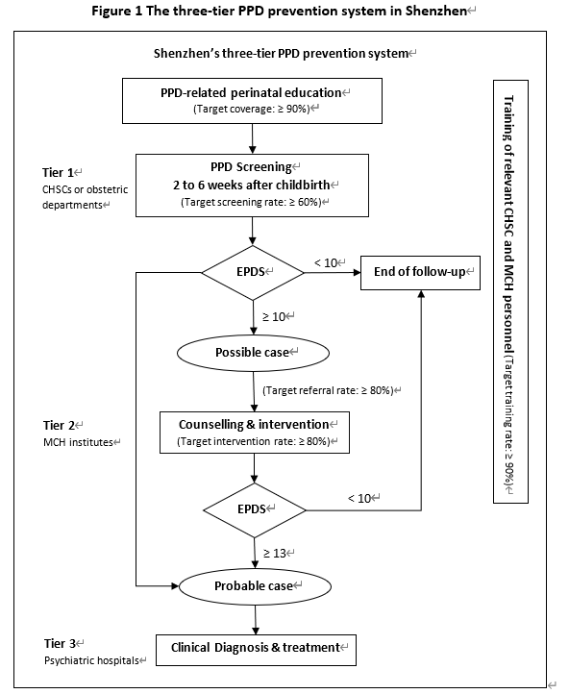

Recent Publications
- Yin, J., Nisar, A., Waqas, A., Guo, Y., Qi, W. L., Wang, D., . . . Li, X. (2020). Psychosocial interventions on perinatal depression in China: A systematic review and meta-analysis. J Affect Disord, 271, 310-327.
- Gong, W., Jin, X., Cheng, K. K., Caine, E. D., Lehman, R., & Xu, D. R. (2020). Chinese Women's Acceptance and Uptake of Referral after Screening for Perinatal Depression. Int J Environ Res Public Health, 17(22).


Biography
Dr. Dadong Wu is an experienced researcher in the field of public health policy and systems, particularly in relation to maternal and child health. She holds a PhD in health policy from University College London (UCL) and have worked with the WHO, UNFPA, UNICEF and China CDC etc. on a number of research projects on perinatal depression control, prevention of mother-to-child transmission (PMTCT), and sexual and reproductive health and rights (SRHR). Dr. Wu holds a research position in the Affiliated Shenzhen Maternity and Child Healthcare Hospital, Southern Medical University, China and works for University of Bern, Switzerland as an individual consultant. Her recent research interests mainly concentrate on (1) referral uptake of women screened positive for postpartum depression, (2) barriers and facilitators to implementing the global PMTCT guidelines at facility level.
Email: Dadong.wu.10@alumni.ucl.ac.uk
Notes/Comments:

Presenting author details
Full name: Dadong Wu
Contact number: +8613823184820
Twitter account: N/A
Linked In account: flora_winter@hotmail.com
Session name/ number:
Category: (Oral presentation)

