Intravenous Sodium Thiosulphate for Vascular Calcification of Hemodialysis Patients -- A Systematic Review and Meta-analysis
Wen Wen, MD,^{1,2*} Ignacio Portales-Castillo, MD,² Rituvanthikaa Seethapathy, MD,² Scott Krinsky, BA,² Daniela Kroshinsky, MD,³ Sahir Kalim, MD,² Jeremy Goverman, MD,⁴ Rosalynn M. Nazarian, MD,⁵ Vipul Chitalia, MD,⁶ Rajeev Malhotra, MD,⁷ Rafael Kramann, MD, PhD, ^{8,9,10} Cindy K. Malhotra, PharmD,¹¹ Sagar U. Nigwekar, MD.²
¹Department of Nephrology, Beijing Tsinghua Changgung Hospital, School of Clinical Medicine, Tsinghua University, Beijing, China.
²Division of Nephrology, Massachusetts General Hospital, Boston, Massachusetts, USA.
³Department of Dermatology, Massachusetts General Hospital, Boston, Massachusetts, USA.
⁴Sumner Redstone Burn Center, Massachusetts General Hospital, Boston, Massachusetts, USA.
⁵Department of Pathology, Massachusetts General Hospital, Boston, Massachusetts, USA.
⁶Renal Section, Department of Medicine, Boston University Medical Center, Boston, Massachusetts, USA.
⁷Cardiovascular Research Center and the Cardiology Division of the Department of Medicine, Massachusetts General Hospital and Harvard Medical School, Boston, USA.
⁸Division of Nephrology and Clinical Immunology, Medical Faculty RWTH Aachen University, Aachen, Germany.
⁹Institute of Experimental Medicine and Systems Biology, Medical Faculty RWTH Aachen University, Aachen, Germany.
¹⁰Department of Internal Medicine, Nephrology and Transplantation, Erasmus Medical Center, Rotterdam, The Netherlands.
¹¹Department of Pharmacy, Massachusetts General Hospital, Boston, Massachusetts, USA.

Abstract (300 word limit)

Background: Vascular calcification is a common comorbidity among patients with chronic kidney disease (CKD) indicating major cardiovascular events. This study aimed to evaluate the effects and safety of intravenous sodium thiosulphate (STS) for vascular calcification in CKD patients.

Methods: Electronic databases were searched for clinical trials that provided data comparing outcomes among patients treated with and without STS. PRISMA guidelines were followed. Efficacy was assessed using calcification scores and arterial stiffness. Safety was examined by analyzing adverse symptoms, electrolytes, and bone mineral density (BMD). Random-effects models were performed. Meta-regression and sensitivity analysis were done. The risk of bias was assessed using Cochrane tools.

Results: Among the 5601 publications, 6 studies involving 305 participants (mean age: 56 years, male: 56.6%) with all participants on maintenance hemodialysis met eligibility criteria. For efficacy, the progression in Agatston scores in the coronary arteries (107 patients, mean difference (MD): -241.27, 95%CIs: -421.50, -61.03) and iliac arteries (55 patients, MD: -382.00, 95% CIs: -751.07, -12.93) was lower in the STS treated group compared with controls. The increase in pulse wave velocity was lower in the STS group (104 patients, MD: -1.29 m/s, 95% CIs: -2.24 m/s, -0.34 m/s). No association was found between the change in calcification scores and STS regimen. For safety, gastrointestinal symptoms (e.g. nausea) and increased anion gap acidosis were noted. No reduction in BMD by STS was observed.

Conclusions: Intravenous STS may attenuate the progression of vascular calcification and arterial stiffness in hemodialysis patients. Large and well-designed randomized controlled trials are warranted.
Image
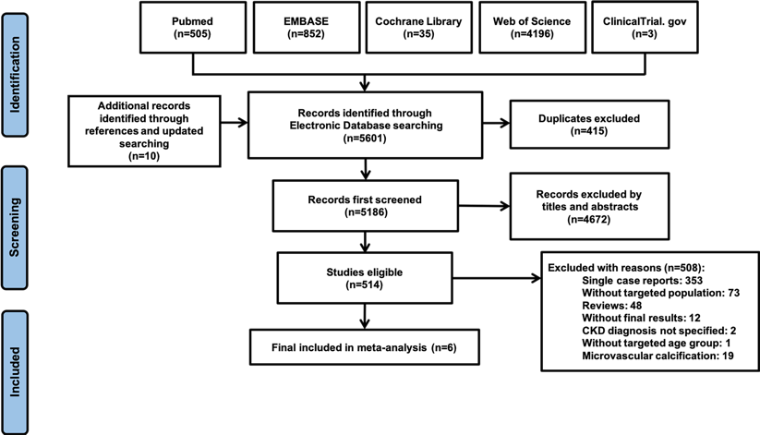
Recent Publications (minimum 5)
1. Wen W, Portales-Castillo I, Seethapathy R, et al. Intravenous sodium thiosulphate for vascular calcification of hemodialysis patients - a systematic review and meta-analysis [published online ahead of print, 2022 May 6]. Nephrol Dial Transplant. 2022;gfac171.
2. Wen W, Li Y, Chen Q, Li J. Serum and urine uric acid level may have different predictive value for urinary stone composition: a retrospective cohort study of 718 patients in Chinese population. Int Urol Nephrol. 2022;54(9):2247-2254.
3. 1. Zhao, X., Chen, Y., Cheng, Y., Wen, W., & Li, Z. *. Autoantibodies against citrullinated-lipopolysaccharide binding protein as a novel biomarker in seronegative rheumatoid arthritis. 2020, preprint.
4. Wen Wen, Yuhui Li, Yongjing Cheng, Jing He, Rulin Jia, Chun Li, Jianping Guo, Xiaolin Sun*, Zhanguo Li*. Lipopolysaccharide-binding protein is a sensitive disease activity biomarker for ESR/CRP negative patients with rheumatoid arthritis, Clinical and Experimental Rheumatology, 2018, 36(2): 233~240.
5. Wen Wen, Yanying Liu, Chuchu Zhao, Xiaolin Sun, Chunfang Zhang, Zhanguo Li. Clinical and serologic features of primary Sjogren's syndrome concomitant with autoimmune hemolytic anemia: a large-scale cross-sectional study. Clinical Rheumatology, 2015, 34(11): 1877-1884.

 Biography (150 word limit)
Wen Wen is a nephrologist in China. She received her medical and clinical training in Peking University Health Science Center, and finished a master degree of medical science in clinical investigation in Harvard Medical School. Her research currently mainly focuses on treatment of CKD-MBD, specifically about vascular calcification and calciphylaxis. She also has special interest on risk factor identification and follow-up of patients with urolithiasis.
Email: wwa01275@btch,edu.cn

)

