Health literacy and attitudes to holistic, complementary and alternative medicine in peritoneal dialysis patients: A descriptive study
ABSTRACT
Nurcan Uzdil,RN, PhD, Faculty of Health Sciences, Department of Mental Health and Disease Nursing, Erciyes University, Kayseri, Turkey
Züleyha Kılıç, RN, PhD, Department of Internal Diseases Nursing, Niğde Ömer Halisdemir University, Zübeyde Hanım School of Health, Niğde, Turkey.

Chronic renal failure (CRF) patients use many complementary and alternative medicine (CAM) practices to manage their symptoms. This research was conducted descriptively and relationally to determine the relationship between the attitudes of peritoneal dialysis patients toward holistic CAM and their health literacy (HL) levels. The study was conducted with 91 peritoneal dialysis patients who were treated in the adult peritoneal dialysis unit of a university, who met the inclusion criteria and who agreed to participate in the study. Data were collected using the survey form Holistic Complementary and Alternative Medicine Questionnaire (HCAMQ) and Health Literacy Scale (HLS). Ethics committee approval, institutional permission and informed consent of the participants were obtained. It was observed that 72.5% of peritoneal dialysis patients use CAM, and the mean HCAMQ score was 24.03 ± 7.94. Moreover, 76.9% of the patients implementing CAM used herbal methods, and 92.3% preferred CAM to strengthen immunity. In addition, 63.6% patients did not inform healthcare personnel about their CAM use. In the present study, the mean HLS score of peritoneal dialysis patients was 102.88 ± 21.06, and a statistically significant and negative correlation was observed between the mean HCAMQ and HLS scores (r=-0.240; p<0.05). Patients who reported their use of CAM to their healthcare personnel had higher HLS scores than those who did not. Perceived health status had a significant effect on both HCAMQ and HLS.
Conclusion: The majority of peritoneal dialysis patients included in the study used CAM, and their attitudes toward CAM use were positive. Most of the patients did not report the use of CAM to healthcare personnel.
Keywords: Complementary and Alternative Medicine, Health Literacy, Holistic, Peritoneal Dialysis.
References
- Shah JM, Ramsbotham J, Seib C, Muir R, Bonner A (2021) A scoping review of the role of health literacy in chronic kidney disease self‐management. Journal of Renal Care 47(4): 221-233.
- Dursun SI, Vural B, Keskin B, Kaçar HK, Beyhan A, Kadioglu H (2019) The relationship between traditional/complementary medical attitude and health literacy and health perception in adults. J Public Health Nurs, 1(1): 1-10.
- Lameire N, Vanholder R. (2021) Health literacy problems of kidney patients. Nephrology Dialysis Transplantation 36(7): 1155-1157.
- Elisabeth Stømer U, Klopstad Wahl A, Gunnar Gøransson L, Hjorthaug Urstad K (2020) Health literacy in kidney disease: associations with quality of life and adherence, J Ren Care 46(2): 85–94.
- Zakaria NF, Mohd Noor MT, Abdullah R (2021) Traditional and complementary medicine use among chronic haemodialysis patients: a nationwide cross-sectional study. BMC complementary medicine and therapies 21(1): 1-12.


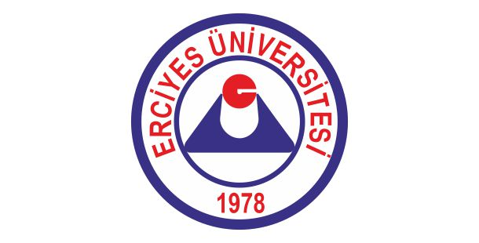
Nurcan UZDİL have received PhD from the mental health and diseases nursing program in 2020. She is working as a fulltime in the Erciyes University. Asist.Prof. at nursing department in Erciyes University Faculty of Health Science.

Email: nuzdil@erciyes.edu.tr

About University
Erciyes University; It is a university that provides accredited education and training services at international standards, produces innovative information and technology with its R&D studies, transforms the information and technology it produces into social contribution, is a pioneer in its fields of activity, is committed to its basic values and is environmentally sensitive. It is one of the leading universities in Turkey and in the world, which contributes to the construction of a better future with its graduates, makes its role as a pioneer in innovative knowledge and technology production sustainable with its R&D activities, contributes to the society with its scientific studies in all fields, is preferred and proud to be a member of.

